Exploring the anti-aging and nootropic potential of aromatic essential oils using Caenorhabditis elegans models

A thesis submitted to
THE UNIVERSITY OF TRANS-DISCIPLINARY HEALTH SCIENCES AND TECHNOLOGY


For THE PARTIAL FULFILMENT OF THE AWARD of the Degree of
M.Sc. Life sciences (ayurveda biology)

BY
Dr. SHACHI SUVAS PRABHU MAHAMBRE

Under the Guidance of

DR. ASHWINI GODBOLE
Associate professor
THE UNIVERSITY OF TRANS-DISCIPLINARY HEALTH SCIENCES AND TECHNOLOGY, BENGALURU

June 2024

THE UNIVERSITY OF TRANS-DISCIPLINARY HEALTH SCIENCES AND TECHNOLOGY
Private University Established in Karnataka by ACT 35 of 2013
BENGALURU – 560064
DECLARATION BY THE CANDIDATE

I declare that this thesis “Exploring antiaging and nootropic potential of aromatic essential oils using Caenorhabditis elegans models.” submitted for the award of Master of Science to THE UNIVERSITY OF TRANS-DISCIPLINARY HEALTH SCIENCES AND TECHNOLOGY, Bengaluru, is my original work, conducted under the supervision of Dr. Ashwini Godbole. I confirm that no part of the work reported herein has been submitted for a degree or examination at any other university. References, funding and material obtained from other sources have been duly acknowledged, and no part of this dissertation has been plagiarised.

Place: TDU, Bengaluru


Signature of the Candidate
Date: 19/06/2024

Name of candidate: Dr. Shachi Suvas Prabhu Mahambre
Reg. No.: 2022MSCAB02

THE UNIVERSITY OF TRANS-DISCIPLINARY HEALTH SCIENCES AND TECHNOLOGY
Private University Established in Karnataka by ACT 35 of 2013
BENGALURU - 560064

CERTIFICATE FROM THESIS SUPERVISOR

This is to certify that the work incorporated in this thesis “Exploring antiaging and nootropic potential of aromatic essential oils using Caenorhabditis elegans models.” submitted by Dr. Shachi Suvas Prabhu Mahambre was carried out under my/our supervision. No part of this thesis has been submitted for a degree or examination at any other university. References, help and material obtained from other sources have been duly acknowledged. I confirm the originality of the work and that there is no plagiarism in any part of the thesis.


Dr. Ashwini Godbole
Associate Professor
19/06/2024

ACKNOWLEDGEMENT

I take this opportunity to extend my deepest gratitude to the University of Transdisciplinary Health Sciences and Technology, Bangalore to my Guide Dr. Ashwini Godbole, Associate Professor, TDU Bangalore, my supervisor and guide. I would like to thank her for granting me with the perfect space to work in and supporting me incessantly throughout the entire duration of my thesis work. I would also like to convey my thanks to Dr. Subramanya Kumar K, for aiding me with the sensory analysis segment in my thesis.
I would like to thank the coordinators of the M.Sc program, Dr. Megha and Dr. C. N. Vishnuprasad for having bestowed me with their effortless support and guidance. My educational experience has improved because of their dedication to fostering a positive learning environment and offering helpful resources imperative for academic growth. I would like to thank my classmates who supported me during this course. I would like to thank other faculties, staff and lab members of TDU for their valuable input and comments.
I would like to thank Mr. Prasanna K Simha for his constant support and confidence, which has kept me motivated and enhanced my performance as a student. I would like to thank the Worm group Ms. Jeevitha G, who has helped me throughout the learning process. I would like to appreciate the willingness of the participants who followed up on the sensory analysis, without which this thesis wouldn’t have been a success.
Lastly, I feel grateful to have come from such a supportive and compassionate family background who have put an insane amount of faith in me to perform to the best of my abilities. Hence, I owe the completion of this thesis to all of them.

SUMMARY

In Ayurveda, selected Sugandhi Dravya (aromatic drugs) are traditionally used to treat depression disorders. This study focused on four essential oils Chandana, Karpura, Vacha, and Jatamansi, which were selected on their therapeutic benefits. Utilizing the Caenorhabditis elegans models, we assessed the nootropic and anti-ageing properties of these essential oils. Additionally, we investigated their effects on Ser-1 knockout mutant strain, which is defective in serotonin signalling and serves as a model for depression. Our research examined the overall lifespan, healthspan, fecundity and oxidative stress in these worms.

The findings revealed that Chandana essential oil demonstrated the most significant positive effects among the tested oils. It extended the mean lifespan and improved the health span of Ser-1 knockout C. elegans. These results suggest that Chandana possesses strong nootropic and anti-ageing properties, making it a promising candidate for further studies on depression and age-related disorders. The study underscores the potential of Ayurvedic aromatic drugs in modern therapeutic applications.

PERSONAL REFLECTION

When I started this journey as a novice researcher, little did I know that 'the worm' would become an important part and parcel of my academic journey. I learnt so many things while working on my thesis over the last 8 months. First and foremost, I understood the importance of slowing down and developing ample patience. Picking of worms requires both of the above.
Technically, I learnt how to work in a lab and handle instruments. I also learnt how to prepare reagents. I learnt to let go off the experiment batches that did not go as per the required standards of the experiments I ran. I learnt to be unbiased and to have a positive attitude. I understood the basics of preliminary data collection and the challenges that come with it.
While it is established in the classics of Ayurveda, that Sugandhi dravyas have an array of functions it was gratifying to see the same with the results of the experiments. I would like to pursue this further to get a more in-depth understanding of the same.
While doing Sensory analysis on human volunteers and analyzing data as also challenging.
Working on this thesis definitely widened my horizon and my social circle. I got to delve into the universe of this mighty tiny creature which is commonly referred to as ‘the worm’ in the world of research.

Contents

1. INTRODUCTION 1
1.1 Sugandhi Dravya (Aromatic Drugs) 1
1.2 Depression Disorder 7
Symptoms 7
Management & Treatment 7
Relation between depression and serotonin 8
Relation between depression and ROS 8
3. Kaphaja Unmad and Depression 9
4. Caenorhabditis elegans 10
Chemosensation 11

2. MATERIALS AND METHODS 12
2.1 Essential Oils- 12
2.2 Caenorhabditis elegans strains 12
2.2.1 Culture and Media 13
2.3 Chemotaxis Assay in C. elegans 14
2.4 Lifespan Assay in C. elegans 15
2.5 Oxidative Stress Assay in C. elegans 16
2.6 Fecundity 17
2.7 RNA isolation 17
2.8 cDNA preparation 18
2.9 Sensory (Odour) Analysis of Selected EO on Human Volunteers 18
2.10 Data analysis 19

3. RESULTS AND DISCUSSION 20
3.1 Selected aromatic EO except Karpura are attractants for wild-type and Serotonin mutants of C. elegans 20
3.2 Chandana and Vacha EO increase mean lifespan in Ser-1 mutants and no changes in lifespan are seen in N2 worms. 22
3.3 Worms treated with Chandana can tolerate higher oxidative stress 25
3.4 Egg laying increases in N2 worms on exposure to Vacha 27
3.5 RNA Isolation 28
3.6 Sensory Analysis in Human Volunteers 28
The volunteers liked all EOs; Chandana being favoured the most 28

4. CONCLUSION 30

REFERENCES 31

APPENDIX 34
1. Progress Report 1 34
2. Progress Report 2 35
3. Progress Report 3 37

1. INTRODUCTION

1.1 Sugandhi Dravya (Aromatic Drugs)
According to Ayurveda, the panchendriya (5 sense faculties) help to gain knowledge from the surroundings. Amongst five, Ghranendriya (Olfactory system) is responsible for sensing odour cues via the nose. This cue is passed from manas (mind)- to buddhi (intellect) to atma (soul) and the smell is perceived. Ghranendrya is also used as a modality to deliver medicines for wellness as well as various medical conditions. The medicines can be in the form of Choorna (powder), dhuma (fumes) and taila (oils) which have Sugandha (good smell) or durgandha (bad smell).
The definition of Sugandha and durgandha is,
“सुखानुबन्धी सूक्ष्मश्च सुगन्धो रोचनो मृदुः ||८|
दुर्गन्धो विपरीतोऽस्मात् हृल्लासारुचिकारकः |९|”
Sugandha is a pleasant fragrance; whereas durgandha has the opposite qualities. In the commentary, Acharya Shivdas Sen from the 14th century further explains the properties of pleasant fragrances as, “Sukhanubandhi” associated with happiness or joy, “Sukha-janaka” generates happiness and is subtle. The properties of unpleasant odours are undesirable, are associated with sorrow, give a contrary effect to pleasant fragrances and cause aversion.
Definition of health according to ayurveda is-
समदोषः समाग्निश्च समधातु मलक्रियाः।
प्रसन्नात्मेन्द्रियमनाः स्वस्थः इत्यभिधीयते ॥
(Prof. Vasanth C. Patil, 2018)

For a human to be called Healthy or Swastha, homeostasis has to be maintained between the tridoshas, agni, dhatus and they have to have a regular bowel movement and their soul mind and mind should be in a pleasant state.
Ayurveda has mentioned that the state of mind is also an indicator of health. According to previous studies by (Kontaris et al., 2020; Masuo et al., 2021) aroma has stress-reducing properties and has a direct effect on emotions. So, to investigate whether the Sugandhi Dravya mentioned in Ayurveda helps in wellness, a literature review was done and four drugs were selected. The four drugs were selected as they are commonly available and are cost-effective. Some of them are widely used in Indian households regularly. With recent advancements and awareness, aromatherapy is commonly used for healthcare and there is high acceptability.
The aromatic drugs used in this study are-
- Acorus calamus Linn
Sanskrit name- Vacha
English name- sweet flag
Family- Araceae
IUCN status- Least Concern [LC] (IUCN 2017)
Part used- Rhizome
- Cinnamomum camphora (L.) Nees & Eberm.
Sanskrit name- Karpura
English name- Camphor
Family- Lauraceae
IUCN status- Least Concern [LC] (IUCN 2017)
Part used- Resinous exudate
- Santalum album Linn
Sanskrit name- Chandana
English name- Sandalwood
Family- Lauraceae
IUCN status- Vulnerable
Part used- heartwood (kanda sara)
- Nardostachys Jatamansi (D.Don) DC
Sanskrit name- Jatamansi
English name- Spikenard
Family- Valerianaceae
IUCN status- Critically endangered
Part used- Rhizome
According to Ayurveda, the classification is done based on the qualities of substances rasa (taste), guna (qualities), virya (potency), vipaka (transformation of taste after food) and Prabhava (distinct activity) are mentioned in table 1.1. Sugandhi dravyas have been mentioned in both Brihatrayi and laghutrayi, as part of treatment regimen for various disease conditions. Below are the uses of the selected drugs used in Dinacharya (daily regimen), ritucharya (seasonal regimen) and for treatment.
Essential oils
For over a decade, essential oils have been popular in the market (Manion & Widder, 2017). They are used in various products such as cosmetics, food, candles, soaps, lotion, oil, perfumes, etc (Sharmeen et al., 2021). They are complex substances with hundreds of bioactives which can vary largely during the extraction process. In this study, the EOs of the above-mentioned drugs were taken.

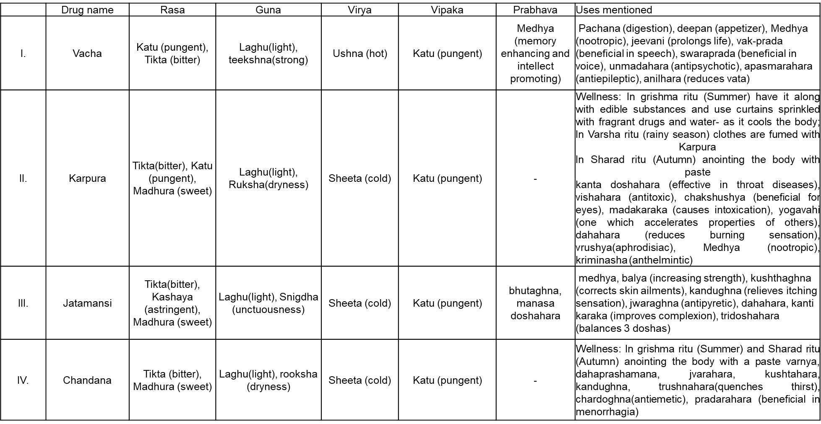

Table1.1 Rasapanchaka of drugs along with their uses as mentioned in samhitas
Ayurveda categorises drugs based on their qualities used for the treatment in various medical conditions which are referred to as ganas. The four drugs used in this study are mentioned in different ganas as follows (Harinarayan Sharma, n.d.)
Gana | Use/proposed activity | Vacha | Karpura | Chandana | Jatamansi
Chardana/ Vamaka gana | For emetics | +
Niruhana gana | For decoction of enema | +
Pittaghna gana | Decreases pitta |  |  | +
Sarivadi gana | Cures burning sensation, bleeding disease, thirst and fever |  |  | +
Anjanadi gana | cure diseases due to poison, burning sensation inside the body, and balance pitta |  |  |  | +
Patoladi gana | balance Kapha-Pitta and cure skin diseases, fevers, poison, vomiting, anorexia and Jaundice |  |  | +
Asanadi gana | cures leucoderma, skin diseases, mitigates kapha, cures diseases and other skin diseases, mitigates kapha, cures diseases caused by worms, anemia, diabetes and diseases of fat accumulation |  |  | +
Vatsakadi gana | cures disorders of vata, kapha and medas, rhinitis, abdominal tumour, fever, colic, and haemorrhoids | +
Vachaharidradi gana | cures acute diarrhoea - caused by accumulations of ama diseases of fat, kapha, stiffness of the things and disorders caused by breast milk | +
Priyangu ambashthadi gana | Good for pitta to decrease and heal ulcers |  |  | +
Mustadi gana | Cures diseases related to vagina, breastmilk and does mala pachana | +
Kandughna gana (Dharkar Nilima, 2023) | Cures spectrum of skin diseases |  |  | + | +

Table 1.2 Drugs mentioned in various ganas and their proposed activity. ‘+’ indicates presence.

1.2 Depression Disorder
Depression is a prevalent mental health disorder that impairs psychosocial functioning and reduces quality of life, affecting approximately 280 million people worldwide in 2023, with around 5% of the global adult population suffering from it, according to the WHO (WHO, 2017). It has a huge impact on individuals and imposes an immense economic burden as it is a challenge to diagnose and manage depression (Malhi & Mann, 2018).

Symptoms
In order for a patient to be clinically diagnosed as depressed, they should have experienced irritability, sadness, emptiness, loss of pleasure or interest in activities for major parts of their day, every day for a period of two weeks. They may also present with other symptoms which include impaired attention, overwhelming feeling of guilt, low self-esteem, hopelessness about their future, disturbed sleep, changes in weight and feeling of low energy levels. (Malhi & Mann, 2018; Rakel, 1999)

Management & Treatment
The management of depression varies on the prognosis of the disease. Before treatment, the patient has to stop substance abuse and start with general hygiene, self-care, regular exercise, a healthy diet, etc. The management strategy includes Psychosocial, Psychological therapy, Pharmacotherapy and Electroconvulsive therapy. The line of treatment is based on the symptoms of the patient and how they respond to the therapy.
- Psychosocial management includes Psychoeducation – family, friends, and caregivers, low-intensity interventions (eg, internet-based education), formal support groups, employment, and housing.
- Psychological therapy includes cognitive behavioural therapy, interpersonal therapy, acceptance and commitment therapy and mindfulness-based cognitive therapy.
- Pharmacotherapy includes First line- Selective serotonin reuptake inhibitors (SSRIs), Noradrenergic and specific serotonergic antidepressants (NaSSAs), Norepinephrine and dopamine reuptake inhibitors (NDRIs), or Serotonin and norepinephrine reuptake inhibitors (SNRIs); melatonin agonist, serotonin modulator and second line – Tricyclic antidepressants, MAOIs.
- Electroconvulsive therapy- it is given to cases of severe depression when the first line of pharmacotherapy does not work (Malhi & Mann, 2018; Rakel, 1999)
SSRIs and SNRIs are associated with a range of side effects, including dizziness, fatigue, headaches, loss of appetite, weight loss, drowsiness, increased suicidal thoughts, nausea, vomiting, sexual dysfunction, and increased risk of cardiovascular and cerebrovascular incidents(Wang et al., 2018).

Relation between depression and serotonin
Serotonin, or 5-hydroxytryptamine (5-HT), is a monoamine neurotransmitter synthesized from the amino acid tryptophan (Liliana Dell’Osso, 2016). The Serotonin hypothesis proposes that diminished activity of serotonin pathways plays a role in the pathophysiology of depression. The major therapeutic agents for treating depression are antidepressants, mostly selective serotonin reuptake inhibitors (SSRI) or combined serotonin/noradrenaline reuptake inhibitors (Cowen & Browning, 2015)

Relation between depression and ROS
Chronic stress is one of the leading causes of depression. Chronic stress can lead to behavioral and genetic changes (Schmidt et al., 2008) Chronic stress is one of the leading causes of depression and mental disorders. Chronic stress can cause behavioral and genetic changes. Aside from psychological pressures, oxidative stress plays a significant effect. In certain investigations, oxidative stress marker levels differed between depressed patients and healthy people. Oxidative stress causes DNA and protein damage, as well as lipid peroxidation, all of which contribute to associated diseases including cardiovascular disease. Therefore, it may be suggested that antidepressant medications must fulfil various roles, i.e., lowering oxidative stress and reactive oxygen species (ROS) formation and boosting levels of neurotransmitters, such as serotonin and dopamine (Naß et al., 2021).

Kaphaja Unmad and Depression
Unmada (a wide term that encompasses a variety of psychiatric issues) is a serious psychiatric disorder mentioned in the Ayurvedic classics as having distorted mental functioning. Unmada’s etymological meaning is “a state of disturbed mental functions.” According to Acharya Charka, the characteristic pathological feature of Unmada is a deviation of manas (mind), buddhi (decision), smriti (memory), sangya gyanam (orientation and responsiveness), bhakti (desire), sheela (habit), Cheshta (activity), and achaara (conduct) as eight factors (either all of them or some of them).
Unmada are classified into five types. Kaphaja Unmada is one amongst them. It shares similarities with depression which are given in the table below:
Sr. No. | Kaphaja unmada | Depression
1. | Sthaanamekadeshe | Inactive/dull
2. | Alpachankramana,  Alpa cheshtha/ Cheshtha manda | Psychomotor retardation
3. | Alpa kathanam/ Manda vaak | Talking less/Sad
4. | Agnisaada/ Arochaka/ Alpa bhuk | Loss of appetite, anorexia, anhedonia
5. | Rahaskaamata, Vivikta priyata | Social withdrawal
6. | Bhibhatsatva/ Shaucha dvesha | Ignoring personal hygiene, hating cleanliness
7. | Sadana | Fatigue, lassitude, lack of energy, body pain
8. | Alpa mati | Decreased cognitive functions/higher mental functions/difficulty in thinking, slowed thinking
9. | Smriti vibhrama | Poor memory
Table 1.4 Comparison of symptoms between Kaphaja unmada and depression (Gupta & Mamidi, 2015; Tubaki et al., 2021)
In the treatment of kaphaja unmada, Shodhana (purification by expelling the increased doshas) is done by using formulations such as Kalyanaka ghrita, mahapaishachika ghrita, mahakalyanaka ghrita, siddharthaka ghrita which has Chandana, Vacha,Jatamansi and Karpura as a content of the formulation.

Caenorhabditis elegans
Kingdom: Animalia
Phylum: Nematoda
Class: Chromadorea
Order: Rhabditida
Family: Rhabditidae
Genus: Caenorhabditis
Species: C. elegans
Caenorhabditis elegans is a small but well-differentiated free-living soil organism. It feeds on bacteria and is an important model system for biological research in many fields including genomics, cell biology, neuroscience and ageing (Leung et al., 2008). C. elegans is an ideal model for ageing and neurodegenerative diseases. (Peng et al., 2011)
Young larvae measure 0.25 mm long and adults 1 mm because of which they are viewed under a dissecting or compound microscope. The life cycle of C. elegans is about 2 to 3 weeks at 20°C, starting as eggs and going through four larval stages before maturing. C. elegans has two sexes: male and hermaphrodite. Hermaphrodites can self-fertilize and produce hundreds of offspring. C. elegans consists of 12 chromosomes in hermaphrodites, five pairs of autosomes - two sex chromosomes, and 11 chromosomes in males, which have a single sex chromosome. They have 302 neurons that make up the C. elegans nervous system (Ann K. Corsi, 2015).
C. elegans are grown and maintained on agar plates seeded with bacteria E. coli OP50. The muscles of C. elegans are arranged in an unsegmented, tapering pattern and are connected to the hypodermis by a strong cuticle cover. For locomotion, it uses a series of opposing muscles. It crawls or swims through the lawn of bacteria with a characteristic sinusoidal pattern. Its trajectory is a random walk, and it goes towards food or potential mates (Donald L. Riddle, 1997)

Chemosensation
Caenorhabditis elegans has been used as a model organism to study chemotactic behavior in a variety of research contexts spanning diverse fields such as neurophysiology, neurobiology, and toxicology, and has played an important role in elucidating chemosensory mechanisms. Caenorhabditis elegans detects the presence of inorganic substances and solutes through a specialized set of chemosensory neurons, the amphid chemosensory phasmid, and inner labial neurons. Amphid neurons, in 11 pairs, are primarily responsible for detection. The detection of volatile and soluble substances requires different types of sensory neurons. C. elegans also perceives taste and smell through several families of chemoreceptors. Chemosensation has been extensively studied and the neural circuits and receptors involved have been well described by (Bargmann, 2006) In addition to odours and sweet substances, worms can detect a wide variety of substances, including the harmful gases oxygen and carbon dioxide, through a specialized set of sensory neurons that use guanylate cyclase as a molecular sensor (Bretscher et al., 2008)
The advantages of C. elegans as a model organism are short life cycle, compact genome, stereotypical development, ease of propagation, large number of progenies, transparent body and small size.

2. MATERIALS AND METHODS

2.1 Essential Oils-
Steam-distilled essential oils were ordered from Deve Herbes and Indus Valley. The details of which are as follows-
- Pure camphor Essential oil (Deve Herbes, Batch ID- 0423)
- Pure Calamus E O (Deve Herbes, Batch ID- 11/23)
- Pure Jatamansi E O (Deve Herbes, Batch ID- 11/23)
- Sandalwood E O (Indus Valley, Batch ID- 2625/8)
Absolute concentration was used for all the experiments.
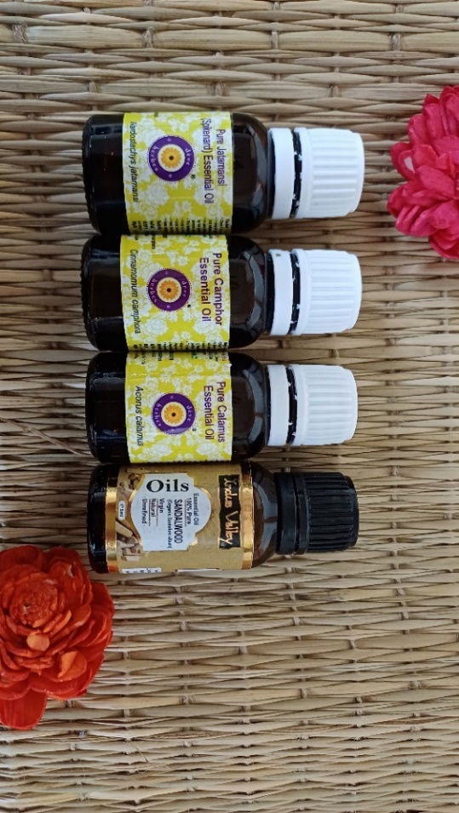
Fig.2.1 Essential oils of Jatamansi, Karpura, Vacha and Chandana

2.2 Caenorhabditis elegans strains
The strains used in my study were:
1. N2 Bristol WT strain
2. DA1814 Ser-1 (ok345) strain
Mutant | Protein | Human Homologue | Role in Depression
DA1814 | Ser-1 | 5-hydroxytryptamine  receptor 2B (HTR2B) | agonism induces an SSRI-like response
Table 2.1 Information about knockout mutant used (Naß et al., 2021)
Both the strains were grown at 20˚ C for the experiments.

2.2.1 Culture and Media
All the buffers and media mentioned below were prepared according to Wormbook and WormAtlas (Theresa Stiernagle 1976, tit. Maintenance of C. elegans).
Preparing NGM plates-
Requirements-
NaCl, Peptone, Agar, Distilled water, 1M MgSO4, 1M CaCl2, Cholesterol (5mg/ml of ethanol), potassium phosphate buffer (pH-6)
NGM media was prepared by maintaining sterile conditions. Plates were poured after they solidified, they were seeded with E. coli with appropriate volume. Plates were incubated for 16 hours at 37˚ C and then stored at 4 ̊ C for 2-3 weeks.
E. coli (OP50) culture preparation
Requirements-
Luria broth, distilled water
LB broth was prepared under sterile conditions. One colony of OP50 E. coli was inoculated to a test tube containing 2ml of LB broth, it was incubated for 6 hours at 37 ̊ C-120 rpm. Later, after 6 hours, 100μl of culture is transferred to the flask of LB and kept for incubation at 37 ̊ C-120 rpm for 16 hours.
Bleaching
Requirements-
Distilled water, 1M NaOH, NaClO (Bleach)
Day 1 adult worms Washed and collected from a petri plate to a falcon tube. After it settled the supernatant was discarded and 1ml of 20% alkaline hypochlorite solution was added. After the worms get dissolved add 4ml of autoclaved distilled water and centrifuge at 2000rpm for 2 minutes. Discarded the supernatant without disturbing the pellet. Add distilled autoclave water to the pellet, mix well and depending on the number of eggs required aliquot it to the NGM plates.

2.3 Chemotaxis Assay in C. elegans
Chemotaxis was performed by (Margie et al., 2013). Briefly, Agar plates were prepared and divided into four equal quadrants, marked with ‘T’ for test and ‘C’ for control diagonally. Equidistant points, 2 cm apart, were marked on the plates. Two microliters of 100 mM sodium azide were applied to both ‘T’ and ‘C’. Worms were washed 4-5 times and collected, and approximately 150 worms were placed at the center. The drugs were applied to 'T' and 'C'. The plates were inverted and incubated at 20˚C for 1 hour. After 1 hour, the worms in each quadrant were counted, and the chemotaxis index was calculated using the formula: Chemotaxis Index (CI) = (Number of Worms in Both Test Quadrants – Number of Worms in Both Control Quadrants) / (Total Number of Scored Worms). An absolute concentration of four essential oils was used, and 1% Diacetyl (DA) dissolved in 90% ethanol was used as a positive control. Three independent trials were performed.
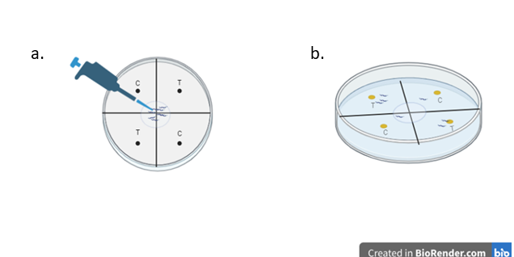
Fig. 2.2 Illustration of Chemotaxis assay. (a) Marked plate with T (test)- C (control) and worms at the centre. (b) Plate after an hour of incubation where the majority of worms attracted towards the test T.

2.4 Lifespan Assay in C. elegans
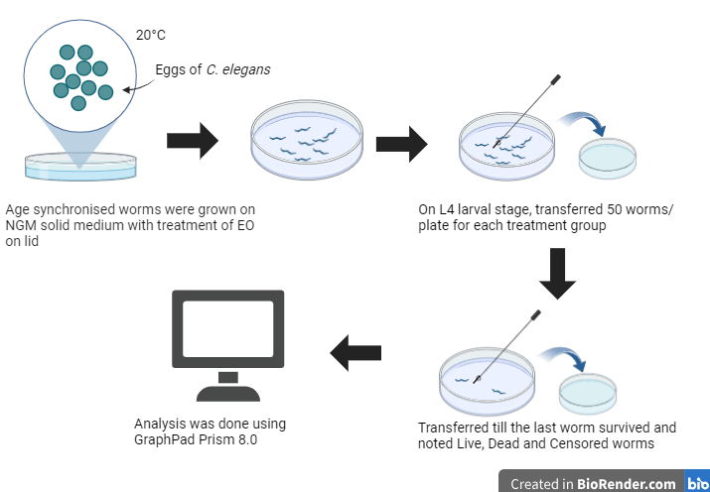
To determine the lifespan of the nematode’s lifespan at 20˚C a modified protocol by (Solis & Petrascheck, 2011) was followed. Both N2 and Ser-1 strains were separately cultured on fresh NGM plates at least for 3 generations without starvation. 50, late L4 larvae were transferred to NGM plates containing OP50 E. coli. The time L4 larvae were transferred to NGM plates was defined as day 0. 1μl of the EO and control was applied freshly on each day to the lid of the plate. Live, dead and censored worms were counted on each day until all worms died. The worms were scored dead if they did not respond to external stimuli with a platinum-wire pick. The worms were transferred to fresh plates till they in their fertile plate and later were transferred on every alternate day. Everyday the worms were exposed to EO Three trials were done for each strain. Oasis software was used for analysing the data.

Fig.2.3 Illustration for Lifespan Assay

2.5 Oxidative Stress Assay in C. elegans
Oxidative stress is a type of stress caused due to free radicals in the cells of an organism. Reactive oxygen species which are produced from the redox cycling of paraquat are highly reactive compounds to degrade cellular macromolecules which induce lipid peroxidation and protein and nucleic acid degradation that leads to oxidative stress and finally cell death.
Here, acute oxidative stress was induced by the chemical Paraquat (100mM) and the effect of the drug was investigated using the protocol then the number of worms alive was scored to understand the effect of the drug on oxidative stress. It was assessed using protocol by (Possik & Pause, 2015). For this assay, N2 worms were grown on NGM plates with the treatment of EOs on the lid till the worms reached Day-1 adult. On the experiment day, five worms were transferred to each well in a 96-well plate for a particular group 6 replicas were done. The number of live worms in each well was determined by gently the worms with a pick to check for movement after an hour for 4-5 hours. Calculated the percentage of survival.

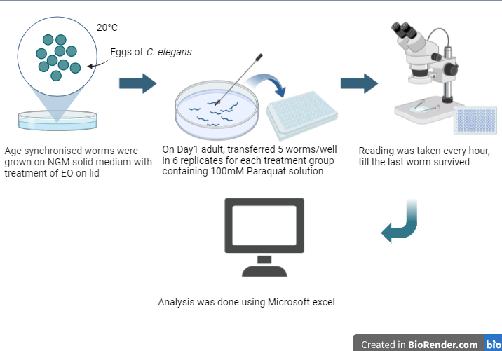
Fig.2.4 Illustration for Oxidative stress using Paraquat
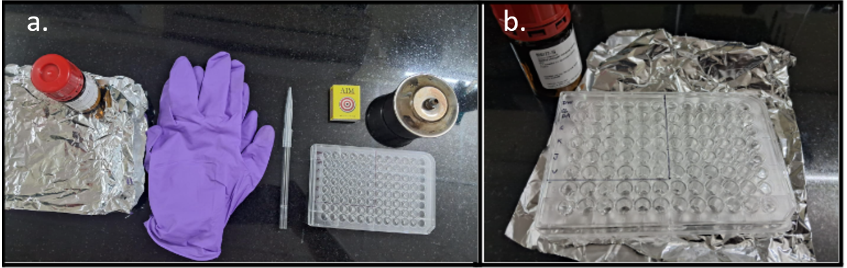Fig. 2.5 Preparation for Oxidative stress assay

2.6 Fecundity
To observe egg laying in C. elegans the protocol by (Lee & Kang, 2017) was slightly modified and used. The EO was applied to the lid and the worms were exposed to it since the egg stage. Late L4 were picked and transferred to a fresh NGM plate, this was repeated for 7 days and the number of eggs laid were counted. Three independent trials were performed.

2.7 RNA isolation
The worms were washed and collected in labelled 1.5 ml Eppendorf tubes. TRIzol reagent was added according to the pellet amount (100-200). The centrifuge was set for fast cooling at 4°C. The worms were homogenized thoroughly. Chloroform was added in a 1:1 ratio with TRIzol, and the mixture was vortexed for 30 seconds. The tubes were allowed to rest at room temperature for 3 minutes, then centrifuged at 14,000 rpm for 15 minutes. The upper transparent phase was carefully transferred to newly labelled DEPC-treated Eppendorf tubes. Double the volume of isopropanol was added to the transferred phase and mixed well. The tubes were centrifuged at 14,000 rpm for 15 minutes. The supernatant was discarded, and the pellet was retained. 400 µl of 70% DEPC ethanol (prepared with DEPC-treated water) was added to the pellet. The pellet was freed from the tube by gentle agitation. The tubes were centrifuged at 14,000 rpm for 10 minutes. The supernatant was carefully removed without disturbing the pellet. This step was repeated once more. The tubes were allowed to air dry to remove ethanol. Finally, 10-15 µl of DEPC-treated water was added to dissolve the RNA pellet. The RNA was quantified using a Nanodrop spectrophotometer.
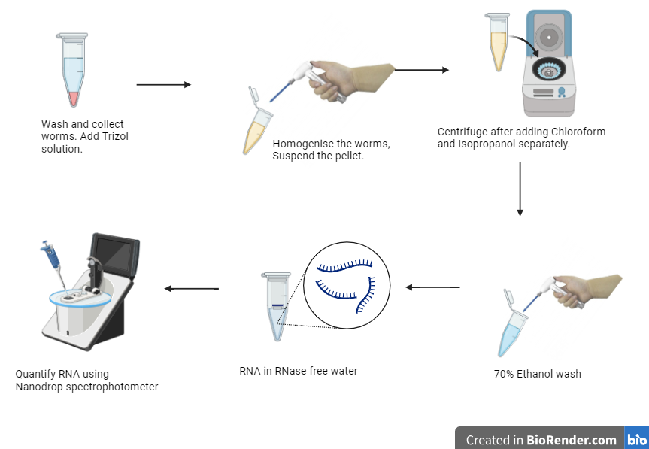
Fig.2.6 RNA isolation procedure

2.8 cDNA preparation
The RNA was quantified to assess purity. The volume required for 500 ng of cDNA and the volume of autoclaved distilled water was calculated. A Master Mix was prepared according to the protocol of TaKaRa in a 1.5 ml tube. 3.5 µl of the Master Mix was added to each sample. Water, RNA, and 3.5 µl of Master Mix were added sequentially to PCR tubes. The tubes were vortexed, and the samples were placed in labelled PCR tubes for synthesis and then stored at -20°C.

2.9 Sensory (Odour) Analysis of Selected EO on Human Volunteers
The sensory analysis only for the odour of EOs was performed using hedonic scaling which refers to a 9-point scale, with values from extremely unpleasant- neutral- to extremely pleasant in human volunteers. The study was blinded Ten healthy volunteers participated and they were allowed to smell one EO per day so that there was a washout period of a particular EO. On the tailor-made questionnaire which had a Hedonic Scale, Intensity and Attributes were given to volunteers. The workflow of this is shown by Fig. 2.7.
Literature Review on Sensory Analysis on odour
Hedonic Scale (1-9)
Intensity
Attributes
Volunteers (n=10);
(Recruited-15, participated-10)
1 sample per day
Qualitative evaluation

Fig. 2.7 Workflow for Sensory analysis of odour for human volunteers

2.10 Data analysis
Data analysis was done by using T-test for Chemotaxis assay, Oxidative stress assay and Sensory analysis. For lifespan experiments log-rank (Mantel-Cox) method is used to test the null hypothesis and calculate P-values. Software such as OASIS 2, Prism GraphPad 8.0.1 and Microsoft Excel was used to analyse data.

3. RESULTS AND DISCUSSION

3.1 Selected aromatic EO except Karpura are attractants for wild-type and Serotonin mutants of C. elegans
Since selected formulations are odours used in Ayurvedic treatments or therapies, we evaluated their effect using a well-standardized chemotaxis assay to study the effect of volatiles on C. elegans behaviour and other physiological parameters.
It was observed that Chandana, Jatamansi and Vacha EOs act as attractants and worms get repelled from Karpura. The extent of attraction or repulsion is indicated by the chemotaxis index (CI). In wild-type (N2) strain worms, Chandana acts as a strong attractant (CI 0.81) followed by Jatamansi (CI 0.44) and Vacha (CI 0.36) and Karpura came up as a repellant with (CI -0.38) (Fig. 3.1)
We also assessed chemotaxis in Ser-1 serotonin mutant, which is a model to study depression. A Similar trend was observed with CI of 0.56, 0.44, and 0.40 for Chandana, Vacha and Jatamansi respectively. Karpura had a CI of -0.20, but the amplitude of the CI was significantly reduced (Fig. 3.2). 1% Diacetyl is a known attractant which was used as a positive control.
The trend for both the graphs of N2 and Ser-1 were the same, but there was a change in amplitude in bars of Chandana and Karpura-treated worms in Ser-1. It might be because these EOs might be working through the Serotonin pathway which is involved in mental health disorders like Depression.
Fig. 3.1 Chemotaxis Index for N2
Fig. 3.2 Chemotaxis Index for Ser-1
 | N2 | Ser-1
DIACETYL 1% | 0.476667 | 0.396667
CHANDANA | 0.806667 | 0.556667
KARPURA | -0.37667 | -0.19667
JATAMANSI | 0.436667 | 0.396667
VACHA | 0.356667 | 0.436667

Table 3.1 Comparison of CI between N2 and Ser-1

3.2 Chandana and Vacha EO increase mean lifespan in Ser-1 mutants and no changes in lifespan are seen in N2 worms.
The findings indicated no increase or decrease in the lifespan of wild-type worms and showed a significant increase in lifespan with Ser-1 mutants on exposure to Chandana (p=0.0015 **) and Vacha (p=0.0432 *). As observed in Ser-1 mutants treated with Chandana and Vacha, increased lifespan. (Fig. 3.4 (b) and (e)). This might be suggestive of, Vacha and Chandana contain bioactive compounds that have beneficial effects on the longevity of C. elegans, particularly in the absence of the Ser-1 receptor. The positive impact on lifespan could be due to the presence of antioxidant or anti-inflammatory bioactive in both the EOs that enhance stress resistance and promote cellular health. The absence of the Ser-1 receptor might alter the worm’s metabolic and stress response pathways, making them more responsive to these beneficial bioactives.
d.
c.
a.
b.
e.

Fig.3.3 Lifespan of N2 treated with samples
b.
a.

d.
c.
Fig.3.4 Lifespan of Ser-1 treated with samples
e.

3.3 Worms treated with Chandana can tolerate higher oxidative stress
Stress resilience is a good indicator of wellness and health span. According to Ayurveda, the effect of Sugandhi Dravya is to give pleasure and happiness, which can contribute to the wellness of an individual.
On exposure to Paraquat after giving treatment for 72 hours it was observed that, to control all the EOs were extending the tolerance to Oxidative stress. At 1 hour, the worms treated with EOs showed not much difference from the control.

Fig.3.5 Oxidative stress with all the samples
Fig.3.6 Oxidative stress after at 1 hour for all the sample

Fig.3.7 Oxidative stress after 3 hours for all the sample

It was observed at 3 hours that, the worms in all four EOs lived longer than the control worms(p=0.006). This might be because the worms have evolved to protect themselves from oxidative damage by complex mechanisms that detoxify ROS.

3.4 Egg laying increases in N2 worms on exposure to Vacha
Reproductive capacity is an indicator of health. Further, in C elegans fecundity, especially egg-laying has a connection with serotonin. Thus, we checked the effect of exposure to Sugandhi dravya on fecundity.
It was observed that upon treatment with Vacha, the fecundity of N2 worms, as represented by (Fig. 3.8) showed an increase in the total number of eggs laid in 7 days in comparison with the control, 1% DA and Chandana treated groups.
These early results were surprising. We need to investigate more into the trends showing an increase in fecundity by Vacha EO exposure.

Fig.3.8 Total number of eggs laid by 12 N2 worms in 7 days

3.5 RNA Isolation
RNA isolation was done of wildtype worms we observed good quantity and purity of the sample as shown in Table 3.1
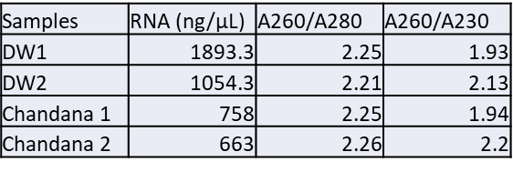
Table 3.2 Quantity and purity of samples

3.6 Sensory Analysis in Human Volunteers

The volunteers liked all EOs; Chandana being favoured the most
Based on whether or not the smell perceived by the participants was liked or not the evaluation was done using a 9-point hedonic scale. It was observed that participants liked Chandana the most (8.2) followed by Karpura (6.9), Vacha (6.5), Jatamansi (5.8), 1% DA (5.2) and Distilled water (5.2) (Fig 3.9). It was observed that in two parameters- sense of good feeling and headache, the odour of all EOs gave a sense of good feeling to the participants. Two participants experienced slight headache just for 15-20 minutes (Fig 3.11). It was observed that most of the volunteers had a sense of good feeling after sniffing the odour of essential oils, Chandana was favoured the most for this feeling (Fig. 3.10). As the smell of these drugs are acceptable and as they have shown a positive effect in the extension of lifespan, positive response to oxidative stress and increase in fecundity it can be studied further on higher model organisms.
Fig.3.9 Evaluation of EOs using hedonic scale for human participants

Fig 3.10 Frequency graph for two of the attributes from the questionnaire. Sense of good feeling and Headache

4. CONCLUSION

- The four aromatic drugs were selected considering their traditional use in treating Kaphaja unmada, which shares symptoms with depression disorders. Evaluation of the effect of these odorants in the C. elegans model is that these drugs demonstrated an ability to reduce stress and extend health span and lifespan, particularly under serotonin-deprived conditions that mimic depression. The Essential oil of Chandana was found to be most effective. Additionally, Vacha extension in lifespan in Ser-1 mutants also showed a notable effect in enhancing fecundity.

- In the part of the study involving human volunteers, sensory analysis using a hedonic scale in healthy adults indicated that Chandana is the most preferred and safest odorant among the tested oils, as it was the 'most liked' odorant with a hedonic score of 8.2. It did not cause any side effects such as nausea or headache.

REFERENCES
- Ann K. Corsi, B. W. (2015). A Transparent window into biology: A primer on Caenorhabditis elegans. In WormBook.
- Bargmann, C. (2006). Chemosensation in C. elegans. WormBook. https://doi.org/10.1895/wormbook.1.123.1
- Bretscher, A. J., Busch, K. E., & De Bono, M. (2008). A carbon dioxide avoidance behavior is integrated with responses to ambient oxygen and food in Caenorhabditis elegans. Proceedings of the National Academy of Sciences, 105(23), 8044–8049. https://doi.org/10.1073/pnas.0707607105
- Cowen, P. J., & Browning, M. (2015). What has serotonin to do with depression? World Psychiatry, 14(2), 158–160. https://doi.org/10.1002/wps.20229
- Dharkar Nilima, P. M. (2023). A critical review of Ayurvedic management of dandruff-like skin disorders using group of ten herbal drugs (Kandughna Gana). INTERNATIONAL JOURNAL FOR INNOVATIVE RESEARCH IN MULTIDISCIPLINARY FIELD, 9(8). https://doi.org/DOIs:10.2015/IJRMF/202308032
- Donald L. Riddle, T. B. (1997). In Introduction to C. elegans. http://dx.doi.org/10.1101/0.1-22
- Gupta, K., & Mamidi, P. (2015). Kaphaja unmada: Myxedema psychosis? International Journal of Yoga - Philosophy, Psychology and Parapsychology, 3(2), 31. https://doi.org/10.4103/ijny.ijoyppp_10_16
- Harinarayan Sharma. (n.d.). Ashtanga hridaya: Vol. sutrasthana,15 shodhanadi gana. CHAUKHAMBHA Bharati Academy.
- Kontaris, I., East, B. S., & Wilson, D. A. (2020). Behavioral and Neurobiological Convergence of Odor, Mood and Emotion: A Review. Frontiers in Behavioral Neuroscience, 14, 35. https://doi.org/10.3389/fnbeh.2020.00035
- Lee, S. Y., & Kang, K. (2017). Measuring the Effect of Chemicals on the Growth and Reproduction of Caenorhabditis elegans. Journal of Visualized Experiments, 128, 56437. https://doi.org/10.3791/56437
- Leung, M. C. K., Williams, P. L., Benedetto, A., Au, C., Helmcke, K. J., Aschner, M., & Meyer, J. N. (2008). Caenorhabditis elegans: An Emerging Model in Biomedical and Environmental Toxicology. Toxicological Sciences, 106(1), 5–28. https://doi.org/10.1093/toxsci/kfn121
- Liliana Dell’Osso, C. C. (2016). Depression, Serotonin and Tryptophan. https://doi.org/10.2174/1381612822666151214104826
- Malhi, G. S., & Mann, J. J. (2018). Depression. The Lancet, 392(10161), 2299–2312. https://doi.org/10.1016/S0140-6736(18)31948-2
- Manion, C. R., & Widder, R. M. (2017). Essentials of essential oils. American Journal of Health-System Pharmacy, 74(9), e153–e162. https://doi.org/10.2146/ajhp151043
- Margie, O., Palmer, C., & Chin-Sang, I. (2013). C. elegans Chemotaxis Assay. Journal of Visualized Experiments, 74, 50069. https://doi.org/10.3791/50069
- Masuo, Y., Satou, T., Takemoto, H., & Koike, K. (2021). Smell and Stress Response in the Brain: Review of the Connection between Chemistry and Neuropharmacology. Molecules, 26(9), 2571. https://doi.org/10.3390/molecules26092571
- Matossian-Rogers, A., & Festenstein, H. (1976). Modification of murine T-cell cytotoxicity by preimmunization with M locus and H-2 incompatibilities. The Journal of Experimental Medicine, 143(2), 456–461. https://doi.org/10.1084/jem.143.2.456
- Naß, J., Kampf, C. J., & Efferth, T. (2021). Increased Stress Resistance and Lifespan in Chaenorhabditis elegans Wildtype and Knockout Mutants—Implications for Depression Treatment by Medicinal Herbs. Molecules, 26(7), 1827. https://doi.org/10.3390/molecules26071827
- Patil, Dr. R. N. M. Prof. V. C. (2018). Sushruta Samhita, Doshadhatumalakshayavruddhi vignyaniyam adhyayam: Vol. Vol. 1 (p. P 214). Chaukhamba Publication.
- Peng, C.-Y., Chen, C.-H., Hsu, J.-M., & Pan, C.-L. (2011). C. elegans model of neuronal aging. Communicative & Integrative Biology, 4(6), 696–698. https://doi.org/10.4161/cib.17138
- Possik, E., & Pause, A. (2015). Measuring Oxidative Stress Resistance of Caenorhabditis elegans in 96-well Microtiter Plates. Journal of Visualized Experiments, 99, 52746. https://doi.org/10.3791/52746
- Rakel, R. E. (1999). Depression. Primary Care: Clinics in Office Practice, 26(2), 211–224. https://doi.org/10.1016/S0095-4543(08)70003-4
- Schmidt, M. V., Sterlemann, V., & Müller, M. B. (2008). Chronic Stress and Individual Vulnerability. Annals of the New York Academy of Sciences, 1148(1), 174–183. https://doi.org/10.1196/annals.1410.017
- Sharmeen, J., Mahomoodally, F., Zengin, G., & Maggi, F. (2021). Essential Oils as Natural Sources of Fragrance Compounds for Cosmetics and Cosmeceuticals. Molecules, 26(3), 666. https://doi.org/10.3390/molecules26030666
- Solis, G. M., & Petrascheck, M. (2011). Measuring Caenorhabditis elegans Life Span in 96 Well Microtiter Plates. Journal of Visualized Experiments, 49, 2496. https://doi.org/10.3791/2496
- Tubaki, B. R., Chandake, S., & Sarhyal, A. (2021). Ayurveda management of Major Depressive Disorder: A case study. Journal of Ayurveda and Integrative Medicine, 12(2), 378–383. https://doi.org/10.1016/j.jaim.2021.03.012
- Wang, S.-M., Han, C., Bahk, W.-M., Lee, S.-J., Patkar, A. A., Masand, P. S., & Pae, C.-U. (2018). Addressing the Side Effects of Contemporary Antidepressant Drugs: A Comprehensive Review. Chonnam Medical Journal, 54(2), 101. https://doi.org/10.4068/cmj.2018.54.2.101

APPENDIX

1. Progress Report 1
Title-
Exploring the antiaging and nootropic potential of aromatic essential oils using Caenorhabditis elegans models.
Objectives-
- Selection of the essential oils (EO) based on Ayurvedic and modern literature as well as practice.
- Evaluation of differential effect of aromatic essential oils on longevity of C. elegans.
- To study the effect of essential oils on chemosensory behavior in disease and wild type C elegans models.
- To investigate the effect of aromatic essential oils on the stress model of C. elegans.
- Sensory analysis to understand aroma preference of the selected essential oils in the lay human population.
Progress made in objectives-
- Objective 1
  - Selection of oils.
  - Quality of oil procured (steam distilled and extracted from pure plant material)
  - In Dravyaguna sangraha according to the definition of ‘sugandh’ (aromatic), one that gives a sense of pleasure and satisfaction; these improve appetite. The therapeutic effects of these drugs vary.
  - 4 aromatic plants for the project are-
- Vacha (Acorus calamus Linn)
- Karpura (Cinnamomum camphora (L.) Nees & Eberm
- Jatamansi (Nardostachys Jatamansi (D.Don) DC)
- Chandana (Santalum album L.)
- The use of Aromatic drugs in Ayurvedic literature at various places in Samhita.
- Literature review on effects of aromatic drugs on C. elegans in different research papers, listing some:
https://www.ncbi.nlm.nih.gov/pmc/articles/PMC8036369/ , https://www.sciencedirect.com/science/article/abs/pii/S0944711321001409, https://www.sciencedirect.com/science/article/abs/pii/S0278691521007961
- Objective 3
  - Standardization of treatment protocol: Growing C. elegans in the presence of essential oil of 100% concentration.
  - Sensory analysis Using Chemotaxis assay
Skills learned-
- Maintaining plate of C. elegans.
- Learning to pick worms.
- Media preparation
- Pouring of plates
- Preparation of Luria Broth
- Preparing E. coli culture
- Bleaching worms

Challenges faced-
- Deciding the C. elegans strains to use
- Finding authentic vendors for steam distilled-procured from plant material essential oil.
- Writing protocol (IEC etc is difficult so dropped the clinical study, but will do the sensorial analysis with a single time point).

2. Progress Report 2
Title-
Exploring the antiaging and nootropic potential of aromatic essential oils using Caenorhabditis elegans models.
Objectives -
1.Selection of the essential oils (EO) based on Ayurvedic and modern literature as well as practice.
2.Evaluation of differential effect of aromatic essential oils on longevity of C. elegans.
- To study the effect of essential oils on chemosensory behavior in disease and wild type C elegans models.
- To investigate the effect of aromatic essential oils on the stress model of C. elegans.
- Sensory analysis to understand the aroma preference of the selected essential oils in the lay human population.
Progress made-
- Effect of selected aromatic essential oils on chemosensory behavior was evaluated through chemotaxis assay in wild type young adult worms.
- Effect of selected aromatic essential oils on egg laying was evaluated through fecundity in wild type young adult worms. One trial was performed and other trials are ongoing.
- Literature review on Lifespan assay done, planned lifespan assay from February.
- Literature review on phenotypic assays- ABC type movement, fecundity done.
Skills learned-
- Picking worms
- Preparing the reagents
- Counting of eggs.
- Setting experiment in duplicates for chemotaxis.
- Setting Fecundity experiment.
Challenges faced-
- While picking worms they either died or got injured.
- Literature on volatile compounds in essential oils.
- Literature survey for primers to be used for q-PCR.
- Obtaining strains.

Progress Report 3
Title-
Exploring the antiaging and nootropic potential of aromatic essential oils using Caenorhabditis elegans models.

Objectives-
- Selection of the essential oils (EO) based on Ayurvedic and modern literature as well as practice.
- Evaluation of differential effect of aromatic essential oils on longevity of C. elegans.
- To study the effect of essential oils on chemosensory behavior in disease and wild type C. elegans models.
- To investigate the effect of aromatic essential oils on the stress model of C. elegans.
- Sensory analysis to understand aroma preference of the selected essential oils in the lay human population.

Progress made-
- The effect of selected aromatic essential oils on chemosensory behavior was evaluated through chemotaxis assay in wild-type and Serotonin mutant (Ser-1 and Ser-4) young adult worms. Three trials were performed.
- Egg laying of wild-type, Serotonin mutants ie. Ser-1 and Ser-4 are evaluated through fecundity to select which mutant to be used. Two trials were done.
- Planning to experiment with the essential oils with Ser-1 mutants.
- The effect of selected aromatic essential oils on longevity was evaluated through Lifespan assay. Second trial ongoing with wildtype of worms.
Planned to set up Ser-1 lifespan in April.
- Literature review on Stress assays.
- Literature review on sensory analysis.

Skills learned-
- Picking worms
- Preparing the reagents.
- Counting of eggs.
- Conducted experiments in duplicates for chemotaxis.
- Conducted Fecundity experiment.
- Conducted lifespan assay.
- Data analysis in Excel.
- Learned to operate Oasis software for analysis of lifespan.

Challenges faced-
- Selection of which strain to be used.
- Literature survey for primers to be used for q-PCR.
- Analysis of the data.

