Comparative analysis of mechanism of anti-diabetic action of Nishakathakadi Kashayam and Varanadi Kashayam
A thesis submitted to
THE UNIVERSITY OF TRANS-DISCIPLINARY HEALTH SCIENCES AND TECHNOLOGY

For THE PARTIAL FULLFILLEMENT OF THE AWARD of the Degree of
M.Sc. Life sciences (ayurveda biology)
BY
Bhuvana Aradhya G.r

Under the Guidance of
Dr.C.N Vishnuprasad

JULY 2024

The university of trans-disciplinary health sciences and technology

THE UNIVERSITY OF TRANS-DISCIPLINARY HEALTH SCIENCES AND TECHNOLOGY
Private University Established in Karnataka by ACT 35 of 2013
BENGALURU - 560064

DECLARATION BY THE CANDIDATE

I declare that this thesis “Comparative analysis of mechanism of anti-diabetic action of Nishakathakadi Kashayam and Varanadi Kashayam” submitted for the award of Master of Science to THE UNIVERSITY OF TRANS-DISCIPLINARY HEALTH SCIENCES AND TECHNOLOGY, Bengaluru, is my original work, conducted under the supervision of Dr. C. N. Vishnuprasad. I confirm that no part of the work reported herein has been submitted for a degree or examination at any other university. References, funding and material obtained from other sources have been duly acknowledged, and no part of this dissertation has been plagiarized.

Place: Bengaluru
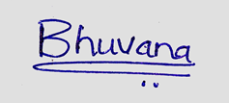
Signature of the Candidate
Date: 19-06-2024

Name of candidate: BHUVANA ARADHYA G.R
Reg. No.: 2022MSCAB06
THE UNIVERSITY OF TRANS-DISCIPLINARY HEALTH SCIENCES AND TECHNOLOGY
Private University Established in Karnataka by ACT 35 of 2013
BENGALURU - 560064

CERTIFICATE FROM THESIS SUPERVISOR/S
This is to certify that the work incorporated in this thesis “Comparative analysis of mechanism of anti-diabetic action of Nishakathakadi Kashayam and Varanadi Kashayam” submitted by Ms. Bhuvana Aradhya G.R was carried out under my supervision. No part of this thesis has been submitted for a degree or examination at any other university. References, help and material obtained from other sources have been duly acknowledged. I confirm the originality of the work and that there is no plagiarism in any part of the thesis.

  Dr. C. N. Vishnuprasad |  | 19.06.2024
Associate Professor,
TDU Bangalore

ACKNOWLEDGEMENT

I would like to express my sincere gratitude to Dr. C.N. Vishnuprasad for his dedicated guidance and invaluable support for my project work. I would also like to thank TDU for its constant support and encouragement to undertake such thesis work, which helped me learn a lot and achieve a new perspective on this subject. I am grateful for their valued guidance during the entire duration of the project.
I thank Dr. Megha, Dr Subrahmanya Kumar, Dr. Sanketh sharma, Dr. Arun Bhanu. K., Ms. Sania Kouser, Ms. Priyanka G pinto, Mr. Abhi .V. Badiger for helping me succeed in this work. Towards the end, I would like to thank my family, friends and loved ones for supporting me during my studies.

SUMMARY

Data collection of phytochemicals present in both Nishakathakadi (NK) and Varanadi (VA) formulations and analyzed which phytochemicals are common between the two, which are unique to each formulation. Additionally, classified the phytochemicals in both formulations. Previous in silico studies showed that both formulations target diabetic-associated genes linked to complications like retinopathy, neuropathy, nephropathy, myopathy, wound healing, and vascular issues. It was found out that NK and VA target 13genes which are similar. Using this information, identified and organized the common phytochemicals in both formulations. To understand the different biological effects due to the overlapped and unique genes targeted by NK and VA, gene ontology and enrichment analysis is performed. These analyses highlighted the biological significance of the targeted genes. The information generated from the enrichment analysis will guide future studies. As part of the comparative analysis, lipase inhibition and cell viability (in intestinal cell lines) were also studied.

PERSONAL REFLECTION

During my project, I learned the basics of cell culture, RNA isolation, gel electrophoresis, cDNA synthesis, primer design, RT-PCR, and RNA quantification using a nanodrop. I also visited the animal house at Acharya College, where I received training from a senior on feeding and maintaining rats. Additionally, I learned to use and analyze SR Plot for gene enrichment analysis and Classyfire for phytochemical classification. I observed how to perform a western blot and took notes on the protocols. I documented the pharmacological actions of different Ayurvedic drugs using classical texts and tried to understand the molecular pathways involved in diabetic complications. Throughout this experience, I also improved my time management skills.

Table of Contents
Abbreviations 1
Comparative analysis of mechanism of anti-diabetic action of Nishakathakadi Kashayam and Varanadi Kashayam 2
1.1 Type 2 Diabetes mellitus 2
1.2 Prameha (Ayurveda reference for diabetes mellitus) 3
Etiology of prameha: 3
Doshaja classification of prameha 4
1.3 Role of Fatty acids in T2DM development 4
1.4 Palmitate-Induced Lipotoxicity and Intestinal Dysfunction 5
1.5 The significance of polyherbal formulations in managing T2DM 6
1.6 Nishakathakadi kashaya 7
Ayurvedic pharmacological action and anti-diabetic action of each ingredient of NK 9
1.7 Varanadi formulation 12
Anti-diabetic activity of each ingredient of VA 14
2.Material and methods 18
2.1 Classification of phytochemicals of NK and VA 18
2.2 Data collection of bioactives of NK and VA targeting Diabetic associated gene 19
2.3 Data collection of Ayurvedic pharmacological action of NK and VA formulations as per three Ayurvedic classics. 19
2.4 Gene ontology and enrichment analysis of diabetic-associated genes 19
2.5 Gallic acid estimation of NK and VA by folin ciocalteu method. 20
2.6 Lipase assay 21
2.7 Cell culture 22
2.8 MTT assay 23
STC-1 cell viability on NK and VA treatment. 23
Preparation of 5mM PA 24
Caco-2 cell viability on co-treatment of PA &NK 24
Caco-2 cell viability on co-treatment of PA &VA 24
2.9 DPP4 Estimation from CaCo2 Cell Line 26
3.Results 27
3.1 Classification of phytochemicals of NK and VA 27
Classification of phytochemicals of NK 27
Classification of Phytochemicals of VA 35
3.2 Phytochemicals of NK and VA targeting diabetic associated genes. 42
Venn diagram analysis 43
Phytochemicals of NK and VA targeting 13 common diabetic associated genes. 44
Phytochemicals of NK targeting 10 diabetic associated genes 46
Phytochemicals of VA targeting 3 diabetic associated genes 47
3.3 Indications of Ayurvedic pharmacological action of NK and VA as per ayurveda classiscs 48
Indications of ayurvedic pharmacological actions of NK and VA as per Ashtangahrudayam. 48
Indications of ayurvedic pharmacological actions of NK and VA as per charaka 49
Indications of ayurvedic pharmacological actions of NK and VA as per sushrutha. 51
3.4 Gene ontology and enrichment analysis of diabetic-associated genes 61
10 biological processes enriched by diabetic asoociated genes targeted by both NK 61
and VA 61
10 Biological processes enriched by diabetic associated genes exclusively targeted by NK 62
10 Biological processes enriched by diabetic associated genes exclusively targeted by VA 63
10 Cellular components enriched by diabetic associated genes targeted by both NK and VA 64
10 Cellular components enriched by diabetic associated genes exclusively targeted by NK 65
10 Cellular components enriched by diabetic associated genes exclusively targeted by VA 66
10 Molecular functions enriched by diabetic associated genes targeted by both NK and VA. 67
10 Molecular functions enriched by diabetic associated genes exclusively targeted by NK 68
10 Molecular functions enriched by diabetic associated genes exclusively targeted by VA 69
3.5 Gallic acid estimation in NK and VA 70
3.6 Lipase Inhibition by NK and VA 71
3.7 MTT Assay 72
STC-1 Cell viability on NK and VA (2hrs) 72
CaCo-2 cell viability on co-treatment of PA & NK 73
CaCo-2 cell viability on co-treatment of PA & VA 73
3.8 DPP4 Estimation from CaCo2 Cell Line 74
4. Discussion 75
5. Conclusion 79
6.References 80
APPENDIX 88
PROGRESS REPORT 1 88
PROGRESS REPORT 2 88
Title 88
Objectives of the project 89
Skills learned 90
PROGRESS REPORT 3 90
Title 90
Objectives of the project 90
Skills learned 91

Abbreviations

1 | T2DM | Type 2 diabetes mellitus
2 | PA | Palmitic acid
3 | FFA's | Free Fatty acids
4 | NK | Nishakathakadi
5 | VA | Varanadi
6 | STC-1 | Intestinal Secretin Tumour Cell line
7 | CaCo2 | Human epithelial colorectal adenocarcinoma
8 | GPCRs | G-protein coupled receptors
9 | IR | Insulin resistance
10 | ROS | Reactive oxygen Species
11 | MEM | Minimal Essential Medium
12 | DMEM | Dulbecco Modified Eagle medium
13 | PBS | Phosphate Buffered Solution
14 | DMSO | Dimethyl sulfoxide
15 | BSA | Bovine serum albumin
16 | LAF | Laminar air flow

Comparative analysis of mechanism of anti-diabetic action of Nishakathakadi Kashayam and Varanadi Kashayam

- INTRODUCTION

Type 2 Diabetes mellitus

Type 2 diabetes mellitus (T2DM) is one of the most common metabolic disorders worldwide, its development is primarily caused by faulty secretion of insulin by pancreatic β-cells and the incapacity of insulin-sensitive tissues to react to insulin properly. The precise coordination of insulin synthesis, release, and action is crucial to metabolic demands. Tight regulation of the molecular mechanisms governing insulin production, secretion, and tissue response is essential. Disruptions in these processes can lead to metabolic dysregulation, which in turn can contribute to the development of type 2 diabetes mellitus (T2DM). Insulin resistance can be triggered by various molecules, including glucose, insulin, free fatty acids (FFA’s), and specific cytokines like TNF-alpha. Elevated plasma FFA levels, commonly observed in obesity, are thought to potentially contribute to insulin resistance. Yet the precise molecular pathways connecting FFA’s to insulin resistance are not fully elucidated (Gao et al., 2010).
As per the WHO, diabetes mellitus (DM) is a persistent metabolic disorder distinguished by heightened blood glucose levels, resulting in gradual harm to the heart, blood vessels, eyes, kidneys, and nerves. T2DM accounts for over 90% of diabetes cases and is characterized by insufficient insulin secretion from pancreatic beta cells, tissue insulin resistance (IR), and insufficient compensatory insulin secretion (Weyer et al., 1999; Stumvoll et al., 2005). As the disease advances, insulin secretion becomes insufficient to regulate glucose levels effectively, resulting in hyperglycemia. Individuals with T2DM are commonly identified by obesity or a higher proportion of body fat, particularly concentrated in the abdominal area. Adipose tissue exacerbates IR through diverse inflammatory pathways, such as heightened release of FFAs and dysregulation of adipokines.

The primary factors contributing to the widespread prevalence of T2DM are the increasing global rates of obesity, sedentary lifestyle , consumption of high-calorie diets, and population aging, collectively leading to a fourfold surge in the incidence and prevalence of T2DM (Chatterjee et al., 2017) (Zhou et al., 2016). Organs implicated in T2DM encompass the pancreatic (beta and alpha cells), liver, skeletal muscles, kidneys, brain, small intestine, and adipose tissue. It have been indicated that dysregulation of adipokines, inflammation and disruptions in gut microbiota, along with immune dysregulation, have emerged as significant pathophysiological contributors (Schwartz et al., 2016).
The risk factors for T2DM involve a complex interplay of genetic, metabolic and environmental elements, which collectively contribute to its prevalence. While certain non-modifiable risk factors like ethnicity and family history/ genetic predisposition have significant genetic influence on individual susceptibility to T2DM. Epidemiological evidence indicates that a considerable number of T2DM cases can be averted by addressing primary modifiable risk factors such as obesity, lack of physical activity and poor dietary habits (Hu et al., 2001) (Schellenberg et al., 2013).

1.2 Prameha (Ayurveda reference for diabetes mellitus)
Prameha is derived from the Sanskrit word "Mih-sechane," meaning "to flow." The term "meha" translates to "micturate," and "mehanam" refers to urination.. The term prefix “pra” from prameha indicating excess in both quantity and frequency. According to sushrutha and vagbhata prameha is a condition marked by significant flow of cloudy or turbid urine. The degree of turbidity in the urine varies depending on the specific type of prameha, which is influenced by the varying proportions of doshas and dushyas involved. Ayurveda delineates a group of inricate clinical conditions characterized by irregularities in urination, collectively referred to as prameha. These conditions exhibit significant correlations with obesity, metabolic syndrome, and diabetes mellitus. Incorporating Ayurvedic principles and treatments into the management of these conditions could yield valuable benefits (Sharma & Chandola, 2011).

Etiology of prameha:
Nidana, a fundamental branch of Ayurveda, focuses on understanding the causes of diseases. In the susrutha samhitha (an Ayurvedic classic text), the etiology of prameha is indicated.As per sushrutha causes are classified into two types: sahaja, which is inherent or hereditary, and Apathyanimittaja is a condition acquired due to lifestyle factors (Sharma & Chandola, 2011). The way Apathyanimittaja prameha is described in sushrutha Samhita is similar to T2DM (also called non-insulin-dependent DM or adult-onset diabetes (Sharma & Chandola, 2011). Some ayurvedic classic texts have the list of types of food and drinks which cause this disease, briefly
explains lifestyle and psychological factors that contribute to the onset of prameha (Sharma & Chandola, 2011).

Doshaja classification of prameha
The classification of prameha is based on the dominant dosha in the disease process. Ayurveda delineates three primary clinical distinctions : kaphaja, pittaja and vataja prameha. Ayurveda has outlined a progression of prameha into various stages.In the initial stage, an excess of kapha disturbs the balance of meda (fat) and (kleda) body fluid, leading to the onset of kaphaja prameha (Sharma & Chandola, 2011).As the condition progresses, there is depletion(kshaya) of kapha, allowing pitta to become predominant. This imbalance leads to the vitiation of blood(Sharma & Chandola, 2011)(rakta), triggering the manifestation of pittaja prameha. Continued progression results in the depletion of pitta, leading to the imbalance of vata. This imbalance causes the expulsion of vital substances or essence from the body through urine, thereby initiating vataja prameha (Sharma & Chandola, 2011).
Ayurveda outlines 20 subtypes of prameha based on unique urinary traits and clinical manifestations. They are further divided into ten subtypes under kaphaja prameha, six under pittaja prameha, and four under vataja prameha. When correlating the dosha-based classification of prameha with its etiology, it’s observed that kaphaja and pittaja prameha consistently arise as Apathymittaja prameha (acquired),whereas vataja prameha can manifest either through hereditary factors or acquired causes(Sharma & Chandola, 2011).

1.3 Role of Fatty acids in T2DM development
Regular excessive consumption in energy-dense foods, including those which are heavy in lipids and sugars, causes increased absorption of nutrients in the intestines. Consequently, there is a surplus accumulation of lipids in organs like the liver, adipose tissue, skeletal muscles, and other organs (Wit et al., 2022). A high-caloric western diet, rich in fats and carbohydrates, raises blood glucose levels and increases the circulation of very low-density lipoproteins (VLDL’s), chylomicrons, and their triglyceride-rich remnants. This increases reactive oxygen species (ROS) levels, causing an abnormal production of inflammatory molecules. This heightened inflammation, induce oxidative stress, creates a synergistic interaction between the two processes, amplifying the harmful effects after eating (Galicia-Garcia et al., 2020).
Persistent elevation in ROS levels plays a crucial role in the onset of type 2 diabetes mellitus (T2DM) and IR.Consequently pro-oxidant setting results in dysfunction of mitochondria, endoplasmic reticulum (ER) stress, and the activation of NADPH oxidase(NOX), leading to the production of superoxide. The surge in superoxide production triggers the activation of the five primary pathways implicated in the development of complications associated with diabetes. The polyol pathway becomes more active, resulting in increased production of advanced glycation end products (AGEs), higher expression of the AGEs receptor and its activating ligands, and the activation of different isoforms of protein kinase C (PKC), and excessive activity within the hexosamine pathway (Dali-Youcef et al., 2013) (Hummasti & Hotamisligil, 2010) (Roca-Rivada et al., 2013).Via these pathways heightened intracellular ROS levels induce faulty angiogenesis in reaction to ischemia, trigger several proinflammatory pathways, and instigate enduring epigenetic alterations that sustain the continuous expression of proinflammatory genes even post normalization of glycaemia (Giacco & Brownlee, 2010).Moreover, elevated blood levels of FFA’s cause mitochondrial dysfunction through two distinct mechanisms: firstly, byproducts of FFA metabolism disrupt electron flow in the mitochondrial respiratory chain. Secondly, FFA’s are incorporated into mitochondrial membranes, potentially promoting electron leakage (Graciano et al., 2011).
In recent years, studies have highlighted that prolonged elevation of circulating FFAs can disrupt gut homeostasis and lead to dysfunction in the intestinal epithelium. Maintaining a healthy intestinal function is crucial for preventing and treating various metabolic disorders caused by long-term high levels of lipids in the blood (Holst, 2013). It is known that metabolic diseases are linked to problems in intestinal cells. Understanding the exact molecular connections is challenging due to the absence of a suitable model for studying obesity in the intestine (Filippello et al., 2022). Obesity is believed to lead to insulin resistance, leading to T2DM.
The action of lipase involves breaking down dietary fats into free fatty acids and monoglycerides, which are subsequently absorbed and stored within the body. High levels of lipase activity can lead to increased absorption and storage of fats, contributing to obesity. Obesity, particularly visceral fat accumulation, is a major risk factor for insulin resistance, a key feature of type 2 diabetes. Excess fat tissue, especially in the abdominal area, releases fatty acids and inflammatory cytokines that interfere with insulin signaling, leading to insulin resistance (Marsha J. Daniel, 2011).

1.4 Palmitate-Induced Lipotoxicity and Intestinal Dysfunction
Palmitic acid (PA) ranks among the most abundant saturated fatty acids in human diets, displaying nearly the highest concentration in bloodstream fat tissues and plasma lipoproteins compared to other fatty acids (Opie & Walfish, 1963). Previous studies have revealed that high-fat diets (HFDs) result in substantial elevations in PA levels in the bloodstream, a phenomenon closely linked to the dysfunction of the intestinal barrier. (Ouyang et al., 2022). PA, found in dietary products, is known to have harmful effects on various human organs due to its lipotoxic properties(Graciano et al., 2011) (Cheon & Cho, 2014). In the intestine, PA is recognized for reducing insulin sensitivity and is linked to a higher chance of developing T2DM. Studies have reported that long-term exposure to PA disrupts cell development in various tissues (Palomer et al., 2018) (Filippello et al., 2022) (Silva Figueiredo et al., 2017). PA shows lipotoxic properties (Madsen et al., 2005) (Tachtsis et al., 2020) (Glenske et al., 2020).I wanted to see whether PA is lipotoxic to the intestinal secretin tumor cell line.

1.5 The significance of polyherbal formulations in managing T2DM
Recent advancements in glycemic control through various drugs, diabetes mellitus continues to be a major health concern due to its significant impact on mortality and morbidity rates
(. Gerstein et al., 2008). Severe hyperglycemia, hyperlipidemia, and related complications adversely affect the quality of life. Therefore, there is an ongoing need for optimal treatments to manage this disease(Sridharan et al., 2011). An effective anti-diabetic therapy should not only focus on controlling blood glucose levels but also aim to prevent the progression of diabetic complications. While standard allopathic treatments have proven effective in managing diabetes mellitus, their success can sometimes be limited(Pandey et al., 2011). In recent years, alternative therapies for diabetes have gained popularity due to their ability to lower blood glucose levels with minimal side effects(Huang et al., 2007). The phytochemicals in herbs, such as alkaloids, flavonoids, and saponins, contribute to the desired therapeutic effects in diabetes mellitus(Singh et al., 2013). A single plant may contain multiple phytochemicals, and combining several such plants or herbs can result in synergistic pharmacological actions(Meena et al., 2009).
In this context, the present work is focusing on comparing the glucose and lipid metabolism related mechanism of action of two Ayurvedic polyherbal formulations viz. Nishakathakadi Kashaya and Varanadi Kashaya. Both formulations are previously studied in the lab for their anti-diabetic effects.

1.6 Nishakathakadi kashaya
Nishakathakadi kashaya is a polyherbal formulation detailed in a classical Ayurvedic text called Sahasrayogam (specifically, in the parishishta prakarana kashayam section).
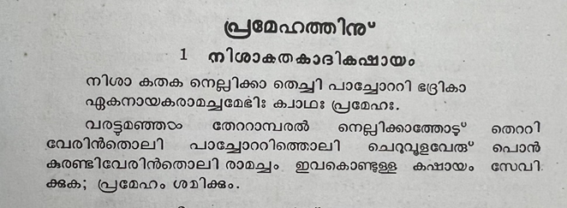
(krishnan & pillai, n.d.)
The above shloka is explaining the ingredients of nishakathakadi formulation and it it is pramehara (anti-diabetic).The Ayurveda formulation NK chosen for this study is composed of eight herbal ingredients known for their hypoglycemic properties. Various phytochemicals identified in these plants are recognized for their multitargeted mechanisms of action(Thottappillil et al., 2023).

TABLE 1. Ingredients and Properties of Nishakathakadi formulation
Botanical name | Parts used | Sanskrit name | Rasa (Taste) | Guna(quality) | Virya(potency) | Vipaka
Curcuma longa | Rhizome | Nisha | Tikta, katu | Ruksha, Laghu | Ushna | Katu
Strychnous potatorum | Seed | Kataka | Madhura, Kashaya, Tikta | Laghu, Vishada | Sheetha | Madhura
Ixora coccinea | root/stem | Paranti | Kashaya, Tikta | Laghu | Sheetha | Katu
Symplocos racemose | stem bark | Lodhra | Kashaya | Laghu, Ruksha | Sheetha | Katu
Emblica officinalis | Fruit | Amalaki | Katu, tikta ,kashaya, madhura, amlapradhana | Guru, Ruksha | Sheehta | Madhura
Aerva lanata juss | entire plant | Gorakshaganja | Kashaya, Tikta | Laghu, Tikshna | Ushna | Katu
Salacia reticulata wight | stem/root | Saptachakra | Kashaya, Tikta | Laghu, Ruksha | Ushna | Katu
Vetiveria zizanioides | Root | Usheera | Tikta, Madhura | Ruksha, Laghu | Seeta | Katu

Ayurvedic pharmacological action and anti-diabetic action of each ingredient of NK

Nisha (Curcuma longa)
Haridra, also known as Curcuma longa, is prominently featured in various Nighantus, which highlight its distinct characteristics. It is described as possessing the Katu (Pungent) and Tikta rasa (Bitter) tastes, along with Ruksha guna (Non-unctuousness), Ushna veerya (Heat), and Kaphapitta shamaka properties. While some Nighantus solely attribute the Tikta rasa and Kapha-Vata-Rakta shamaka properties to Haridra. The efficacy of a medicinal herb lies in its ability to exert local and general effects through its taste (Rasa), properties (Guna), and specific therapeutic actions facilitated by its post-digestive effect (Vipaka) and potency (Veerya). Haridra finds application in the management of Meha, characterized by increased urine frequency and turbidity (Sojeetra et al., 2019).
Administering a methanolic extract of Curcuma longa (C. longa) to alloxan-induced diabetic rabbits significantly improved serum glucose levels, serum transaminases, and antioxidant activity. The aqueous extract of C. longa induced a stepwise increase in glucose uptake from abdominal muscle tissues both with and without insulin; notably, combining the extract with insulin significantly enhanced this glucose uptake. Moreover, the water-based extract prompted insulin release from mouse pancreatic tissues in both normal and hyperglycemic states. However, its peak impact reached only 68% of tolbutamide, the reference compound.The extract consistently triggered a gradual increase in glucose uptake from abdominal muscle tissues, both with and without insulin and showed a notable enhancement when combined with insulin., with a significant increase when combined with insulin(Mohankumar & McFarlane, 2011).

Kataka (Strychnous potatorum)
Kataka (S. potatorum) possesses Madhura (sweet), Kashaya (astringent), and Tikta pradhana (bitter) among the Pancha rasa (five tastes). It has Laghu (light) and Vishada (clear) qualities, Sheeta virya (cold potency), and Madhura vipaka (sweet post-digestion effect). Kataka is also indicated as Mehanashanam (anti-diabetic)(Sharma AP, 2015b).
Strychnos potatorum Linn., a plant used in Ayurvedic medicine, helps treat diabetes. It includes substances such as compresterol, sitosterol, stigmasterol, isomotiol, diaboline, and strychnine. Traditionally, its seeds are known for their bitter taste and for helping with bowel issues, as well as having tonic, diuretic, and liver- and kidney-benefiting effects. The fruits have qualities like inducing vomiting, promoting sweating, and acting as a protective remedy against toxins. The powdered seeds as well as their aqueous extracts safeguard the liver and exhibit antioxidative characteristics. Methanol extracts from the seeds have strong diuretic effects(Yadav et al., 2014). Ethanol extracts from the plant can lower blood sugar levels and prevent diabetes, even at lower doses like 100 mg/kg (Sanmugapriya & Venkataraman, 2006).

Paranti (Ixora coccinea )
Ixora coccinea has an astringent and bitter taste, cooling properties, and a pungent post-digestive effect. It is light and has properties that reduce Pitta (Johar Iquba & Murlidhar Joglekar, 2020)
Ixora coccinea root samples exhibit the ability to counteract free radicals and decrease oxidant levels. Polyphenolics in Ixora coccinea protect against free radicals, and detoxify harmful substances(Ganesan & Xu, 2017), providing hepatoprotective benefits. Quercetin, the flavonoid in every root sample is recognized as a potent antioxidant(Muhammad et al., 2020).Phenolic compounds like gallic acid, catechin, coumarin, and p-coumaric acid. These substances possess antioxidative, hypoglycemic, and additional bioactive characteristics.(Nagao et al., 2005).

Lodhra (Symplocos racemosa)
S. racemosa has a primarily astringent taste, is light and dry, and has cooling properties with a pungent post-digestive effect. Lodhra is recommended for treating Prameha (Sharma AP, 2015)
Treatment with methanol extract of S. racemosa bark in streptozotocin-induced diabetic rats reduced blood glucose and triglyceride levels. This effect might be due to an insulin-like action on peripheral tissues, either by promoting glucose uptake and metabolism or by inhibiting hepatic gluconeogenesis. The methanol extract showed hypocholesterolemic and hypotriglyceridemic effects and increased HDL levels in diabetic rats (Acharya et al., 2016).

Amalaki (Emblica officinalis)
Amlaki (Emblica officinalis), commonly known as indian gooseberry, it has predominantly sour taste (amla pradhana), it have five tastes (pancharasa), is heavy (guru) and dry (ruksha guna), possesses a cooling potency (sheetha virya), has a sweet post-digestive effect (madhura vipaka), and balances three doshas (tridoshahara). It is also known for its rejuvenating effects (rasayana) (Om Parkash Sharma & Shalu Sharma, 2022)
Administering a diet rich in ellagic acid (5% and 12 consecutive weeks) to diabetic mice proved effective in boosting plasma insulin levels (Chao et al., 2010). Gallic acid supplementation elevated plasma insulin levels, and histopathological examinations of the pancreas affirmed its beneficial effects (Punithavathi et al., 2011).STZ-induced diabetic rats fed with gallic acid for 28 days made their bodies produce more insulin.

Gorakshaganja (Aerva lanata)
Aerva lanata has a primarily bitter and astringent taste, is light and sharp, has hot potency, and has a pungent post-digestive effect. Bhadrika is recommended for treating Prameha (Sharma AP, 2015a).
Alkaloid-rich fraction extracted from Aerva lanata exhibits significant anti-diabetic properties. The roots of Aerva lanata have been documented to have antidiabetic effects. In Ayurvedic medicine, the roots of Aerva lanata Linn is traditionally used for their antihyperglycemic properties (Agrawal et al., 2013).

Sapthachakra (Salacia reticulata wight)
Salacia reticulata wight possesses Tikta and Kashaya as its primary tastes, with Laghu, Ruksha, and Tikshna as its attributes, Ushna as its potency, and Katu as its post-digestive effect. It is recommended for the treatment of Madhumehahara(Sharma AP, 2015d).
The extract from the root bark of S. reticulata has shown hypoglycemic effects in healthy mice models. Different substances derived from the stem and roots of S. reticulata have shown to enhance glucose tolerance while significantly lowering fasting blood sugar , glycated hemoglobin, and fructosamine levels.It have reduced hyperphagia, polydipsia, and weight loss in rats(Ruvin Kumara et al., 2005).It regulates the mRNA levels of genes involved in liver glucose metabolism and controls the expression of several genes associated with the TCA cycle and glycolysis(Im et al., 2009).

Usheera (Vetiveria zizanioides)
It has tikta and madhura pradhana rasa, laghu, Ruksha, and tikshna guna, sheeta virya, and katu vipaka, and is indicated for Prameha(Sharma AP, 2015e).
Vetiver zizanioides root extracts have shown hypoglycaemic and antihyperglycaemic activity as it lowered blood glucose level in diabetic rats

1.7 Varanadi formulation
Varanadi kashaya is a polyherbal formulation explained in an Ayurveda classical text of ashtangahrudayam suthrasthana 15 chapter (Shloka 21-22).
वरुणसैर्यकयुग्मशतावरी दहनमोरट बिल्वविषाणिकाः ।
द्विबृहतीद्विकरञ्जाजयद्वयं बहलपल्लवदर्भारुजाकराः।।२१।।
वरुणादिः कफा मेदो मन्दाग्नित्वं नियच्छति ।
आढयवातं शिरःशूलं गुल्मं चान्तः सविद्रधिम् ।।२२।।

The varunadi group which subjugates kapha, checks fat and dyspepsia, is also capable of curing the rigidity of thigh aches, tumors, and abscesses inside the stomach. The group includes the following plants: Varuna, the two sairyaka, satavari, dahana, morata, bilva, and vishanika, the two brihati, the two karanja, the two jaya, bahalapallava, darbha and rujakara.
Ayurvedic texts mention VA kashayam for treating hyperlipidemia abscesses, tumors and chronic arthritis (Bhishagratna, 1907), (Vishnu P.M & Sripathi A, 2017) and have documented its antioxidant, anti-lipase, anti-inflammtory, and anti-adipogenic effects.

TABLE 2. Ingredients and Properties of Varanadi formulation

Botanical name | Parts used | Sanskrit name | Rasa | Guna | Virya | Vipaka
Crateva magna | stem bark | Varuna | Tikta, madhura, kashaya | Laghu, ruksha | Ushna | Katu
Barleria strigosa Wild. | entire plant | Sahachara | Madhura,tikta | Snigdha | Ushna | Katu
Asparagus racemosus Wild. | tuberous root | Shatavari | Madhura,tikta | Guru,snigdha | sheetha | Madhura
Plumbago zeylanica L. | root | Chitraka | Katu | laghu,tiksna,ruksa | Ushna | Katu
Marsdenia tenacissima | stem and root | Murva | Madhura,tikta | Guru,sara | Ushna | Madhura
Aegle marmelos (L.) Corrêa | root/ root bark | Bilwa | Madhura | Laghu | sheetha | madhura
Aristolochia bracteolata Lam | root | Kitamari | Tikta | Laghu. Tiksna, Ruksha | Ushna | Katu
Solanum indicum L. | root | Brihati | Katu,Tiktha | Laghu | Ushna | Katu
Aerva lanata (L.) Juss. ex Schult. | entire plant | Bhadra | Tiktha,Kashaya | laghu,tiksna | Ushna | katu
Pongamia pinnata (L.) Pierre | seeds/stem bark | Karanja | Katu,tikta | Tiksna | Ushna | Katu
Holoptelia integrifolia(Roxb.) Planch | Bark | chiribilwa | Tikta,Kashaya | Laghu, Ruksha | Ushna | Katu
Premna corymbosa (Burm.f.) Rottl. &amp; Willd. | Root | Agnimantha | Tikta, Katu,Kashaya, madhura | Laghu, Ruksha | Ushna | Katu
Terminalia chebula Retz. | Fruit | Haritaki | Madhura,amla,katu,tikta,kashaya | Laghu,ruksha | Ushna | madhura
Moringa olifera Lam. | stem bark | Shigru | Madhura,katu,tikta | Laghu,Picchila,Ruksa,sara,tiksna | Ushna | Katu
Desmostachya bipinnata (L.) Stapf | entire plant | Darbha | Madhura,Kashaya | Laghu | Sheetha | Madhura
Semicarpus anacardium L | Seed | Bhallataka | Madhura,katu,tiktha,kashaya | Laghu,thikshna,snigdha | Ushna | Madhura

Anti-diabetic activity of each ingredient of VA
Varuna (Crateva magna)
The acetone and methanol extracts of Crateva magna bark exhibit potent α-glucosidase and α-amylase inhibitory activities, suggesting their potential to reduce postprandial blood glucose levels and manage diabetes. Additionally, both alcoholic and aqueous extracts of the stem bark demonstrate significant antioxidant activity(Loganayaki & Manian, 2012).

Sahachara (Barleria strigosa Wild.)
Barleria strigosa demonstrated inhibitory effects against the α-glucosidase enzyme, exhibiting greater efficacy than the standard drug acarbose. Additionally, the antioxidant properties of Barleria strigosa extract indicate its potential in combating oxidative damage(Lei et al., 2023).

Shatavari (Asparagus racemosus Wild)
Asparagus racemosus roots have demonstrated the ability to enhance insulin secretion in perfused pancreas and isolated islets. This enhancement has led to reduced blood glucose levels in rats and rabbits. The constituents found in root extracts exert a broad range of stimulatory effects on physiological insulinotropic pathways. It significantly inhibits glucose absorption during gut perfusion and suppresses postprandial hyperglycemia after sucrose ingestion. It impacts on intestinal disaccharidase enzyme activity suggests that its ability to retard carbohydrate absorption is partially due to the inhibition of gut enzyme activity(Hannan et al., 2012) .

Chitraka (Plumbago zeylanica L.)
Plumbago zeylanica L. effectively inhibits the alpha-amylase enzyme in vitro in a dose-dependent manner, leading to a reduction in glucose absorption in the gastrointestinal tract(Praveen Kumar Soni & Ashish Agrawal, 2022).

Murva (Marsdenia tenacissima)
Marsdenia tenacissima demonstrates an anti-hyperglycemic effect by lowering blood glucose levels in glucose-loaded hyperglycemic animals. Additionally, it reduces the blood lipid profile in triton-treated rats (Nayak, 2023).

Bilwa (Aegle marmelos (L.) Corrêa)
The methanolic extract of Aegle marmelos effectively lowered blood sugar levels in rats with alloxan-induced diabetes. The extract effectively diminished the oxidative stress caused by alloxan (M C Sabu & Ramadasan Kuttan, 2004).

Kitamari (Aristolochia bracteolata Lam)
The root extract of A. bracteolata in methanol has demonstrated inhibitory effects on α-amylase and α-glucosidase enzymes. Additionally, this extract has been reported to possess both anti-diabetic and hypolipidemic activities(Agada et al., 2022)

Brihati (Solanum indicum L)
The methanolic extract demonstrated a dose-dependent hypoglycemic effect in an oral glucose tolerance test. Compared to STZ-diabetic rats, the extract significantly reduced blood glucose levels. This effect may be attributed to the stimulation and release of insulin from regenerated pancreatic β cells through inhibition of ATP-sensitive K+ channels, similar to the standard drug Glibenclamide. Additionally, the phenolic and antioxidant compounds present in the extract likely contribute to this hypoglycemic activity.

Bhadra (Aerva lanata (L.) Juss. ex Schult).
The dry fractions of Aerva lanata exhibited the most potent α-glucosidase inhibitory activity, with values recorded at twice the inhibitory effect of the standard α-glucosidase inhibitor, acarbose. While the maximum α-amylase inhibitory effect was also observed, it was less potent compared to acarbose (Pieczykolan et al., 2021).

Karanja (Pongamia pinnata (L.) Pierre)
The alcohol extract of Pongamia pinnata has been found to significantly lower high blood glucose levels and prevent weight loss in alloxan-induced diabetic mice. This extract increased the glucose threshold in normal mice, demonstrating its antihyperglycemic properties and its ability to prevent further weight loss in diabetic animals. The active compoundsis responsible for these significant antihyperglycemic effects from the stem bark of Pongamia pinnata(Badole et al., 2008).

Chiribilwa (Holoptelia integrifolia(Roxb.) Planch)
The ethanolic, chloroform, and aqueous extracts demonstrated significant antidiabetic activity, likely due to the presence of steroids and glycosides in the extracts. These phytocompounds may inhibit ATP-sensitive potassium channels in pancreatic beta cells, leading to cell membrane depolarization. This depolarization triggers the opening of voltage-dependent calcium channels, increasing intracellular calcium levels in the beta cells and stimulating insulin release (Ganie & Yadav, 2014).

Agnimantha (Premna corymbosa (Burm.f.) Rottl. &amp; Willd.)
The root extract of Premna corymbosa has demonstrated a significant reduction in blood glucose levels in alloxan-induced hyperglycemic rats. This effect was dose-dependent, with marked decreases in blood glucose observed. The extract's ability to significantly lower blood sugar levels in these rats suggests that it possesses extrapancreatic effects(Dash et al., 2005).

Terminalia chebula Retz. (Haritaki)
Treatment with Terminalia chebula and glibenclamide led to a significant reduction in body weight, followed by improved weight gain, particularly noticeable in rats administered Terminalia chebula. Moreover, the ethanol extract from Terminalia chebula fruit demonstrated significant hypoglycemic effects in STZ-induced diabetic rats, surpassing the effectiveness of glibenclamide (senthi kumar et al., 2006).
Moringa olifera Lam. (Shigru)
The leaves of Moringa oleifera serve as an excellent source of green leafy vegetables for reducing diabetic complications in patients. The aqueous extract of these leaves inhibits the activity of α-amylase and α-glucosidase, enhances antioxidant capacity, improves glucose tolerance, and increases the rate of glucose uptake. Therefore, the aqueous extract can be utilized as a phytopharmaceutical for managing diabetes(Fatoumata et al., 2020).

Darbha (Desmostachya bipinnata (L.) Stapf )
The ethanolic extract of the whole plant Desmostachya bipinnata exhibits a hypoglycemic effect in alloxan-induced diabetic rats. This plant has beneficial effects on blood glucose levels in both normal and alloxan-induced diabetic rats. Additionally, the plant extracts significantly protect against various metabolic, physiological, and biochemical aberrations associated with diabetes(Babu Sajja & Bhaskari D, 2015).
Bhallataka(Semicarpus anacardium)
Normal rats treated with ethanolic extracts of Semicarpus anacardium experienced a decrease in blood glucose levels. Diabetic rats treated with the extract showed a significant reduction in blood glucose levels.. Plasma insulin levels in the diabetic group were significantly lower than in the normal group. However, treatment with Semicarpus anacardium extract led to a significant increase in insulin levels in diabetic rats. In normal rats, the ethanolic extract caused a slight increase in insulin levels(Kothai et al., 2005).
Nishakathakadi and varanadi kashayam are two polyherbal formulations prescribed for the clinical management of diabetes and associated comorbidities. Both formulations have shown positive results in the management of diabetes. As above mentioned each ingredient of both the formulations are showing anti-diabetic activity as per the literature Mainly focusing on the fate, activities and pathways altered in diabetic-associated genes . From previous studies, we have found 23 and 16 diabetic-associated genes (Thottappillil et al., 2023). Some phytochemicals of these two anti-diabetic polyherbal formulations, NK and VA, have been shown to target these 26 diabetic-associated genes. Here, some phytochemicals of NK target 23 diabetic-associated genes, while VA targets 16 genes. By analyzing the previous studies and data, it has been found that among 23 and 16 diabetic- associated genes. 13 genes are common gene targets, for NK and VA, 10 genes are exclusively targeted by the NK, and 3 genes are exclusively targeted by the VA. In the present lab it has been found out NK and VA inhibits DPP4 dose-dependently in vitro as well as enhances GLP1 secretion from an intestinal cell line GLUTag, target mapping of phytochemicals of both the formulation was done.The present study is trying to investigate the viability of intestinal cell lines in different concentrations of both formulations and which classes of phytochemicals of both formulations is targeting diabetic-associated genes and Gene ontology, and enrichment analysis of diabetic-associated genes targeted by NK and VA.

2.Material and methods

2.1 Classification of phytochemicals of NK and VA

Classification of phytochemicals was done using the tool classyfire.(Djoumbou Feunang et al., 2016) http://classyfire.wishartlab.com.
Open the above-mentioned website. Upload the input as canonical SMILES of each phytochemical which was collected from Pubchem. Total input allowed to upload was 60 SMILES (This varies depending upon the upgradation of the website. Once input is uploaded download the file in SDF format to get the classification of uploaded inputs.
The obtained classification included kingdom, superclass, class, and subclass. The above information was copied into Microsoft Excel. Only the classes of phytochemicals sorted manually in Excel. Further, sorted which phytochemicals come under which classes. Duplicates of phytochemicals were removed and filtered.

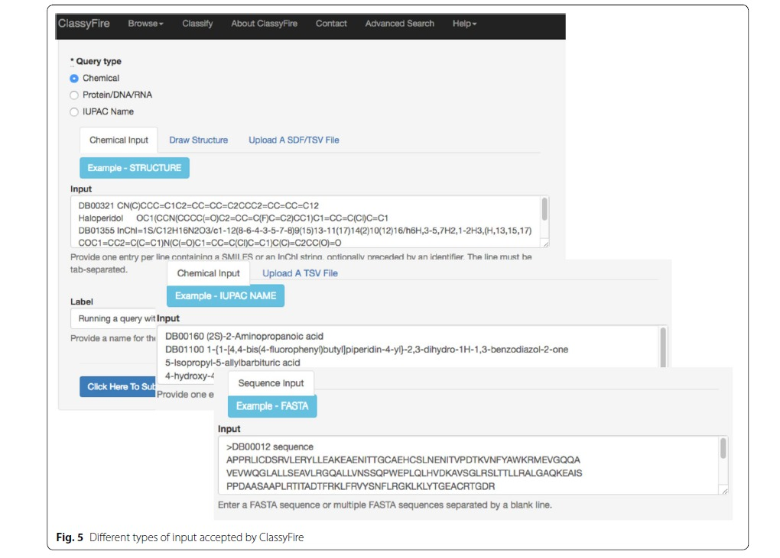
FIGURE 1. Format of input given to extract the classification
(Djoumbou Feunang et al., 2016)

2.2 Data collection of bioactives of NK and VA targeting Diabetic associated gene

Previous in silico investigations have demonstrated that NK & VA bioactives can target various proteins and pathways that are therapeutically significant for diabetes and related conditions (Thottappillil et al., 2023). Thottappillil et al. (2023) presented a Venn diagram illustrating NK bioactives targeting 37 proteins associated with diabetic complications and related disorders, including inflammation, fatty liver, and metabolic abnormalities. Additionally, 23 other proteins are linked to diabetes complications such as cardiomyopathy and nephropathy, as well as neuropathy, retinopathy, and other diabetes-related issues like diabetic foot conditions, poor wound healing, and both microvascular and macrovascular complications.

2.3 Data collection of Ayurvedic pharmacological action of NK and VA formulations as per three Ayurvedic classics.

Ingredients of NK and VA formulation were collected from the above-mentioned shloka in the introduction. Synonyms of each ingredient were found out using Bhavprakash Nighantu.
All ingredient names and synonyms were searched in different groups of different Ayurveda classics. Information collected from three different classics was from ashtangahrudayam chapter-15, sushrutha chapter-38, Charka samhitha chapter-4. After finding out the ingredients in different groups the indications of each group was collected.

2.4 Gene ontology and enrichment analysis of diabetic-associated genes
Gene ontology and enrichment analysis was done using the Scientific and Research Plot tool SRplot: A free online platform for data visualization and graphing https://www.bioinformatics.com.cn/SRplot (Tang et al., 2023).
Input : The excel file having the data of 23 diabetic-associated genes targeted by NK and 16 diabetic associated gene targeted by VA genes was copy-pasted into the SRplot input box.
Standard formatting options, such as setting the plot name, figure size, font size, and series colors, are all provided by the tool. Some parameters and the final appearance of the graph were set. With a single click of the submit button, the input data and specified style formats are combined to produce the resulting plot in real time.
Output: The plots were easily downloaded in a high-resolution bitmap (TIFF) format. Once downloaded in TIFF format converted to PDF.

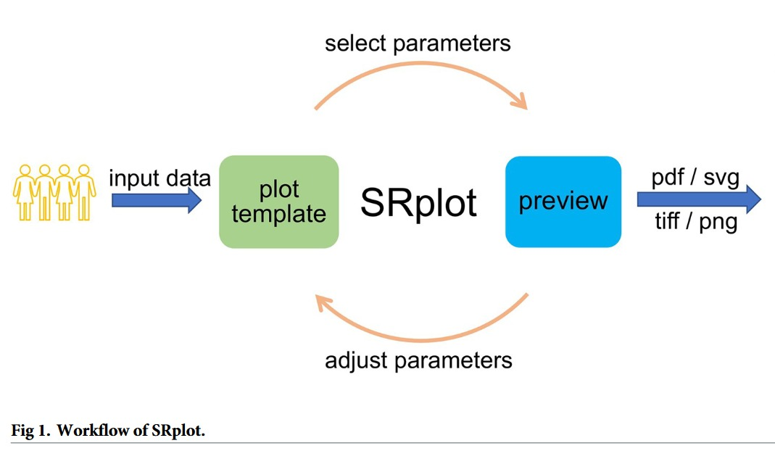

FIGURE 2. Workflow of Srplot tool (Tang et al., 2023)

2.5 Gallic acid estimation of NK and VA by folin ciocalteu method.
Materials required: gallic acid standard solution, folin-ciocalteu reagent 3.5% Sodium carbonate solution, 1M Sodium-potassium buffer solution, 96-well plate, Distilled water, Test tubes, Spectrophotometer, Pipettes Vortex mixer or shaker, samples: NK (Vaidyaratnam) and VA (The Arya vaidya Pharmacy)
Reagents preparation: Gallic acid standard solution: 1 mg/ml concentration. (Weigh 1 mg of gallic acid salt & vortex in 1 ml 0.02M sodium potassium buffer).For 250 µgm/ml concentration aliquot 250µl from the above solution & make up to 1ml.Folin-Ciocalteu reagent: Prepare a 1:1 ratio of Fc reagent with water according to the number of wells and volume required. 3.5% Sodium carbonate solution: add 3.5 gm of Sodium carbonate in 100 ml of nice water. For 25 ml of sodium carbonate: add 0.875 gm in 20 ml nice water. Prepare 1M Sodium-potassium buffer.
Sample preparation: NK and VA samples were taken in two different 15 ml tubes. Transfer 500 microliter of the sample to a 1.5ml Eppendorf tube for centrifugation. Centrifuge these samples at 5000 rpm for 5 minutes at 25 to 26-degree temperature. After centrifugation, transfer the supernatant to another 1 ml tube without disturbing the sediment.
Procedure:
Add 0.02 M of 40 microlitres of NAP buffer to all the wells in triplicate. Add 10 µl of sample to all the wells in triplicate. Add 50µl of Fc reagent to the sample and mix it well except the control group, while adding fc reagent lights should be turned off. Add 50 microlitre of 0.02 M of NAP buffer to the control . Incubate the plate for 30 minutes in a dark chamber. Add 3.5 % of 100 microlitres of Sodium carbonate to all the wells and mix it well. Read the plate under a microplate reader against 700 nm wavelength(200 path length).

2.6 Lipase assay

Materials required: 96-well plate, Distilled water, Test tubes, Spectrophotometer, Pipettes Vortex mixer or shaker.
Reagents required : 1M sodium Phosphate buffer (1M stock), 50Mm sodium phosphate buffer (50Mm working solution), 10mg/ml lipase, substrate PNPB , Samples :NK (Vaidyaratnam) and VA (The Arya vaidya pharmacy) (inhibitors)
Reagents preparation: Prepare 50mM of sodium phosphate buffer of pH 8.0. Weigh 200 mg of lipase aliquot, 10 ml of 50mM NaP buffer in two different tubes and add 100 mg of weighed lipase into each tubes and vortex it for 4 minutes.Then centrifuge it for 4000rpm for 10 minutes. Then collect the supernatant in a separate vial. Then prepare lipase buffer mix by adding 1.5 ml of prepared lipase to 3.5ml of 50mM NaP buffer.
Sample preparation: To prepare 160µg concentration of 500µl of samples NK and VA.180 µl of Nk was added to 320 µl of 50mM NaP buffer.
PNPB substrate preparation: This should be prepared freshly before the addition.Add 3µl of PNPB in 15ml of 50mM NaP buffer.
Procedure:
Aiquote 50µl of 50mMNaP buffer in all the wells except 1st row wells.Then add 100µl of prepared concentration of sample NK and VA in the 1st row wells in duplicates and do the serial dilutions and keep the last row wells as blank.
Then add 150µl of lipase buffer mix to one set of duplicate of NK and for the other set of NK duplicate set add 150µl of 50mMNap buffer (colour control) and same for the VA samples.Then keep the plate for incubationfor 30 minutes at 37ᐤc. Then add 90µl of freshly prepared subsatrate to all the wells.Then read the plates under spectrophotometer against 405nm for 45 minutes.

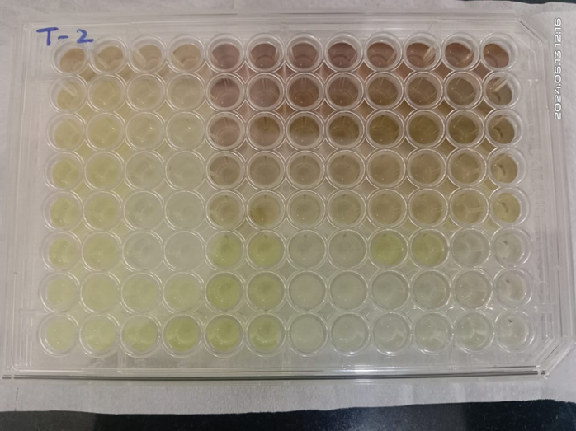
Lipase inhibition by NK and VA

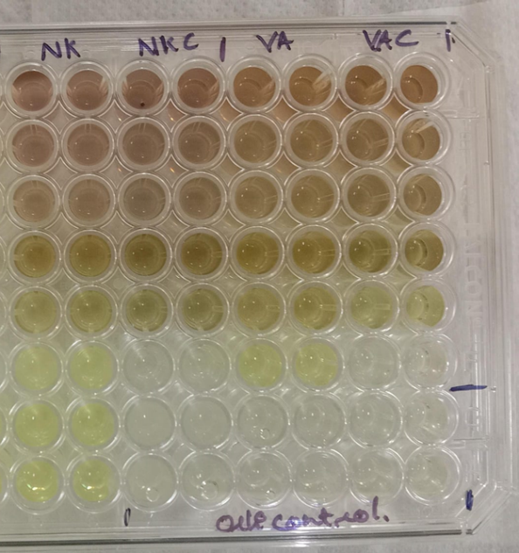

2.7 Cell culture
The intestinal secretin tumor cell line STC-1 were obtained from ATCC (American Type culture collection). This was cultured in Dulbecco Modified Eagle Medium (DMEM) containing 4.5g/l D-glucose, without sodium pyruvate) (GlutaMAX, GIBCO, Paisley, UK) supplemented with 17.5% fetal bovine serum , 100 U/ml penicillin, 100mg/l streptomycin, and incubated in a 5% CO2 humidified atmosphere at 37 degree Celsius. Cells were passaged at 80-90% confluence. STC-1 comes from special cell lines called enteroendocrine cells. STC-1 shares similarities with these natural enteroendocrine cells. STC-1 cells are regularly employed in screening setups to detect foods or substances that can influence the secretion of gut hormones in the laboratory. These cells are originated from the cells found in enteroendocrine tumors in mice. These tumors developed in the duodenum of mice with a specific genetic makeup, expressing the rat insulin promoter linked to the simian virus 40 large T antigen and the polyomavirus small T antigen (Saitoh et al., 2007). These cells exhibit a slower growth rate compared to other cell lines. In reaction to hormonal, neural, and nutrient cues, these cells secrete gut hormones like cholecystokinin (CCK), glucagon-like peptide-1 (GLP-1), and peptide YY (PYY), glucose-dependent insulinotropic peptides (GIP), pancreatic polypeptide neurotensin, and proglucogon derivatives like glucagon-like peptide-2 (GLP-2), which helps to reduce hunger and manage food intake and metabolism (McCarthy et al., 2015).
Human epithelial colorectal adenocarcinoma (Caco2) cells were obtained from NCCS(National centre for cell sciences), were maintained in a Minimal Essential Medium (MEM) containing amino acids and fetal bovine serum. The Caco-2 cell line, originally derived from a colon carcinoma, offers insights into the biological and biochemical basis of the intestinal mucosa's barrier properties. It can also provide valuable information on the absorption of drugs and dietary components, relevant to both the pharmaceutical and food industries. This cell line is instrumental in elucidating pathways for drug transport, studying the potential toxic effects of drug candidates or food metabolites on the intestinal mucosa, and investigating the mechanisms and effects of bioactive compounds on the barrier function of the intestinal epithelium (Lea, 2015).

2.8 MTT assay

STC-1 cell viability on NK and VA treatment.
STC-1 cells were seeded into a 96-well plate, count as mentioned above. The cells were incubated at 37ᐤc in a 5% carbon dioxide humidified incubator for 4 days to allow the attachment, growth, and 80-90% confluency.
After the cells was attached, different concentrations of NK and VA (8µg/ml, 4µgm/ml, 2µg/ml, 1µg/ml, 0.5µg/ml, 0.25µg/ml, and 0.125µg/ml) was added to the wells. The cells were then incubated for 2 hours.
Following the incubation period, the MTT assay was performed. A 0.5mg/ml MTT dye solution was added to each well. The cells was incubated for 4 hours at 37ᐤc and 5% carbon dioxide to allow the formation of formazan crystals. After the incubation, the medium was removed, and the formazan precipitate was solubilized in dimethyl sulfoxide (DMSO). The absorbance of the solubilized formazan was measured at 570nm using a microplate reader.

Preparation of 5mM PA
Set the water bath at 70ᐤc temperature, shaker at 40ᐤc temperature.
Aliquote 1ml of 100Mm palmitate in 1.5ml eppendorf tube. Once the water bath temperature reaches 70ᐤc place the above Eppendorf tube in the water bath with a floater for 30 minutes (till it liquifies). Then aliquots 9.5 ml of prepared 5% BSA MEM media in a 15 ml tube inside the LAF. Once palmitate is liquefied add this 1 ml of PA into 9.5ml of aliquot ted 5%BSA MEM media. Place the 15 ml tube in a shaker inside the beaker for 1 hour at 140 speed and 40ᐤ c temperature. After 1 hour take out the tube and filter the prepared 5milimolar PA in LAF.

Caco-2 cell viability on co-treatment of PA &NK
Caco-2 cells were seeded into a 96-well plate and counted as mentioned above. The cells were incubated at 37ᐤc in a 5% carbon dioxide humidified incubator for 24 hours to allow attachment, growth, and 80-90% confluency.
After the cells were attached,different concentrations of palmitate (0.125mM,0.25mM,0.5mM,1mM) were added to the wells. The cells were then incubated for 24HRS. After 24 hours of incubation, the media was removed followed by the addition of different concentrations of NK(8µg/ml,4µg/ml,2µg/ml,1µg/ml,0.5µg/ml,0.125µg/ml). The cells were then incubated for 24 hours.
Following the incubation period, the MTT assay was performed. A 0.5mg/ml MTT dye solution was added to each well. The cells were incubated for 4 hours at 37ᐤc and 5% carbon dioxide to allow the formation of formazan crystals. After the incubation, the medium was removed, and the formazan precipitate was solubilized in dimethyl sulfoxide (DMSO). The absorbance of the solubilized formazan was measured at 570nm using a microplate reader. DMSO was added to the wells to facilitate solubilization.

Caco-2 cell viability on co-treatment of PA &VA
Caco-2 cells were seeded into a 96-well plate and counted as mentioned above. The cells were incubated at 37ᐤc in a 5% carbon dioxide humidified incubator for 24 hours to allow attachment, growth, and 80-90%confluency. After the cells were attached, different concentrations of palmitate (0.125mM,0.25mM,0.5mM,1mM) were added to the wells. The cells were then incubated for 24HRS. After 24 hours of incubation, the media was removed followed by the addition of different concentrations of VA(8µg/ml,4µg/ml,2µg/ml,1µg/ml,0.5µg/ml,0.125µg/ml). The cells were then incubated for 24 hours. Following the incubation period, the MTT assay was performed. A 0.5mg/ml MTT dye solution was added to each well. The cells were incubated for 4 hours at 37ᐤc and 5% carbon dioxide to allow the formation of formazan crystals. After the incubation, the medium was removed, and the formazan precipitate was solubilized in dimethyl sulfoxide (DMSO). The absorbance of the solubilized formazan was measured at 570nm using a microplate reader. DMSO was added to the wells to facilitate solubilization.

Cell lines after DMSO addition
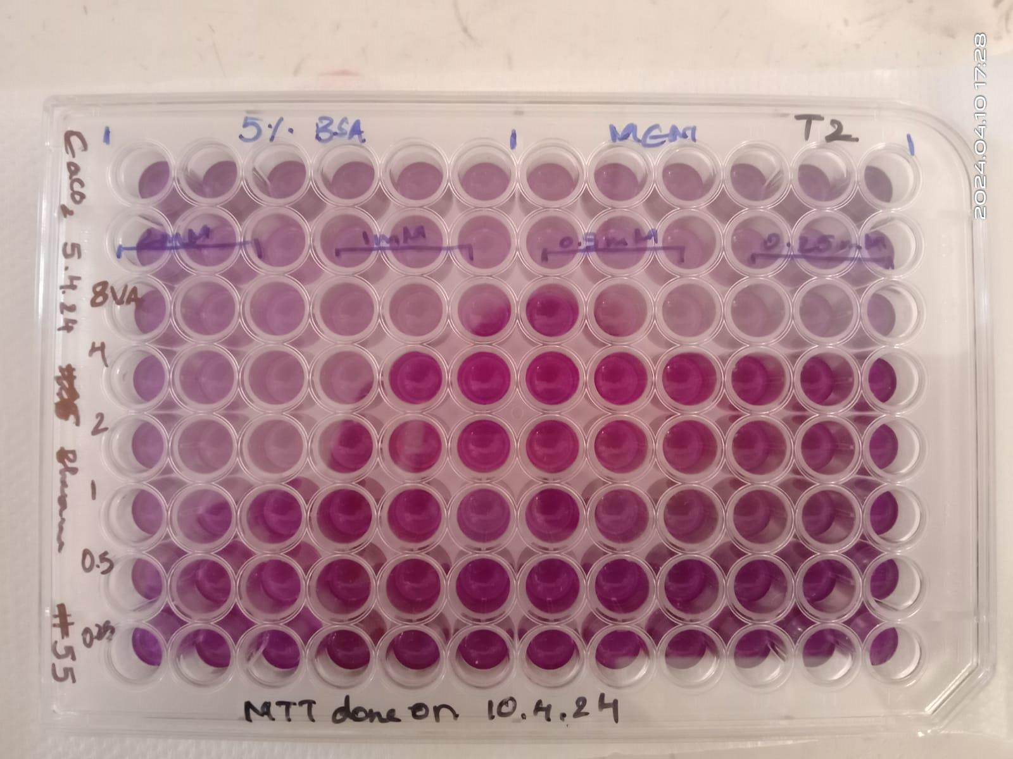

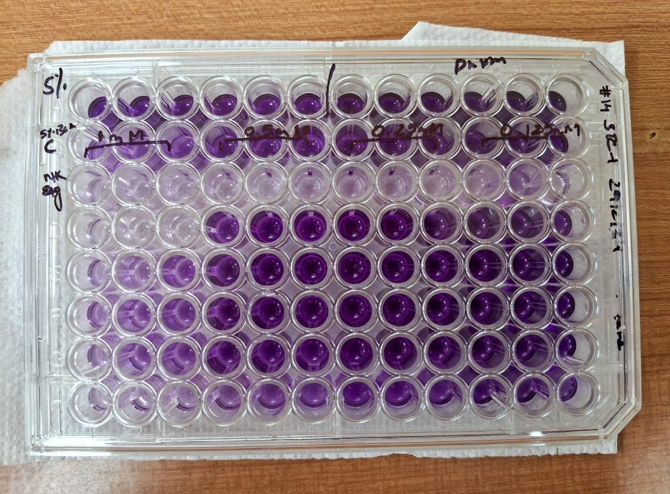

2.9 DPP4 Estimation from CaCo2 Cell Line

Materials: 12-well plate, CaCo2 cells, VA and NK formulations, Sitagliptin (positive control), PBS (1x), PBST (1% PBST), DPP4 substrate (500 µM concentration), Buffer for enzyme reaction, Spectrophotometer

Procedure: Seed 1,50,000 CaCo2 cells per well in a 12-well plate, Incubate until the cells form a monolayer. Once a monolayer is formed, treat the cells with the following:VA at concentrations of 4 µg/mL, 2 µg/mL, and 1 µg/mL. NK at concentrations of 4 µg/mL, 2 µg/mL, and 1 µg/mL. Sitagliptin as a positive control at 100 µM concentration. Incubate the treated cells for 24 hours. After 24 hours of treatment, wash the cells thoroughly 4 times with 1x PBS. Add 250 µL of 1% PBST to each well. Scrape the cells to collect the lysate.

DPP4 Estimation: Prepare the DPP4 substrate solution at a concentration of 500 µM. Add the DPP4 substrate and enzyme to the cell lysate. Make up the reaction volume with the appropriate buffer. Incubate the reaction mixture at 37°C for 1 hour. Measure the absorbance at 405 nm using a spectrophotometer to estimate the amount of DPP4 secreted from the CaCo2 cells.

3.Results

3.1 Classification of phytochemicals of NK and VA

Classification of phytochemicals of NK

Classes | Phytochemicals | Number of phytoconstituents
Benzene and substituted derivatives | Gallic Acid | 6
Benzene and substituted derivatives | Phyllemblin | 6
Benzene and substituted derivatives | p-hydroxybenzoic acid | 6
Benzene and substituted derivatives | Benzoic acid | 6
Benzene and substituted derivatives | Syringic acid | 6
Benzene and substituted derivatives | Vanillic acid | 6
Phenols | Pyrogallol | 4
Phenols | Guaiacol | 4
Phenols | Eugenol | 4
Phenols | Vanillin | 4
Organooxygen compounds | Mucic Acid, fructose | 17
Organooxygen compounds | Glucose | 17
Organooxygen compounds | Inositol | 17
Organooxygen compounds | Arabinose | 17
Organooxygen compounds | Salirepin | 17
Organooxygen compounds | Benzoylsalireposide | 17
Organooxygen compounds | Locoracemosides B | 17
Organooxygen compounds | Salireposide | 17
Organooxygen compounds | Symponoside | 17
Organooxygen compounds | Symplososide | 17
Organooxygen compounds | Symploveroside | 17
Organooxygen compounds | Diacetyl | 17
Organooxygen compounds | Glycerol | 17
Organooxygen compounds | Khusimone | 17
Organooxygen compounds | Khusinol | 17
Organooxygen compounds | Khusitone | 17
Organooxygen compounds | Sucrose | 17
Tannins | Glucogallin | 9
Tannins | 1,2,4,6-Tetra-O-Galloyl-Beta-D-Glucose | 9
Tannins | 1,6-Bis-O-Galloyl-Beta-D-Glucose | 9
Tannins | Chebulagic-Acid | 9
Tannins | Chebulinic Acid | 9
Tannins | Corilagin | 9
Tannins | Ellagic Acid | 9
Tannins | Punicafolin | 9
Tannins | Terchebin | 9
Prenol lipids | Gibberellin A3 | 83
Prenol lipids | A1 Gibberllin | 83
Prenol lipids | A7 Gibberellin | 83
Prenol lipids | A9 Gibberllin | 83
Prenol lipids | Linalool | 83
Prenol lipids | Camphor | 83
Prenol lipids | Limonene | 83
Prenol lipids | Isoborneol | 83
Prenol lipids | Isoprocurcumenol | 83
Prenol lipids | P-Cymene | 83
Prenol lipids | Terpineol | 83
Prenol lipids | Zedoarondiol | 83
Prenol lipids | Alpha-Pinene | 83
Prenol lipids | D-Camphor | 83
Prenol lipids | Guaiane | 83
Prenol lipids | Procurcumenol | 83
Prenol lipids | Ar-Turmerone | 83
Prenol lipids | Bisacurone | 83
Prenol lipids | Camphene | 83
Prenol lipids | L-Alpha-Curcumene | 83
Prenol lipids | Zingiberene | 83
Prenol lipids | Curcumenol | 83
Prenol lipids | Beta-Pinene | 83
Prenol lipids | Curcumene | 83
Prenol lipids | Curzerenone-C | 83
Prenol lipids | Lbeta curcumene | 83
Prenol lipids | Isomotiol | 83
Prenol lipids | Oleanoloic acid | 83
Prenol lipids | 3-O-Acetyloleanolic acid | 83
Prenol lipids | Betulin | 83
Prenol lipids | β-amyrin | 83
Prenol lipids | 24-hydroxyolean-12-en-3-one | 83
Prenol lipids | betulinic acid | 83
Prenol lipids | Betulic acid | 83
Prenol lipids | 3beta-Hydroxy-20(29)-lupene | 83
Prenol lipids | Lupeol | 83
Prenol lipids | β-sesqui phellandrene | 83
Prenol lipids | betunolic acid | 83
Prenol lipids | α-amyrin | 83
Prenol lipids | ursolic acid | 83
Prenol lipids | 3-acetylursolic acid | 83
Prenol lipids | Oleanonic acid | 83
Prenol lipids | Tocopheryl quinone | 83
Prenol lipids | 3-acetylbetulic acid | 83
Prenol lipids | 16α-hydro-19-acetoxy-(−) kauran-17-oic acid | 83
Prenol lipids | Alpha-Calacorane, Beta-vetispirine | 83
Prenol lipids | Alpha-vetivone,Epikhusinol | 83
Prenol lipids | Beta-vetivene | 83
Prenol lipids | Beta-vetivenene | 83
Prenol lipids | Beta-vetivone | 83
Prenol lipids | Cyclocopacamphene | 83
Prenol lipids | Cyclocopacampheno | 83
Prenol lipids | Delta-3-carene | 83
Prenol lipids | Elemol | 83
Prenol lipids | Gamma-vetivenene | 83
Prenol lipids | Isobisaboline | 83
Prenol lipids | Isokhusenic acid | 83
Prenol lipids | Khusene | 83
Prenol lipids | Khusimyl-acid | 83
Prenol lipids | Khusol | 83
Prenol lipids | Terpinen-4-ol | 83
Prenol lipids | Zizanene | 83
Prenol lipids | Zizanoic-acid | 83
Prenol lipids | Zizanol | 83
Prenol lipids | Valencene | 83
Prenol lipids | Vetiselinenol | 83
Prenol lipids | vetivenic acid | 83
Prenol lipids | Nootkatol | 83
Prenol lipids | Nootkatone | 83
Prenol lipids | L-Delta-Cadinol | 83
Prenol lipids | L-gamma-2-cadinene | 83
Prenol lipids | L-gamma-cadinene | 83
Prenol lipids | Tricyclovetivene | 83
Prenol lipids | Vetivene | 83
Prenol lipids | Prezizaan-15-al | 83
Prenol lipids | Prezizaene | 83
Prenol lipids | Solavetivone | 83
Prenol lipids | Isokhusimol | 83
Prenol lipids | Isovalencenol | 83
Prenol lipids | Khusimol | 83
Prenol lipids | Laevojunenol | 83
Prenol lipids | alpha-Amyrin | 83
Prenol lipids | Sitosteryl palmitate | 83
Flavonoids | Eriodictyol | 14
Flavonoids | Kaempferol | 14
Flavonoids | Myricitrin | 14
Flavonoids | Proanthocyanidin | 14
Flavonoids | Procyanidin | 14
Flavonoids | Quercetin | 14
Flavonoids | Quercitrin | 14
Flavonoids | Luteolin | 14
Flavonoids | (−)-epicatechin | 14
Flavonoids | (+)-catechin | 14
Flavonoids | Chrysin | 14
Flavonoids | Narcissin | 14
Flavonoids | Typhaneoside | 14
Flavonoids | Kaempferol 3-O-beta-D-galactoside | 14
Pteridines and derivatives | Riboflavin | 1
Imidazopyrimidines | Trans-Zeatin | 1
Diarylheptanoids | Desmethoxycurcumin | 5
Diarylheptanoids | Curcumin | 5
Diarylheptanoids | Bisdemethoxycurcumin | 5
Diarylheptanoids | Letestuianin B | 5
Diarylheptanoids | Letestuianin A | 5
Cinnamic acids and derivatives | Cinnamic-Acid | 7
Cinnamic acids and derivatives | P-coumaric acid | 7
Cinnamic acids and derivatives | 1,5-Bis-(4-Hydroxy-3-Methoxyphenyl)-1,4-Pentadien-3-One | 7
Cinnamic acids and derivatives | P-Methoxy-Cinnamic-Acid | 7
Cinnamic acids and derivatives | ferulic acid | 7
Cinnamic acids and derivatives | Moupinamide | 7
Cinnamic acids and derivatives | Caffeic-Acid | 7
Fatty Acyls | Caprylic-Acid | 8
Fatty Acyls | ketochaulmoogric acid | 8
Fatty Acyls | Methyl triacontanoate | 8
Fatty Acyls | 9, 12-Octadecadienoic acid | 8
Fatty Acyls | Palmitic acid | 8
Fatty Acyls | Stearic acid | 8
Fatty Acyls | Oleic acid | 8
Fatty Acyls | Linoleic acid | 8
Unsaturated hydrocarbons | Alpha-vetispirene | 2
Unsaturated hydrocarbons | Azulene | 2
Steroids and steroid derivatives | Sitosterol | 8
Steroids and steroid derivatives | Stigmasterol | 8
Steroids and steroid derivatives | Campesterol | 8
Steroids and steroid derivatives | Phytosterols | 8
Steroids and steroid derivatives | Beta sitosterol | 8
Steroids and steroid derivatives | sitosteryl-3-O-β-d-glucoside | 8
Steroids and steroid derivatives | 6β-hydroxystigmast-4-en-3-one | 8
Steroids and steroid derivatives | Daucosterol | 8
Strychnos alkaloids | Brucine | 2
Strychnos alkaloids | Strychnine | 2
Indoles and derivatives | Icajine | 2
Indoles and derivatives | Novacine | 2
Phenylpropanoids and polyketides | Symplocomoside | 4
Phenylpropanoids and polyketides | Symposide | 4
Phenylpropanoids and polyketides | Kaempferol-7-oglucoside | 4
Phenylpropanoids and polyketides | epicatechin-4β-8 | 4
Coumarins and derivatives | Scopoletin | 2
Coumarins and derivatives | Coumarin | 2
Organic oxides | Khusilal | 1
Indolonaphthyridine alkaloids | Canthin-6-one | 3
Indolonaphthyridine alkaloids | Ervoside | 3
Indolonaphthyridine alkaloids | Ervine | 3
Harmala alkaloids | Aervolanin | 2
Harmala alkaloids | Thalicrines | 2
Dihydrofurans | l-ascorbic acid | 1
Organic sulfuric acids and derivatives | Salacinol | 2
Organic sulfuric acids and derivatives | Kotalanol | 2
Anthracenes | 1,3,8‐Trihydroxyanthraquinone | 7
Anthracenes | Chrysophanol | 7
Anthracenes | Physcion | 7
Anthracenes | aloe‐emodin | 7
Anthracenes | Lunatin | 7
Anthracenes | Emodin | 7
Anthracenes | chrysophanol‐10,10'‐bianthrone | 7
Total Classified Phytochemicals |  | 191

Table 3: 191 Phytochemicals reported from Ingredients of NK is classified under 23 classes using ClassyFire tool

Classification of Phytochemicals of VA

Classes | Phytochemicals | Number of phytoconstituents
Steroids and steroid derivatives | Tenacissoside_G | 9
Steroids and steroid derivatives | Tenacissoside_L | 9
Steroids and steroid derivatives | Daucosterol | 9
Steroids and steroid derivatives | Marsdenin | 9
Steroids and steroid derivatives | Phytosterols | 9
Steroids and steroid derivatives | Ecdysterone | 9
Steroids and steroid derivatives | Beta-sitosterol | 9
Steroids and steroid derivatives | Clion asterol | 9
Cinnamic acids and derivatives | Cinnamic acid | 4
Cinnamic acids and derivatives | Moupinamide | 4
Cinnamic acids and derivatives | 2-Coumarinate | 4
Cinnamic acids and derivatives | Ferulic acid | 4
Coumarins and derivatives | 3-Hydroxycoumarin | 16
Coumarins and derivatives | Imperatorin | 16
Coumarins and derivatives | Isoimperatorin | 16
Coumarins and derivatives | Psoralen | 16
Coumarins and derivatives | Skimmin | 16
Coumarins and derivatives | Xanthotoxol | 16
Coumarins and derivatives | Scopoletin | 16
Coumarins and derivatives | Methoxsalen | 16
Coumarins and derivatives | Coumarin | 16
Coumarins and derivatives | Umbelliferone | 16
Coumarins and derivatives | Marmin | 16
Coumarins and derivatives | Marmesin | 16
Coumarins and derivatives | Aegelinol | 16
Coumarins and derivatives | Ammijin | 16
Coumarins and derivatives | Alloimperatorin | 16
Coumarins and derivatives | Isopimpinelli | 16
Prenol lipids | Dipentene | 15
Prenol lipids | Sitosteryl palmitate | 15
Prenol lipids | Alpha-amyrin | 15
Prenol lipids | Betulin | 15
Prenol lipids | betulinic_acid | 15
Prenol lipids | Friedelanol | 15
Prenol lipids | Epilupeol | 15
Prenol lipids | Friedlein | 15
Prenol lipids | Hederagenin | 15
Prenol lipids | Lupeol | 15
Prenol lipids | Beta-Amyrin | 15
Prenol lipids | Solavetivone | 15
Prenol lipids | Arjungenin | 15
Prenol lipids | Arjunolic_acid | 15
Prenol lipids | Auraptene | 15
Quinolines and derivatives | Gamma-Fagarine | 3
Quinolines and derivatives | Skimmianine | 3
Quinolines and derivatives | Haplopine | 3
Organooxygen compounds | Gentiobiose | 13
Organooxygen compounds | beta-D-Glucose | 13
Organooxygen compounds | Anacardoside | 13
Organooxygen compounds | 9-Heptadecanone | 13
Organooxygen compounds | Maltose | 13
Organooxygen compounds | Pectin | 13
Organooxygen compounds | Quinic_acid | 13
Organooxygen compounds | Shikimic_acid | 13
Organooxygen compounds | Sorbitol | 13
Organooxygen compounds | Fructose | 13
Organooxygen compounds | Glucose | 13
Organooxygen compounds | Sucrose | 13
Organooxygen compounds | Arabinose | 13
Azoles | Halfordinol | 1
Naphthalenes | Plumbagin | 9
Naphthalenes | 2-Amino-1,4-naphthoquinone | 9
Naphthalenes | 3,3'-Biplumbagin | 9
Naphthalenes | Chitranone | 9
Naphthalenes | Droserone | 9
Naphthalenes | Elliptinone | 9
Naphthalenes | Seselin | 9
Naphthalenes | Xanthoxyletin | 9
Naphthalenes | Karanjin | 9
Dihydrofurans | Ascorbic acid | 1
Indolonaphthyridine alkaloids | Ervine | 2
Indolonaphthyridine alkaloids | Canthin-6-one | 2
Flavonoids | Kaempferol 3-O-beta-D-galactoside | 10
Flavonoids | Typhaneoside | 10
Flavonoids | Chrysin | 10
Flavonoids | Pongapin | 10
Flavonoids | Galluflavanone | 10
Flavonoids | Nallaflavanone | 10
Flavonoids | Isoquercitrin | 10
Flavonoids | Kaempferol-3-Rutinoside | 10
Flavonoids | Quercetin | 10
Flavonoids | Luteolin | 10
Benzene and substituted derivatives | Vanillic acid | 8
Benzene and substituted derivatives | Benzyl-Amine | 8
Benzene and substituted derivatives | Syringic_acid | 8
Benzene and substituted derivatives | Anacardic_acid | 8
Benzene and substituted derivatives | Ethyl_Gallate | 8
Benzene and substituted derivatives | Phthalic_acid | 8
Benzene and substituted derivatives | Gallic acid | 8
Benzene and substituted derivatives | Tembamide | 8
Phenols | Vanillin | 3
Phenols | Cardol | 3
Phenols | Pyrocatechol | 3
Phenanthrenes and derivatives | Aristolochic_acid | 1
Aporphines | Magnoflorine | 1
Benzothiazoles | Saccharin | 1
Carboxylic acids and derivatives | Asparagine | 14
Carboxylic acids and derivatives | Oxalic_acid | 14
Carboxylic acids and derivatives | Succinicacid | 14
Carboxylic acids and derivatives | Arginine | 14
Carboxylic acids and derivatives | DL-Arginine | 14
Carboxylic acids and derivatives | DL-Valine | 14
Carboxylic acids and derivatives | L-Histidine | 14
Carboxylic acids and derivatives | Leucine | 14
Carboxylic acids and derivatives | Methionine | 14
Carboxylic acids and derivatives | L-Threonine | 14
Carboxylic acids and derivatives | Phenylalanine | 14
Carboxylic acids and derivatives | Acetic_Acid | 14
Carboxylic acids and derivatives | Chebulic-Acid | 14
Carboxylic acids and derivatives | Proline | 14
Fatty Acyls | 1-Octacosanol | 13
Fatty Acyls | Stearic_acid | 13
Fatty Acyls | Linoleic-acid | 13
Fatty Acyls | Palmitic_acid | 13
Fatty Acyls | Oleic acid | 13
Fatty Acyls | 1-Decanol | 13
Fatty Acyls | Hexacosanoic_acid | 13
Fatty Acyls | Octacosanoic_acid | 13
Fatty Acyls | Octadeca-9,12-Dienoic_Acid | 13
Fatty Acyls | Octadecanoate | 13
Fatty Acyls | Tetracosanoate | 13
Fatty Acyls | Tetracosanoic- | 13
Fatty Acyls | Tetradecanoic_Acid | 13
Indoles and derivatives | 5-Hydroxytryptamine | 2
Indoles and derivatives | Dl-Tryptophan | 2
Organonitrogen compounds | Histamine | 1
Tannins | ellagic acid | 12
Tannins | 1,2,3,4,6-Pentagalloylglucose | 12
Tannins | 1,3,6-Trigalloylglucose | 12
Tannins | beta-Glucogallin | 12
Tannins | Chebulanin | 12
Tannins | Pentagalloyl-Beta-D-Glucose | 12
Tannins | Terchebulin | 12
Tannins | Terchebin | 12
Tannins | Chebulagic acid | 12
Tannins | Chebulinic acid | 12
Tannins | Corilagin | 12
 | Tannic acid
Biflavonoids and polyflavonoids | Amentoflavone | 1
Amino acids, peptides, and analogues | l-Isoleucine | 1
Pyridines and derivatives | Nicotinate | 1
Indenes and isoindenes | 1h-Indene | 1
Saturated hydrocarbons | Cyclododecane | 2
Saturated hydrocarbons | Cyclohexane | 2
Alkyl halides | Heptafluorobutyric_Acid | 1
Epoxides | Oxirane | 1
Non-metal oxoanionic compounds | Phosphoric_acid | 1
Anthracenes | Sennoside-A | 1
Pteridines and derivatives | Riboflavin | 1
Total no. of Phytochemicals |  | 150

Table 4: 150 Phytochemicals reported from Ingredients of VA is classified under 31 classes using classyfire tool

FIGURE 3. Reported phytochemicals from ingredients of NK have been classified into 23 distinct classes.Prenol lipids class is having more number (80) of different phytochemicals ,4 distinct classes of compounds are having least number of phytochemicals (1) in NK formulation.

FIGURE 4. Reported Phytochemicals from ingredients of VA have been classified into 31 classes. Coumarins and derivatives class is having more number (16) of different phytochemicals ,15 distinct classes of compounds are having least number of phytochemicals (1) in this formulation.

3.2 Phytochemicals of NK and VA targeting diabetic associated genes.
From the previously gathered data, Manually which phytochemicals from the plants of NK formulation target 23 specific genes and which phytochemicals from the plants in the VA formulation target 16 specific genes is done.
Among these 23 and 16 genes, through venn diagram analysis it has been found out there are 13 common genes targeted by both NK and VA formulation, 3 genes exclusively targeted by the VA formulation and 10 genes exclusively targeted by NK formulation, by the following information out of curious which phytochemicals of NK and VA formulation is targergeting overlapped 13 diabetic associated gene, which phytochemicals of VA is exclusively targeting 3 diabetic associated genes and which phytochemicals of NK is exclusively targeting 10 diabetic associated gene is being sorted in the below tables. This sorting was completed using Microsoft Excel.

Venn diagram analysis
Here 23 diabetic associated genes targeted by NK and 16 diabetic associated genes was given as input the tool SR plot has analysed the given genes and represents below venn diagram depicting in the given set of genes 13 genes were targed by both NK and VA, other 10 genes targeted only by NK and 3 genes targeted by VA

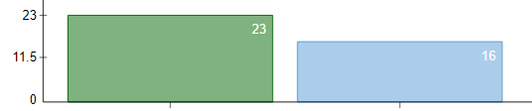
Targeted by NK Targeted by VA
Diabetic associated genes targeted by NK and VA

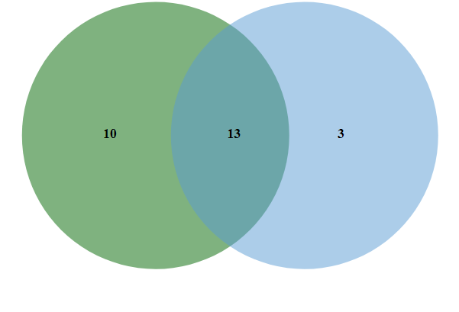

Diabetic associated genes exclusively Diabetic associated genes exclusively
trageted by NK targeted by VA

FIGURE 5. Venn diagram representing how overlaped and unique genes were found out. From 23 and 16 diabetic associated genes targeted by NK and VA

Phytochemicals of NK and VA targeting 13 common diabetic associated genes.

TABLE 5. Among 13 overlapping genes 9 overlapping genes (MMP2, TNF, SOD2, APOE,ALB,VEGFA,AKR1B1,RELA,MMP9 ) is being targeted similar phytochemicals of both NK and VA formulation.

Phytochemicals of NK targeting 10 diabetic associated genes

TABLE 6. Among 10 genes 4 genes (ADH1B,GSTM1,PTGS2,ATM) is being targeted unique (in terms of comparing the comprised data) phytochemicals NK formulation.

Phytochemicals of VA targeting 3 diabetic associated genes

TABLE 7. Among 3 geens 1 gene (CAT) is being targeted by 1 unique phytochemical (Oxalic acid)

3.3 Indications of Ayurvedic pharmacological action of NK and VA as per ayurveda classiscs

Indications of ayurvedic pharmacological actions of NK and VA as per Ashtangahrudayam.
GANA | Indications
Virecana gana | Purgative plants
Kaphagna gana | These are asanadi group of herbs which actuate kapha & deacrease balasa
Rodhradi gana | Rodhra group of herbs is capable to cure diseases of fat &Kapha.It causes blockage to movement of doshas and malas , destroys poison related effects.
Sarivadi gana | The herbs which cure burning sensation,bleeding disease,thirst & fever.
Parusakadi gana | These are the herbs which cure thirst ,urinary disorders & actuate vata
Asanadi gana | This group of herbs is capable of cure skin diseases,They actuate kapha & are capable to cure diabetes & disease of fat accumulataion.
Virataradi gana | These group of herbs are capable to cure diseases generated by vata, urinary stones & gravel, dysuria, suppression of urine and pain.
Vacaharidradi gana | This group of herbs cure diseases of fat, kapha,adhyapavana.
Mustadi gana | This group of herbs cooks all the doshas.
Padmakadi gana | These are the herbs which subjugate vata & pitta.They are nourishing enlivening,stoutening.
Chardana gana | Emetic herbs
Aragvadhadi gana | These herbs actuate kapha,itching, diabetes & also cleans wounds
Jivaniya gana | Group of restorative herbs .
Arkadi gana | Group of herbs which actuates kapha & checks fat.Cleanses the wounds.
Vatsakadi gana | Cures disorders of vata,kapha & medas,rhinitis ,abdominal tumour,colic,haemorrhoids.
Syamadi gana | Cures abdominal tumour,anorexia, diseases of kapha,heart ache & dysuria.

TABLE 8. The groups (gana) containing the ingredients of NK and VA have been tabulated.

Indications of ayurvedic pharmacological actions of NK and VA as per charaka.
GANA | INDICATIONS
Lekhaniya | Reducing /emaciating drugs which reduces the corpulence
Kusthaghna | kusta
Visaghna | Alexipharmic/anti-poison drug
Sukrasodhana | Semen depurants
Virecanaopaga | Group of adjuvants (decoctives) of purgative
Chardinigrahana | Group of anti-emetic drugs
Purisasamgrahaniya | Group of constipating drugs
Mutravirechaniya | Group of diuretics
Kasahara | Group of anti-tussive
Jwarahara | Group of febrifuge/antipyretic drugs
Daha-prasamana | Group of allevistors of burning sensation
Angamarda-prasamana | Group of drugs of alleviator of body ache
Sonithasthapana | Group of hemoststic drugs
Prajasthapana | Group of drugs of fertility promoting/fetus stabilizer
Vayahsthapana | Group of longevity promoting drugs
Jivaniya | Group of life prolonging drugs
Bhedaniya | Lump breaking/cathartic /purgative drugs
Dipaniya | Appetizer/digestive/fire stimulant group
Balya | strength promoting/ tonic group
Kanthya | beneficial for throat group
Traptighna | Anti-satiety group
Arsoghna | Piles eliminator group
Kusthaghna | Kustha eliminator group
Kandughna | Anti-itching group
Stanyajanana | Galactogogues group
Stanyasodhana | Galacto-purificator group
Snehopaga | Group of adjuvants decoctives of unction
Virecanaopaga | Group of adjuvants decoctive of purgatives
Asthapanopaga | Group of adjuvants decoctive of cleansing enema
Anuwasanopaga | Group of adjuvants decoctive of oleaginous enema
Hikkanigrahana | Group of hiccup restraining drugs
Mutrasamgrahaniya | Group of urine-collecting i.e;retaining drugs
Mutravirechaniya | Group of diuretic drugs
Kasahara | Group of anti-tussive drugs
Swashara | Group of anti-dyspnoeic acid
Swayathuhara | Group of anti-edema/anti-inflmammatory drugs
Jwarahara | Group of febrbifuge/antipyretic drugs
Sitaprasamana | Group of drugs alleviator of cold
Angamarda-prasamana | Group of drugs alleviator of body ache

TABLE 9. The groups (gana) containing the ingredients of NK and VA have been tabulated.

Indications of ayurvedic pharmacological actions of NK and VA as per sushrutha.
GANA | INDICATIONS
Salasaradi gana | Cures diabetes, dries up kapha and medas
Muskakadi gana | Mitigates fat, cures diabetes,haemorrhoids,urinary calculus & gravel
Haridradi gana | Relieve nacent diarrhoea & mitigate the doshas
Sarivadi gana | Cures severe thirst, bleeding diseases,mitigates fever of pitta origin & burning sensation
Parusakadi gana | Mitigates vata, disorders of urine, good for heart,relieves severe thirst, bestows taste
Lodhradi gana | Mitigates fat & kapha, witholds elimination, bestows colour & destroys poison
Nyagrodhadi gana | It is constipating, cures burning sensation, obesity.
Mustadi gana | Mitigates kapha, it is digestive.
Triphala gana | All three together mitigates kapha & pitta, cures diabetes,good for eyes,kindles digestion.
Amalakyadi gana | Mitigates kapha & anorexia, kindles hunger,good for vision
Vidarigandhadigana | Mitigates pitta & vata , cures consumption.
varunadi gana | Mitigates kapha & medas (fat) , cures internal abscesses
Viratarvadi gana | Cures diseases caused by aggravation of vata, urinary calculus & gravel, dysuria & pain of retention of urine.
Arkadi gana | Mitigates kapha, medas , heals wounds.
Syamadi gana | Cures abdominal tumors, flatulence, enlargement of abdomen, reverse perisstalsis.
Brhatyadi gana | It is digestive, mitigates pitta, vata & kapha, cures anorexia, heart diseases & dysuria.
Patoladi gana | Mitigates pitta & kapha,good for ulcers,cures vomitting,itching & poison.
Kakolyadi gana | Mitigates pitta, rakta & vata, is restorative, stoutening & increases kapha.
Kaniya/hrasva/laghu pancamula | This is astringent, bitter & sweet in taste, mitigates vata & pitta , is stoutening & bestows strength
Mahat /brhat panchamula | It is bitter in primary taste & sweet in secondary taste, mitigates kapha & vata, light ( Easily digestible) & kindles digestive fire.
Kantaki panchamula | Cures bleeding diseases , all three types of swelling , all types of diabetes.
Trna panchamula | Cures quickly diseases of urine & bleeding disease when administered along with milk.

TABLE 10. The groups (gana) containing the ingredients of NK and VA have been tabulated.

TABLE 11. Ayurvedic pharmacological action of Ingredients of NK as per Ashtangahrudayam.

Nisha is found out in 3 groups, Kataka, lodra, Gorakshaganja, usheera, Amalaki in 1 group as per ashtangahrudayam. Indications of each group is mentioned in table 11.

TABLE 12. Ayurvedic pharmacological action of ingredients of NK as per sushrutha.

Nisha is found in 2 groups, Kataka in 1 group, lodra in 2 group, saptachakra in 1 group, usheera in 1 group, Amalaki in 5 groups as per sushrutha. Indications of each group is mentioned in table 12.

TABLE 13.Ayurvedic pharmacological action of ingredients NK as per charaka

Nisha is found in 3 groups, Kataka, Gorakshaganja is found in 1 group, Lodra is found in 2 groups, Amalaki is found in 6 groups, Usheera in 4 groups as per charaka. Indications of each group is mentioned in table 13.

TABLE 14. Ayurvedic pharmacological action of ingredients of VA as per Ashtangahrudayam.

Varuna,bilwa ,brihati , Sahachara, shatavari, Agnimantha, shigru, darbha,bhallataka is found in 1 group, Chitraka , Murva , Karanja, chribilwa in 4 groups , Haritaki in 5 groups as per Ashtangahrudayam. Indications of each group is mentioned in table 14.
TABLE 15 . Ayurvedic pharmacological action of ingredients of VA as per Sushrutha

Varuna, Bilwa, Brihati, Shigru, in 1 group, Sahacahara, Shatavari, Karanja, Chiribilwa, Darbha in 2 group, Murva, Agnimantha, Bhallataka in 3 groups, Haritaki in 6 groups as per sushrutha. Indications of each group is mentioned in table 15.

TABLE 16. Ayurvedic pharmacological action of ingredients of VA as per Charaka.
Shatavari, Bhallataka in 2 groups, Murva, Bilwa, Darbha in 4 groups, Brihati in 5 groups, Bhadra, Karanja, chiribilwa in 1 group, Agnimantha in 1 group, Haritaki in 12 groups as per charaka. Indications of each group is mentioned in Table 16.

TABLE 17. Similar Ganas found between NK and VA

In total there are 18 similar ganas among NK and VA.

3.4 Gene ontology and enrichment analysis of diabetic-associated genes

10 biological processes enriched by diabetic asoociated genes targeted by both NK

and VA
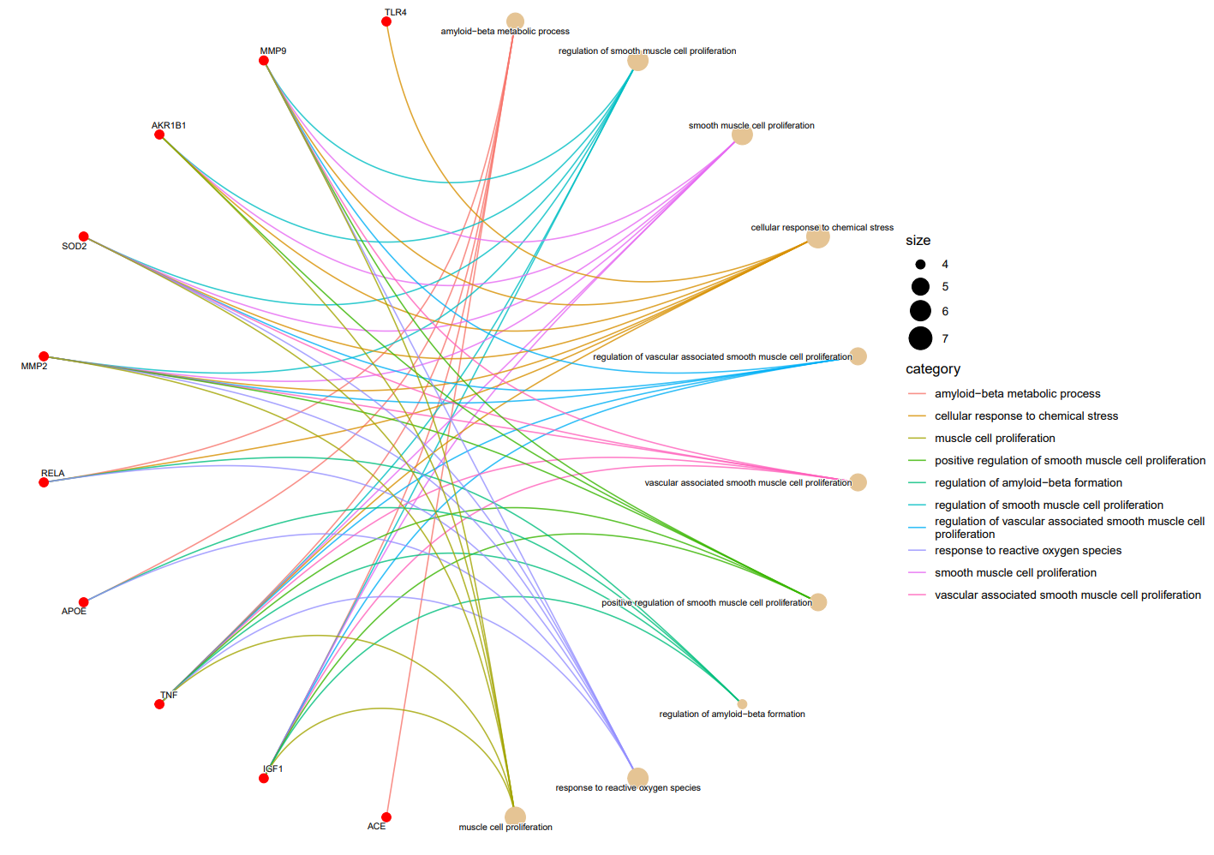
FIGURE 6. cnetplot representing top 10 significantly enriched biological process in the given set of diabetic associated gene.

NK and VA target 13 diabetes-associated genes, of which 10 genes, visualized in the graph above, are overrepresented in several biological processes. Amyloid-beta metabolic process is enriched by 5 out of the 13 genes, regulation of smooth muscle cell proliferation by 6 genes, smooth muscle cell proliferation by 6 genes, cellular response to chemical stress by 7 genes, regulation of vascular-associated smooth muscle cell proliferation by 5 genes,Vascular associated smooth muscle cell proliferation by , positive regulation of smooth muscle cell proliferation by 5 genes, regulation of amyloid-beta formation by 4 genes, response to reactive oxygen species by 6 genes, and muscle cell proliferation by 6 genes. These biological processes are the top 10 enriched processes in the given set of 13 genes.

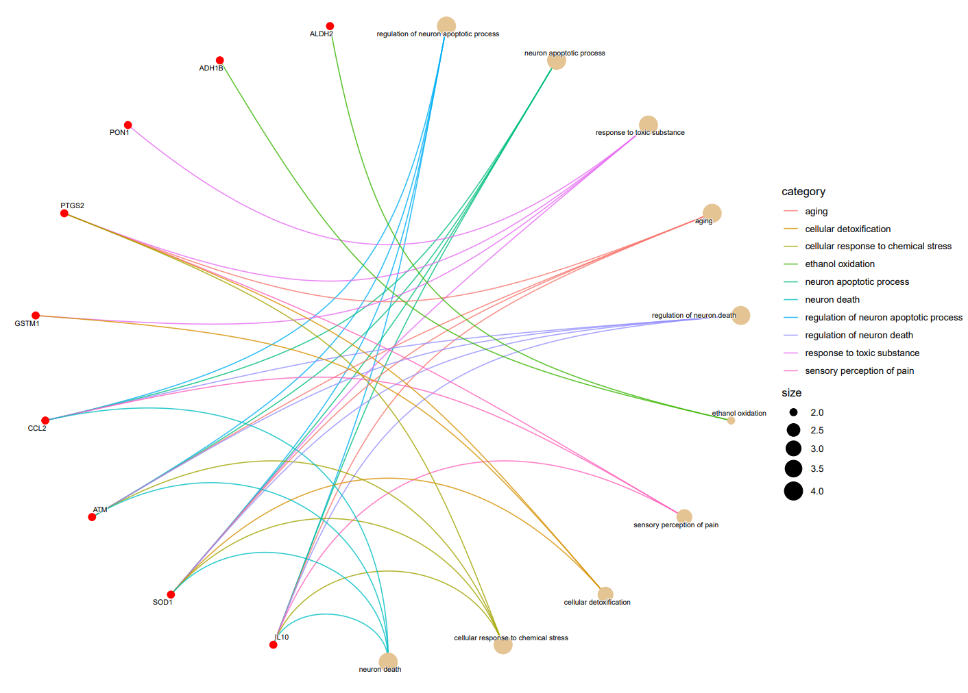
10 Biological processes enriched by diabetic associated genes exclusively targeted by NK

FIGURE 7. cnetplot representing top 10 significantly enriched biological process in the given set of diabetic associated gene.

NK is exclusively targeting 10 diabetes-associated genes, of which 9 genes, visualized in the graph above, are overrepresented in several biological processes. regulation of neuron apoptotic process is enriched by 4 out of the10 genes, neuron apoptotic process by 4 genes, response to toxic substance by 4 genes, aging by 4 genes, regulation of neuron death by 4 genes, ethanol oxidation by 2 genes, sensory perception of pain by 3 genes, cellular detoxification by 3 genes, cellular response to chemical stress by 4 genes, and neuron death by 4 genes. These biological processes are the top 10 enriched processes in the given set of 10 genes.

10 Biological processes enriched by diabetic associated genes exclusively targeted by VA
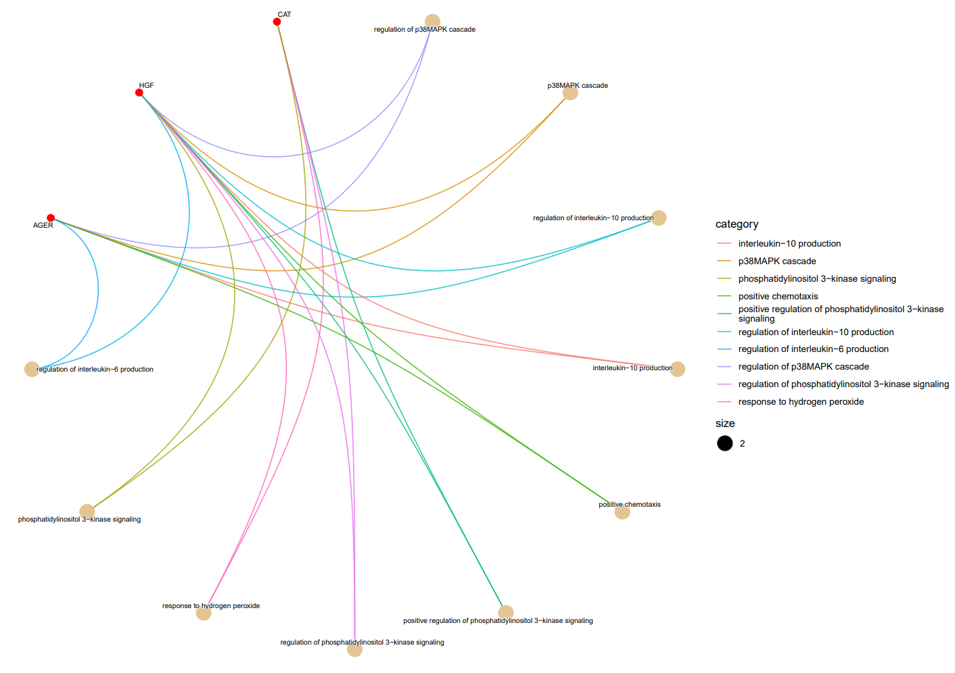
FIGURE 8. cnetplot representing top 10 significantly enriched biological process in the given set of diabetic associated gene.
VA is exclusively targeting 3 diabetes-associated genes, of which 3 genes, visualized in the graph above, are overrepresented in several biological processes. regulation of p38MAPK cascade process is enriched by 2 out of the 3 genes, p38MAPK cascade by 2 genes, regulation of interleukin-10 production by 2 genes, interleukin-10 production by 2 genes, positive chemotaxis by 2 genes, positive regulation of phosphatidylinositol 3-kinase signaling by 2 genes, regulation of phosphatidylinositol 3-kinase signaling by 2 genes, response to hydrogen peroxide by 2 genes, phosphatidylinositol 3-kinase signaling by 2 genes, and regulation of interleukin-6 production by 2 genes. These biological processes are the top 10 enriched processes in the given set of 3 genes.

10 Cellular components enriched by diabetic associated genes targeted by both NK and VA
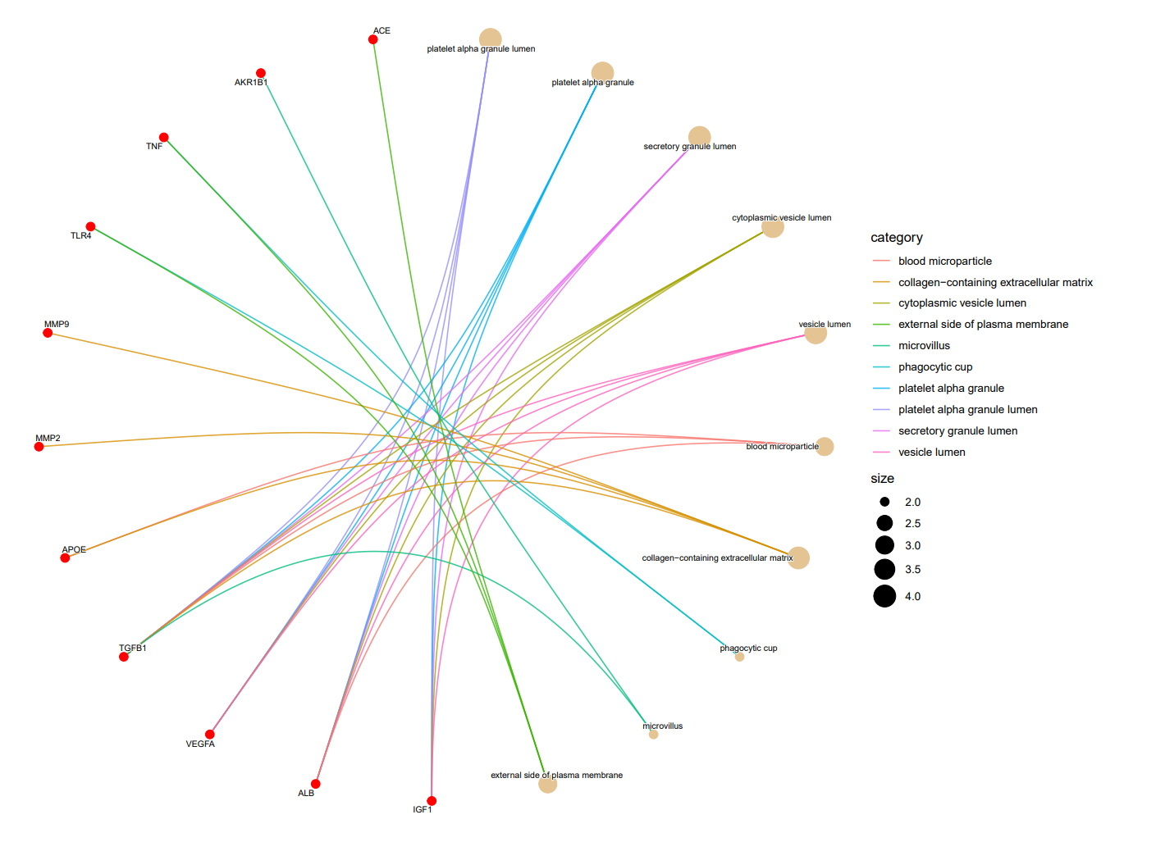
FIGURE 9. cnetplot representing top 10 significantly enriched cellular components in the given set of diabetic associated gene.

NK and VA target 13 diabetes-associated genes, of which 11 genes, visualized in the graph above, are overrepresented in several cellular components. platelet alpha granule lumen is enriched by 4 out of the 13 genes, platelet alpha granule by 4 genes, secretory granule lumen by 4 genes, cytoplasmic vesicle lumen by 4 genes, vesicle lumen by 4 genes, blood microparticle by 3 genes, collagen-containing extracellular matrix by 4 genes, phagocytic cup by 2 genes, microvillus by 2 genes, and external side of plasma membrane by 3 genes. These cellular components are the top 10 enriched components in the given set of 13 genes.

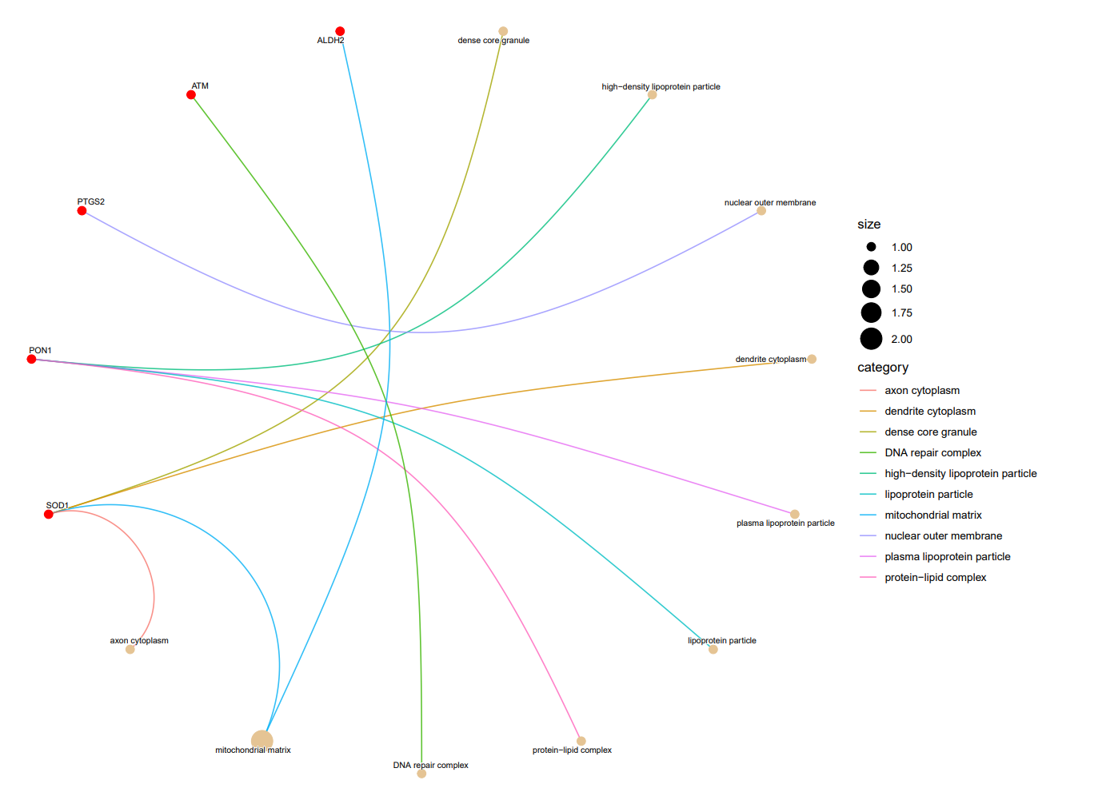
10 Cellular components enriched by diabetic associated genes exclusively targeted by NK

FIGURE 10. cnetplot representing top 10 significantly enriched cellular components in the given set of diabetic associated gene.
NK is exclusively targeting 10 diabetes-associated genes, of which 5 genes, visualized in the graph above, are overrepresented in several cellular components. dense core granule is enriched by 1 gene out of the10 gene, high-density lipoprotein particle by 1 gene, nuclear outer membrane by 1gene, dendrite cytoplasm by 1 gene, plasma lipoprotein particle by 1 gene, lipoprotein particle by 1gene, protein-lipid complex by 1gene, DNA repair complex by 1 gene, mitochondrial matrix by 2 genes, and axon cytoplasm by 1 gene. These cellular components are the top 10 enriched components in the given set of 10 genes.

10 Cellular components enriched by diabetic associated genes exclusively targeted by VA
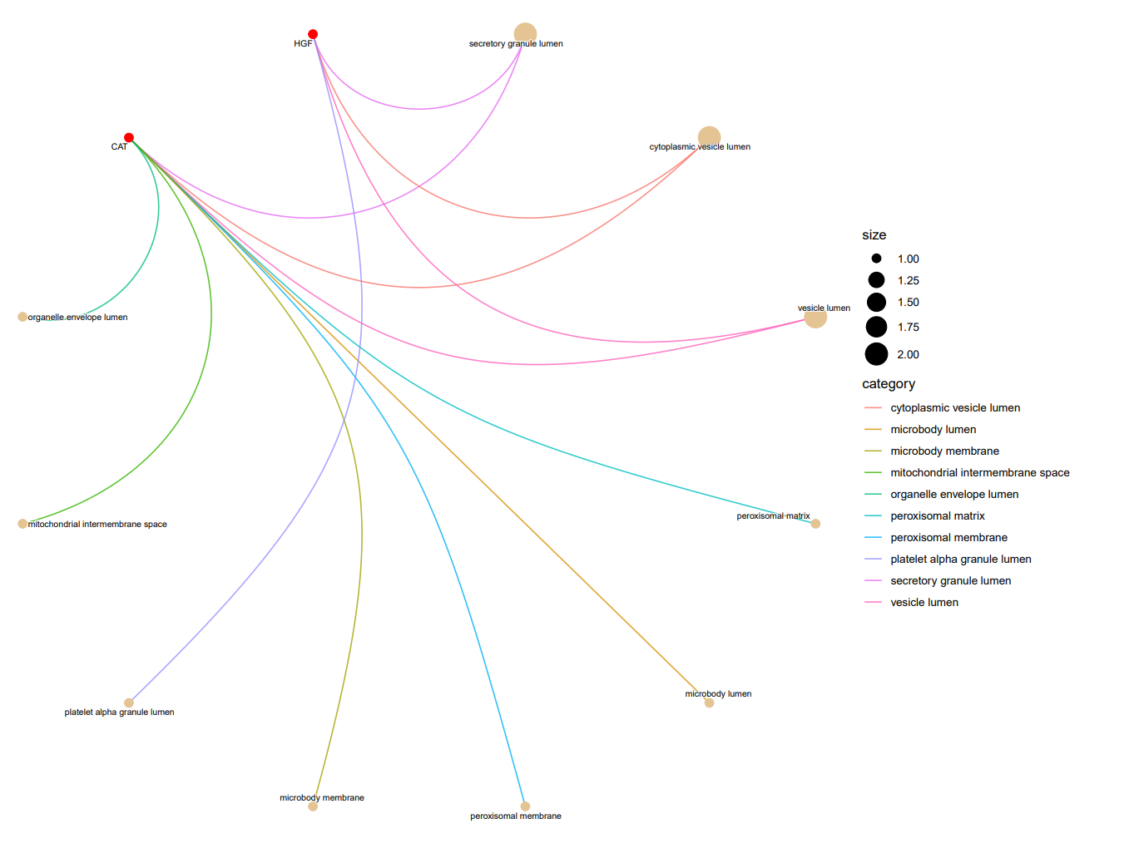
FIGURE 11. cnetplot representing top 10 significantly enriched cellular components in the given set of diabetic associated gene.
VA is exclusively targeting 3 diabetes-associated genes, of which 2 genes, visualized in the above graph, are overrepresented in several cellular components secretory granule lumen is enriched by 2 out of the 3 genes, cytoplasmic vesicle lumen by 2 genes, vesicle lumen by 2 genes, peroxisomal matrix by 1 gene, microbody lumen by 1 gene, peroxisomal membrane by 1gene, microbody membrane by 1 gene, platelet alpha granule lumen by 1 gene, mitochondrial intermembrane space by 1 gene, and organelle envelope lumen by 1gene. These cellular components are the top 10 enriched processes in the given set of 3 genes.

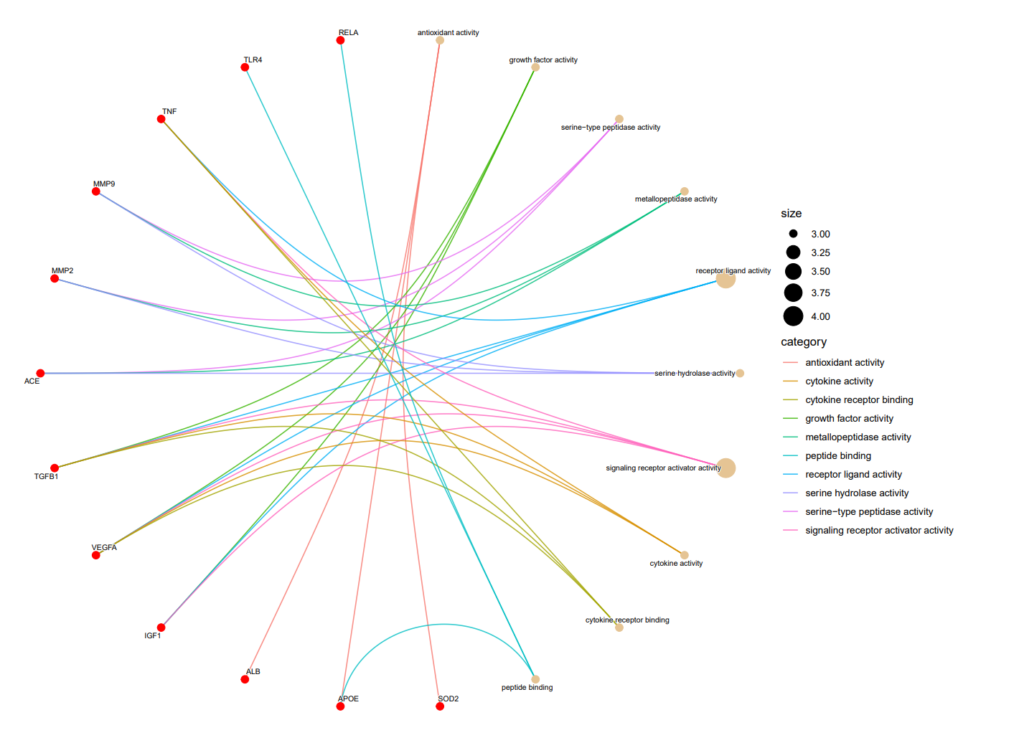
10 Molecular functions enriched by diabetic associated genes targeted by both NK and VA.

FIGURE 12. cnetplot representing top 10 significantly enriched molecular functions in the given set of diabetic associated gene.
NK and VA target 13 diabetes-associated genes, of which 12 genes, visualized in the above graph , are overrepresented in several molecular functions. antioxidant activity is enriched by 3 out of the 13 genes, growth factor activity by 3 genes, serine-type peptidase activity by 3 genes, metallopeptidase activity by 3 genes, receptor ligand activity by 4 genes, serine hydrolase activity by 3 genes, signaling receptor activator activity by 4 genes, cytokine activity by 3 genes, cytokine receptor binding by 3 genes, and peptide binding by 3 genes. These Molecular functions are the top 10 enriched functions in the given set of 13 genes.
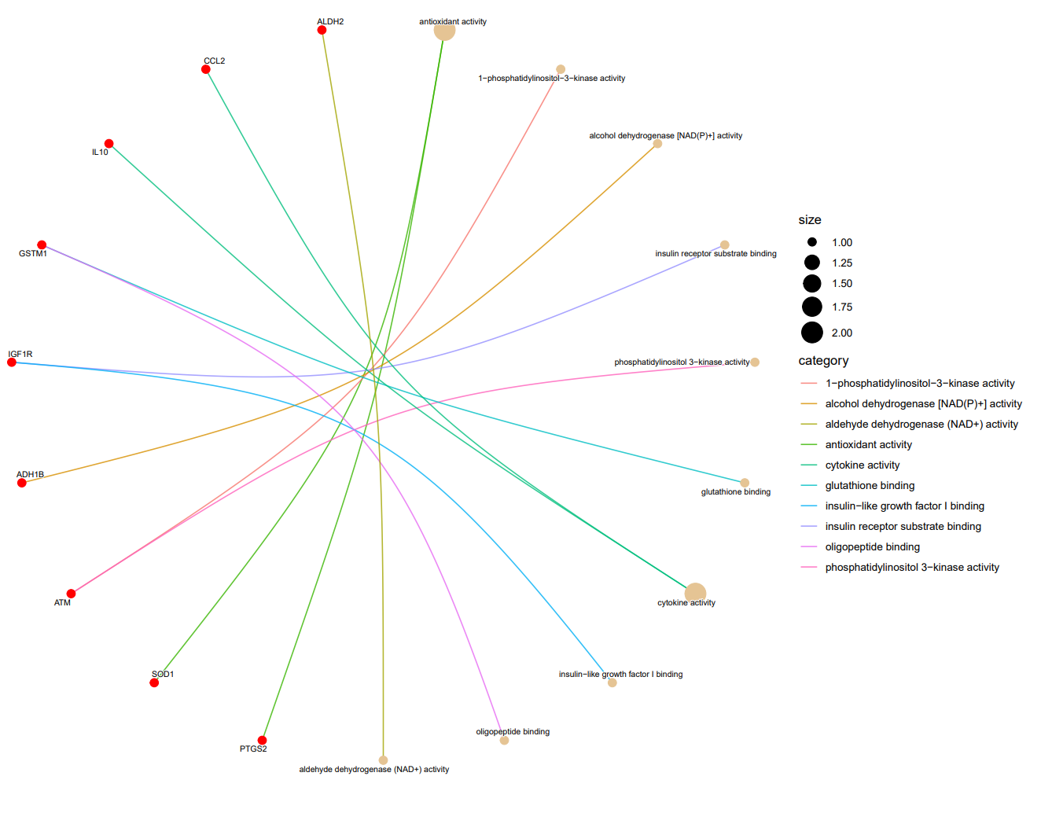
10 Molecular functions enriched by diabetic associated genes exclusively targeted by NK.

FIGURE 13. cnetplot representing top 10 significantly enriched molecular functions in the given set of diabetic associated gene.
NK is exclusively targeting 10 diabetes-associated genes, of which 9 genes, visualized in the graph above, are overrepresented in several molecular functions. antioxidant activity is enriched by 2 gene out of the10 gene, 1-phosphatidylinositol-3-kinase activity by 1 gene, alcohol dehydrogenase [NAD(P)+] activity by 1gene, insulin receptor substrate binding by 1 gene, phosphatidylinositol 3-kinase activity by 1 gene, glutathione binding by 1gene, cytokine activity by 2gene, insulin-like growth factor I binding by 1 gene, oligopeptide binding by 1 gene, and aldehyde dehydrogenase (NAD+) activity by 1 gene. These molecular functions are the top 10 enriched functions in the given set of 10 genes.
10 Molecular functions enriched by diabetic associated genes exclusively targeted by VA.
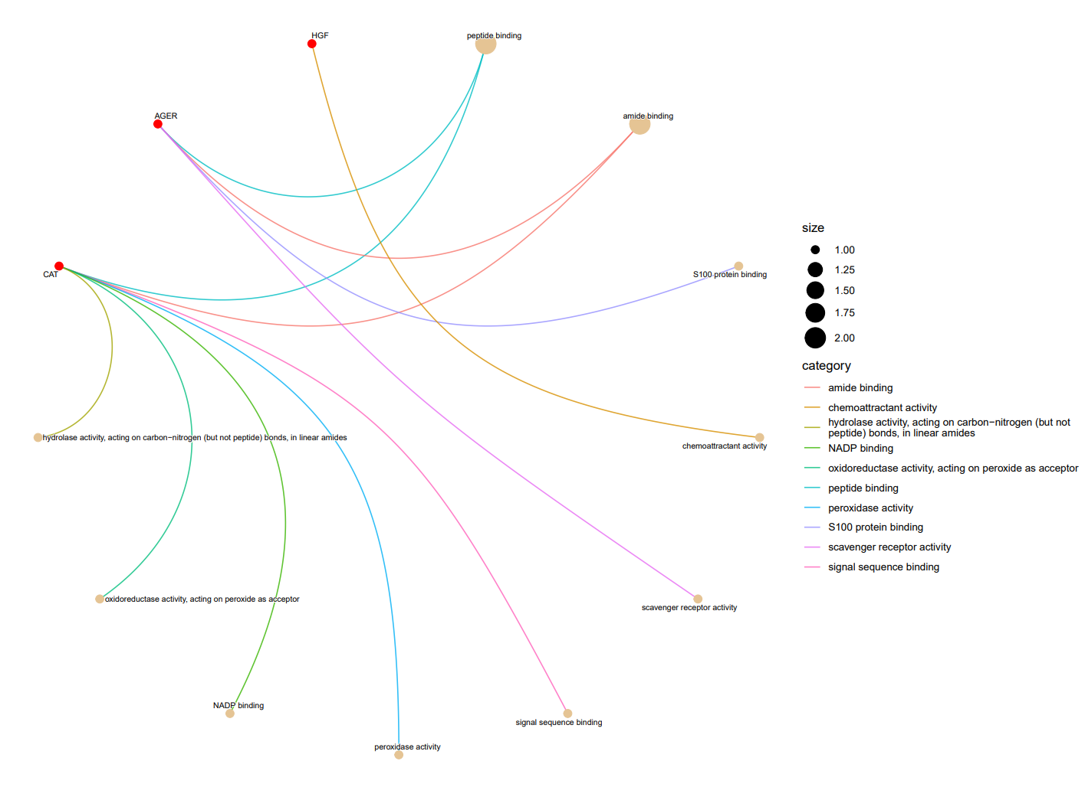

FIGURE 14. cnetplot representing top 10 significantly enriched molecular functions in the given set of diabetic associated gene.
VA is exclusively targeting 3 diabetes-associated genes, of which 3 genes, visualized in the above graph, are overrepresented inseveral molecular functions peptide binding is enriched by 2 out of the 3 genes, amide binding by 2 genes, S100 protein binding by 1 gene, chemoattractant activity by 1 gene, scavenger receptor activity by 1 gene, signal sequence binding by 1gene, peroxidase activity by 1 gene, NADP binding by 1 gene, oxidoreductase activity, acting on peroxide as acceptor by 1 gene, and hydrolase activity, acting on carbon-nitrogen (but not peptide) bonds, in linear amides by 1gene. These molecular functions are the top 10 enriched functions in the given set of 3 genes.

3.5 Gallic acid estimation in NK and VA
After averaging the absorbance values from triplicates of NK and VA and its controls, the difference between the average absorbance value of NK and its controls and VA and its control was calculated. Trend equation was applied to the different concentrations of standard,to the average values of absorbance, differenced value of NK and its control and same was done for VA and its control.

FIGURE 15. The average of trend value of three trials is considered as the concentration of gallic acid equivalents in the NK is determined to be 243.63µg/ml and in VA it is determined to be 275.83µg/ml.

The standard deviation of the trend values for NK and VA is calculated based on the average trend value from three trials of NK and VA .The standard deviation of the trend values for the NK is calculated as 14.02 µg/ml and for VA is 20.41µg/ml.

3.6 Lipase Inhibition by NK and VA

FIGURE 16. NK shows dose-dependent lipase inhibition, with the following percentages of inhibition (mean ± standard deviation): 96.9% ± 3.4% at 160 µg/GAE, 54.8% ± 11.4% at 80 µg/GAE, 38.7% ± 10.8% at 40 µg/GAE, 25.9% ± 14.7% at 20 µg/GAE, and 14.4% ± 18.6% at 10 µg/GAE

FIGURE 17. VA shows dose-dependent lipase inhibition, with the following percentages of inhibition (mean ± standard deviation): 98.7% ± 2.03% at 160 µg/GAE, 77.9% ± 7.95 % at 80 µg/GAE, 58.7% ± 3.8% at 40 µg/GAE, 40% ± 4.8% at 20 µg/GAE, and 26.7% ± 5.4% at 10 µg/GAE

Comparison of lipase inhibition percentages between NK and VA reveals that VA exhibits greater lipase inhibition than NK at the same concentrations, in a dose-dependent manner.(FIG16 and 17).

3.7 MTT Assay

STC-1 Cell viability on NK and VA (2hrs)
The percentage viability of the STC-1 cell line was determined at various concentrations (µg/ml) of NK and VA

FIGURE 18. The cells treated with NK for 2 hours showed the following viability percentages (mean ± standard deviation): 14.7% ± 5.9% at 8 µg/ml, 34.4% ± 30.1% at 4 µg/ml, 76.16% ± 31.9% at 2 µg/ml, 106.2% ± 19% at 1 µg/ml, 102.5% ± 10% at 0.5 µg/ml, 107.5% ± 15.7% at 0.25 µg/ml, and 94.3% ± 5.27% at 0.125 µg/ml.
The cells treated with VA for 2 hours showed the following viability percentages (mean ± standard deviation): 14.03% ± 7.2% at 8 µg/ml, 11.9% ± 4.4% at 4 µg/ml, 38.8% ± 30.9% at 2 µg/ml, 98.5% ± 24.7% at 1 µg/ml, 112.6% ± 19% at 0.5 µg/ml, 113.9% ± 15.4% at 0.25 µg/ml, and 107.8% ± 7.5% at 0.125 µg/ml.

At concentrations of 8 µg/GAE, 4 µg/GAE, and 2 µg/GAE, both NK and VA are toxic to the STC-1 cell line. From 1 µg/GAE to 0.125 µg/GAE, the cells remain viable.

CaCo-2 cell viability on co-treatment of PA & NK

FIGURE 19.The cells treated with 1 mM PA for 24 hours, followed by treatment with NK for the next 24 hours at different concentrations, showed the following viability percentages (mean ± standard deviation): 76.9% ± 2.9% with 1 mM PA alone, 83.1% ± 6.1% with 1 µg/ml NK, 77% ± 5% with 0.5 µg/ml NK, and 80.1% ± 7.6% with 0.25 µg/ml NK.

CaCo-2 cell viability on co-treatment of PA & VA

FIGURE 20. The cells treated with 1 mM PA for 24 hours, followed by treatment with VA for the next 24 hours at different concentrations, showed the following viability percentages (mean ± standard deviation): 81.5%±12.5% with 1 mM PA alone, 87.4%±17.2% with 1 µg/ml VA, 88%±17.8% with 0.5 µg/ml VA, and 94.5%±17.5% with 0.25 µg/ml VA.

Upon treatment with 1 mM palmitate, cell viability decreases compared to the control. However, cell viability improves with NK and VA treatment. Notably, 1 µg/GAE of NK shows higher viability than other NK concentrations, while 0.25 µg/GAE of VA shows higher viability than other VA concentrations (FIG 20 & 21).

3.8 DPP4 Estimation from CaCo2 Cell Line

FIGURE 21. Treatment of CaCo2 cells with NK and VA formulations resulted in a dose-dependent decrease in DPP4 secretion. Specifically, NK at 1 µg/mL showed 84.9% DPP4 secretion, while higher concentrations of 2 µg/mL and 4 µg/mL resulted in 55% and 54.8% secretion, respectively. Similarly, VA at 1 µg/mL showed 61.4% DPP4 secretion, and higher concentrations of 2 µg/mL and 4 µg/mL resulted in 49.4% and 53% secretion, respectively. Sitagliptin, used as a positive control, showed a significant reduction in DPP4 secretion to 33%. The untreated control cells exhibited 100% DPP4 secretion.

4. Discussion
The comparative analysis of the reported bioactives from NK and VA formulations reveals 15 similar classes of compounds in both formulations. NK exhibits 8 unique classes of compounds, while VA shows 16 unique classes. The common classes of compounds include benzene and substituted derivatives, phenols, organo-oxygen compounds, tannins, prenol lipids, flavonoids, pteridines and derivatives, cinnamic acids and derivatives, fatty acyls, steroids and steroid derivatives, indoles and derivatives, coumarins and derivatives, indolophthalamidine alkaloids, dihydrofurans, and anthracenes. NK's unique 8 classes of compounds are imidazopyrimidines, diarylheptanoids, unsaturated hydrocarbons, strychnous alkaloids, phenylpropanoids, organic oxides, harmala alkaloids, and organic sulfuric acids. VA's unique 16 classes of compounds are quinolines and derivatives, azoles, naphthalenes, phenanthrenes, azorphines, benzothiazoles, linear 1,3-diarylheptanoids, carboxylic acids and derivatives, organonitrogen compounds, amino acids, peptides and analogues, pyridines and derivatives, indenes and isoindenes, saturated hydrocarbons, alkyl halides, epoxides, and non-metal oxanionic compounds. This analysis provides specific insights into the management of T2DM.
Further investigation into which phytochemicals in NK and VA formulations target the aforementioned genes may offer customized medications for specific conditions of T2DM. Among the 13 diabetes-associated genes, some are targeted by similar phytochemicals from both NK and VA. Notably, ferulic acid, ellagic acid, gallic acid, kaempferol 3-O-beta-D-galactoside, and moupinamide from both formulations target the MMP2 gene. Quercetin from both formulations targets TNF-alpha. Ascorbic acid and glucose from both NK and VA target SOD2. Stearic acid from both NK and VA targets APOE. Betulinic acid, stearic acid, and oleic acid target ALB, while sucrose and vanillin target VEGFA. Arabinose, ellagic acid, kaempferol, quercetin, rutin, typhaneoside, and chrysin target AKR1B1. Chrysin targets RELA. Ferulic acid, kaempferol-3-O-beta-D-galactoside, gallic acid, moupinamide, narcissin, quercetin, rutin, and typhaneoside target MMP9. Of the 13 genes, similar phytochemicals from both formulations were identified for 9 genes according to the analysis.
In diabetic individuals, TNF-α is involved in apoptosis, differentiation, and cell recruitment. Through TNFR-1, TNF-α activates and recruits immune cells to propagate inflammation and activates transcriptional pathways that induce oxidative stress. This stress interacts with inflammation to promote cellular degeneration. TNF-α is critical in the pathogenesis of insulin resistance and glucose abnormalities linked to T2DM. It causes serine phosphorylation of IRS-1, which hampers the activity of the insulin receptor and the subsequent PI3K signaling pathway . TNF-α also reduces the expression of glucose transporter type 4 (GLUT4), primarily located in adipocytes, skeletal muscle, and cardiac muscle(Akash et al., 2018). In diabetic individuals, TNF-α mRNA and protein levels increase in adipose tissues, impairing insulin sensitivity by downregulating IRS-1, GLUT4, CEBP-PPAR, perilipin, and Acrp30. It decreases fatty acid oxidation and increases plasma free fatty acid levels, contributing to tissue-specific inflammation and the pathogenesis of T2DM (Cao et al., 2023).
It has been identified that two single-nucleotide polymorphisms in the promoter region of the MMP-2 gene that may be linked to an increased risk of T2DM (Gajewska & Śliwińska-Mossoń, 2022).These are zinc-dependent endopeptidases crucial for tissue remodeling and extracellular matrix (ECM) degradation(Verma & Hansch, 2007). Insulin influences MMP regulation differently depending on the organ. Free fatty acids and insulin stimulate the activation of MMP-2 by promoting the production of pro-inflammatory cytokines. Conversely, in the liver, hyperinsulinemia leads to a reduction in the levels of MMP-2(Berg & Miksztowicz, 2015). In diabetic nephropathy, the altered expression of MMPs contributes to ECM deposition and glomerular hypertrophy, which can result in proteinuria and renal insufficiency. An excess of MMPs may also play a role in poor wound healing (Tsioufis et al., 2012).
A significant rise in urinary ACE levels in type II DM patients with nephropathy, compared to those without complications or with only mild complications, suggesting a direct link between elevated ACE activity and nephropathy(Cheng et al., 2019).
Under hyperglycemia, AKR1B1 activity is stimulated and can increase up to 33% in tissues that exhibit insulin-independent glucose uptake. This heightened glucose metabolism through the polyol pathway leads to various cellular stress conditions, underlying chronic diabetic complications(Han et al., 2020). AKR1B1 has been identified as a major mediator of inflammation, playing a key role in the generation and propagation of ROS-induced inflammation. Both AKR1B1 and ROS are crucial intervention targets for managing diabetic complications(Franko et al., 2020).
RELA encodes the p65 subunit of the regulatory transcriptome responsible for cytokine (TNFα and IL6) and chemokine production. TNFα and IL6 are key proinflammatory cytokines involved in the development of insulin resistance (IR) and type 2 diabetes (T2DM). Increased levels of TNFα in patients with IR and T2DM are believed to disrupt the downstream insulin signaling pathway, diminishing insulin's effectiveness. Elevated expression of RELA (p65) subunits of NF-κB has been observed in conditions of hyperglycemia and in the presence of advanced glycation end products, which activate NF-κB and trigger an inflammatory response(Mehndiratta et al., 2024).
Hyperglycemic conditions enhance the expression and activity of MMP-9 genes in endothelial cells and macrophages. MMPs are proteolytic enzymes linked to proinflammatory environments diabetes, and can be activated by reactive nitrogen species(Rastgoo Haghi et al., 2021). The increased activity of MMP-9 in vascular endothelial cells under hyperglycemia is partly due to the elevated transcription of MMP-9 through a redox-sensitive mechanism(Uemura et al., 2001).
Inflammation reduces insulin sensitivity in part by activating the Toll-Like Receptor (TLR) family of pattern recognition receptors, with TLR4 playing a significant role in insulin resistance. TLR4, a cell surface receptor, initiates innate immune responses to pathogens by inducing signalling cascades that activate kinases and transcription factors. These cascades result in the production of pro-inflammatory cytokines, chemokines, eicosanoids, and reactive oxygen species (ROS), key effectors of innate immunity. TLR4 is expressed in various insulin target tissues, including the liver, adipose tissue, skeletal muscle, vasculature, pancreatic β cells, and brain. Consequently, TLR4 activation can impair insulin action directly by activating pro-inflammatory kinases and ROS, and indirectly by triggering cytokine signaling cascades and the systemic release of insulin-desensitizing, pro-inflammatory factors(Kim & Sears, 2010).
IGF-1 is crucial for maintaining normal insulin sensitivity; a deficiency in IGF-1 synthesis can lead to insulin resistance.In biological fluids, IGFs are accompanied by IGFBPs, which play a significant role in regulating the biological activity and metabolic signaling pathways of IGFs.. The liver's production of IGF-1 influences the reduction of IGF-1 levels, which in turn increases insulin levels in the blood, causing elevated blood glucose levels and insulin resistance. According to the National Health and Nutrition Examination Survey III, individuals with low serum IGF-1 levels face a higher risk of insulin resistance, metabolic syndrome, and T2DM . Additionally, low IGF-1 levels have been shown to predict glucose intolerance in T2DM (Biadgo et al., 2020).
Overexpression of SOD2 ,is aimed at combating oxidative stress, reducing ROS, and enhancing antioxidant defense. A higher level of extracellular-SOD led to a six-fold increase in the total its activity in the islets, preventing superoxide radicals secreted into the extracellular space from contributing to β-cell destruction. Elevated SOD2 levels have been shown to alleviate oxidative stress, reduce mitochondrial cytochrome C release, and decrease apoptosis. Increased oxidative stress and a reduction in antioxidant capacity are associated with complications in , such as oxidative DNA damage and insulin resistance. A decline in the plasma's antioxidant potential of SOD2 contributes to the complications of diabetes.
Insulin resistance is linked to metabolic dyslipidemia, and the role of apoE isoforms in lipid metabolism may be crucial in the development of T2DM . Previous studies have shown that serum apoE levels are elevated in individuals with T2DM .Additionally, serum apoE levels have been independently associated with urinary albumin excretion in T2DM patients. These levels are significantly higher in patients with both albuminuria and T2DM compared to those with only T2DM , suggesting a connection between apoE and T2DM along with its complications(Zhang et al., 2017).
Low circulating albumin serves as an indicator of inflammation, Albumin is a negative acute-phase reactant, with lower levels suggesting greater inflammatory activity. Consequently, reduced circulating albumin might be associated with a heightened risk of T2DM. Indeed, individuals with T2DM have lower circulating albumin levels compared to those without the condition. The current study shows that lower albumin is linked to higher glucose concentrations and an increased risk of developing T2DM, suggesting a potential mechanism that affects albumin levels and contributes to T2DM pathogenesis. Glycated albumin has an impaired ability to bind various ligands and serves as a precursor to advanced glycation end-products, which contribute to oxidative stress and inflammation(Chang et al., 2019).
Activation of VEGF receptor 2 (VEGFR2) by VEGF-A at the onset of a high-fat diet exacerbates metabolic alterations in mice. Overexpression of VEGF-A in β-cells leads to disorganized, hypervascularized, and fibrotic islets, along with progressive macrophage infiltration and proinflammatory cytokine production. This results in impaired insulin secretion, reduced β-cell mass, and age-related hyperglycemia. Conversely, VEGF-A production appears to be decreased in the cells of patients with Type 2 diabetes(Elias et al., 2013).TGF-β signaling plays various roles in the development, proliferation, apoptosis, dedifferentiation, and function of islet cells. In cases of metabolic syndrome and diabetes, TGF-β signaling becomes systemically activated, with elevated serum levels of TGF-β1 observed in both patients with obesity and diabetic animal models.In high glucose conditions , TGF-β1 inhibit the replication of cells stimulated by the high glucose levels(Wang et al., 2022).These are the fate of genes in diabetic condition, the above mentioned genes are targeted by both NK and VA connecting the above mentioned role of genes with action of each classes of compounds may give us future insights in mangement of T2DM.

5. Conclusion
This study provides a comprehensive comparative analysis of NK and VA formulations, focusing on their phytochemical composition and their potential therapeutic targets in the context of T2DM.
Comparing both formulations revealed 15 similar classes of compounds, with VA containing 16 unique classes and NK having 8 unique classes. The presence of similar phytochemicals in both formulations suggests they may exhibit comparable effects, though further experimental validation is needed. Each formulation’s distinct distribution of bioactives likely contributes to their different biological effects, warranting additional validation to confirm these analytical predictions.
The present analysis revealed that NK and VA share phytochemicals targeting 13 common diabetic-associated genes, with NK uniquely targeting an additional 10 genes and VA targeting 3 genes exclusively. Gene ontology and enrichment analysis further highlighted the biological significance of these targets.
Functional assays demonstrated the impact of NK and VA on cell viability. In STC-1 cells, both formulations showed similar efficacy, while in CaCo2 cells treated with palmitate, both NK and VA improved viability, suggesting protective effects against lipotoxicity. Additionally, the lipase inhibition assay indicated distinct effects of NK and VA on lipase activity, potentially contributing to their differential metabolic impacts.
Overall, this study underscores the therapeutic potential of NK and VA formulations in modulating key genetic and cellular pathways in T2DM, offering insights into their mechanisms of action and guiding future research for optimizing their clinical application

6.References

1. Gerstein, H. C., Hamilton, Miller, M. E., Byington, R. P., David C. Goff, & Winston-Salem. (2008). Effects of Intensive Glucose Lowering in Type 2 Diabetes. New England Journal of Medicine, 358(24), 2545–2559. https://doi.org/10.1056/NEJMoa0802743
2.Acharya, N., Acharya, S., Shah, U., Shah, R., & Hingorani, L. (2016). A comprehensive analysis on Symplocos racemosa Roxb.: Traditional uses, botany, phytochemistry and pharmacological activities. Journal of Ethnopharmacology, 181, 236–251. https://doi.org/10.1016/j.jep.2016.01.043
3.Agada, R., Lydia2, D. E., & Khusro3, A. (2022). Studies on antioxidant, anti-diabetic and GC-MS analyses of methanol extract of Aristolochia bracteolata root bark. https://doi.org/doi.org/10.36721/PJPS.2022.35.5.REG.1287-1294.1
4.Akash, M. S. H., Rehman, K., & Liaqat, A. (2018). Tumor Necrosis Factor‐Alpha: Role in Development of Insulin Resistance and Pathogenesis of Type 2 Diabetes Mellitus. Journal of Cellular Biochemistry, 119(1), 105–110. https://doi.org/10.1002/jcb.26174
5.Babu Sajja, R., & Bhaskari D, S. (2015). EVALUATION OF ANTI-DIABETIC ACTIVITY OF ETHANOLIC EXTRACT OF DESMOSTACHYA BIPINNATA ON ALLOXAN INDUCED DIABETES IN RATS. Volume 4, Issue 06, 902-911.
6. Badole, S. L., Subhash, & Bodhankar, L. (2008). Antihyperglycemic Activity of Pongamia pinnata Stem Bark in Diabetic Mice. Pharmaceutical Biology, 46(12), 900–905. https://doi.org/10.1080/13880200802370381
7.Berg, G., & Miksztowicz, V. (2015). Metalloproteinases in the pathogenesis and progression of metabolic syndrome: Potential targets for improved outcomes. Metalloproteinases In Medicine, 51. https://doi.org/10.2147/MNM.S88993
8. Bhishagratna, K. L. (1907). Sushrutha samhitha sutrasthanam.
9. Biadgo, B., Tamir, W., & Ambachew, S. (2020). Insulin-like Growth Factor and its Therapeutic Potential for Diabetes Complications Mechanisms and Metabolic Links: A Review. Review of Diabetic Studies, 16(1), 24–34. https://doi.org/10.1900/RDS.2020.16.24
10. Cao, R., Tian, H., Zhang, Y., Liu, G., Xu, H., Rao, G., Tian, Y., & Fu, X. (2023). Signaling pathways and intervention for therapy of type 2 diabetes mellitus. MedComm, 4(3), e283. https://doi.org/10.1002/mco2.283
11. Chang, D. C., Xu, X., Ferrante, A. W., & Krakoff, J. (2019). Reduced plasma albumin predicts type 2 diabetes and is associated with greater adipose tissue macrophage content and activation. Diabetology & Metabolic Syndrome, 11(1), 14. https://doi.org/10.1186/s13098-019-0409-y
12. Chao, C., Mong, M., Chan, K., & Yin, M. (2010). Anti‐glycative and anti‐inflammatory effects of caffeic acid and ellagic acid in kidney of diabetic mice. Molecular Nutrition & Food Research, 54(3), 388–395. https://doi.org/10.1002/mnfr.200900087
13. Chatterjee, S., Khunti, K., & Davies, M. J. (2017). Type 2 diabetes. The Lancet, 389(10085), 2239–2251. https://doi.org/10.1016/S0140-6736(17)30058-2
14. Cheng, G., Qin, X., Gorret, A. M., Deo, K., An, C., Liu, J., & Gilbert, A. (2019). A review of urinary angiotensin converting enzyme 2 in diabetes and diabetic nephropathy. Biochemia Medica, 29(1), 28–38. https://doi.org/10.11613/BM.2019.010501
15. Cheon, H., & Cho, Y. (2014). Protection of palmitic acid-mediated lipotoxicity by arachidonic acid via channeling of palmitic acid into triglycerides in C2C12. Journal of Biomedical Science, 21(1), 13. https://doi.org/10.1186/1423-0127-21-13
16. Dali-Youcef, N., Mecili, M., Ricci, R., & Andrès, E. (2013). Metabolic inflammation: Connecting obesity and insulin resistance. Annals of Medicine, 45(3), 242–253. https://doi.org/10.3109/07853890.2012.705015
17. Dash, G. K., Patro, Ch. P., & Maiti, A. K. (2005). A study on the anti-hyperglycaemic effect of Premna corymbosa Rottl. Roots. Vol 5/1.
18. Djoumbou Feunang, Y., Eisner, R., Knox, C., Chepelev, L., Hastings, J., Owen, G., Fahy, E., Steinbeck, C., Subramanian, S., Bolton, E., Greiner, R., & Wishart, D. S. (2016). ClassyFire: Automated chemical classification with a comprehensive, computable taxonomy. Journal of Cheminformatics, 8(1), 61. https://doi.org/10.1186/s13321-016-0174-y
19. Elias, I., Franckhauser, S., & Bosch, F. (2013). New insights into adipose tissue VEGF-A actions in the control of obesity and insulin resistance. Adipocyte, 2(2), 109–112. https://doi.org/10.4161/adip.22880
20. Fatoumata, Ba., MamadouSaïdou, Bah., Mohamet, S., Joseph, K. S., Modou, M. G., & El, H. B. (2020). Antidiabetic properties of Moringa oleifera: A review of the literature. Journal of Diabetes and Endocrinology, 11(1), 18–29. https://doi.org/10.5897/JDE2019.0136
21. Feingold, K. R., Memon, R. A., Moser, A. H., & Grunfeld, C. (1998). Paraoxonase activity in the serum and hepatic mRNA levels decrease during the acute phase response. Atherosclerosis, 139(2), 307–315. https://doi.org/10.1016/S0021-9150(98)00084-7
22. Filippello, A., Di Mauro, S., Scamporrino, A., Torrisi, S. A., Leggio, G. M., Di Pino, A., Scicali, R., Di Marco, M., Malaguarnera, R., Purrello, F., & Piro, S. (2022). Molecular Effects of Chronic Exposure to Palmitate in Intestinal Organoids: A New Model to Study Obesity and Diabetes. International Journal of Molecular Sciences, 23(14), 7751. https://doi.org/10.3390/ijms23147751
23. Franko, A., Berti, L., Hennenlotter, J., Rausch, S., Scharpf, M. O., De Angelis, M. H., Stenzl, A., Birkenfeld, A. L., Peter, A., Lutz, S. Z., Häring, H.-U., & Heni, M. (2020). Transcript Levels of Aldo-Keto 24. Reductase Family 1 Subfamily C (AKR1C) Are Increased in Prostate Tissue of Patients with Type 2 Diabetes. Journal of Personalized Medicine, 10(3), 124. https://doi.org/10.3390/jpm10030124
25. Gajewska, B., & Śliwińska-Mossoń, M. (2022). Association of MMP-2 and MMP-9 Polymorphisms with Diabetes and Pathogenesis of Diabetic Complications. International Journal of Molecular Sciences, 23(18), 10571. https://doi.org/10.3390/ijms231810571
26. Ganesan, K., & Xu, B. (2017). A Critical Review on Polyphenols and Health Benefits of Black Soybeans. Nutrients, 9(5), 455. https://doi.org/10.3390/nu9050455
27. 2Ganie, S. A., & Yadav, S. S. (2014). Holoptelea integrifolia (Roxb.) Planch: A Review of Its Ethnobotany, Pharmacology, and Phytochemistry. BioMed Research International, 2014, 1–12. https://doi.org/10.1155/2014/401213
28. Gao, D., Nong, S., Huang, X., Lu, Y., Zhao, H., Lin, Y., Man, Y., Wang, S., Yang, J., & Li, J. (2010). The Effects of Palmitate on Hepatic Insulin Resistance Are Mediated by NADPH Oxidase 3-derived Reactive Oxygen Species through JNK and p38MAPK Pathways. Journal of Biological Chemistry, 285(39), 29965–29973. https://doi.org/10.1074/jbc.M110.128694
29. Giacco, F., & Brownlee, M. (2010). Oxidative Stress and Diabetic Complications. Circulation Research, 107(9), 1058–1070. https://doi.org/10.1161/CIRCRESAHA.110.223545
30. Glenske, K., Schäpe, K., Wieck, A., Failing, K., Werner, J., Rohnke, M., Wenisch, S., & Mazurek, S. (2020). Effect of long term palmitate treatment on osteogenic differentiation of human mesenchymal stromal cells—Impact of albumin. Bone Reports, 13, 100707. https://doi.org/10.1016/j.bonr.2020.100707
31. Graciano, M. F., Valle, M., Kowluru, A., Curi, R., & Carpinelli, A. (2011). Regulation of insulin secretion and reactive oxygen species production by free fatty acids in pancreatic islets. Islets, 3(5), 213–223. https://doi.org/10.4161/isl.3.5.15935
32. Han, Z., Qi, G., Zhu, J., Zhang, Y., Xu, Y., Yan, K., Zhu, C., & Hao, X. (2020). Novel 3,4-dihydroquinolin-2(1H)-one derivatives as dual inhibitor targeting AKR1B1/ROS for treatment of diabetic complications: Design, synthesis and biological evaluation. Bioorganic Chemistry, 105, 104428. https://doi.org/10.1016/j.bioorg.2020.104428
33. Hannan, J. M. A., Ali, L., Khaleque, J., Akhter, M., Flatt, P. R., & Abdel-Wahab, Y. H. A. (2012). Antihyperglycaemic activity of Asparagus racemosus roots is partly mediated by inhibition of carbohydrate digestion and absorption, and enhancement of cellular insulin action. British Journal of Nutrition, 107(9), 1316–1323. https://doi.org/10.1017/S0007114511004284
34. Hu, F. B., Manson, J. E., Stampfer, M. J., Colditz, G., Liu, S., Solomon, C. G., & Willett, W. C. (2001). Diet, Lifestyle, and the Risk of Type 2 Diabetes Mellitus in Women. New England Journal of Medicine, 345(11), 790–797. https://doi.org/10.1056/NEJMoa010492
35. Huang, E. S., Brown, S. E. S., Ewigman, B. G., Foley, E. C., & Meltzer, D. O. (2007). Patient Perceptions of Quality of Life With Diabetes-Related Complications and Treatments. Diabetes Care, 30(10), 2478–2483. https://doi.org/10.2337/dc07-0499
36. Hummasti, S., & Hotamisligil, G. S. (2010). Endoplasmic Reticulum Stress and Inflammation in Obesity and Diabetes. Circulation Research, 107(5), 579–591. https://doi.org/10.1161/CIRCRESAHA.110.225698
37. Im, R., Mano, H., Matsuura, T., Nakatani, S., Shimizu, J., & Wada, M. (2009). Mechanisms of blood glucose-lowering effect of aqueous extract from stems of Kothala himbutu (Salacia reticulata) in the mouse. Journal of Ethnopharmacology, 121(2), 234–240. https://doi.org/10.1016/j.jep.2008.10.026
38. Johar Iquba, Dr. R. T., & Murlidhar Joglekar, Dr. P. (2020). PARANTHI (IXORA COCCINEA) A REVIEW. World Journal of Pharmacy and Pharmaceutical Sciences, Vol 9, Issue 3, 2020. https://doi.org/10.20959/wjpps20203-Kim, J. J., & Sears, D. D. (2010). TLR4 and Insulin Resistance. Gastroenterology Research and Practice, 2010, 1–11. https://doi.org/10.1155/2010/212563
39. Koren-Gluzer, M., Aviram, M., & Hayek, T. (2013). Paraoxonase1 (PON1) reduces insulin resistance in mice fed a high-fat diet, and promotes GLUT4 overexpression in myocytes, via the IRS-1/Akt pathway. Atherosclerosis, 229(1), 71–78. https://doi.org/10.1016/j.atherosclerosis.2013.03.028
40. Kothai, R., Arul, B., Kumar, K. S., & Christina, A. J. M. (2005). Hypoglycemic and Antihyperglycemic Effect of Semecarpus anacardium Linn in Normal and Alloxan-Induced Diabetic Rats. Journal of Herbal Pharmacotherapy, 5(2), 49–56. https://doi.org/10.1080/J157v05n02_05
41. krishnan, K. V., & pillai, S. gopala. (n.d.). Sahasrayogam sujana priya vyakya.
42. Lea, T. (2015). Caco-2 Cell Line. In K. Verhoeckx, P. Cotter, I. López-Expósito, C. Kleiveland, T. Lea, A. Mackie, T. Requena, D. Swiatecka, & H. Wichers (Eds.), The Impact of Food Bioactives on Health (pp. 103–111). Springer International Publishing. https://doi.org/10.1007/978-3-319-16104-4_10
43. Lei, M., Wang, L., Olatunde, O. O., Singh, S., Ovatlarnporn, C., Basit, A., & Olatunji, O. J. (2023). UPLC–ESI–QTOF–MS profiling, antioxidant, antidiabetic, antibacterial, anti-inflammatory, antiproliferative activities and in silico molecular docking analysis of Barleria strigosa. Chemical and Biological Technologies in Agriculture, 10(1), 73. https://doi.org/10.1186/s40538-023-00451-2
44. Loganayaki, N., & Manian, S. (2012). Evaluation of Indian sacred tree Crataeva magna (Lour.) DC. for antioxidant activity and inhibition of key enzymes relevant to hyperglycemia. Journal of Bioscience and Bioengineering, 113(3), 378–380. https://doi.org/10.1016/j.jbiosc.2011.10.020
45. M C Sabu, & Ramadasan Kuttan. (2004). Antidiabetic activity of Aegle marmelos and its relationship with its antioxidant properties.
46. Madsen, L., Petersen, R. K., & Kristiansen, K. (2005). Regulation of adipocyte differentiation and function by polyunsaturated fatty acids. Biochimica et Biophysica Acta (BBA) - Molecular Basis of Disease, 1740(2), 266–286. https://doi.org/10.1016/j.bbadis.2005.03.001
47. Marsha J. Daniel,. (2011). Lipid Management in Patients with Type 2 Diabetes. page 321.
48. Meena, A. K., Bansal, P., & Kumar, S. (2009). Plants-herbal wealth as a potential source of ayurvedic drugs. http://asianjtm.syphu.edu.cn/EN/ http://asianjtm.syphu.edu.cn/EN/Y2009/V4/I4/152
49. Mehndiratta, M., Almeida, E. A., Chawla, D., Madhu, S. V., Garg, S., & Kar, R. (2024). Higher oxidative stress and inflammation in obese compared to lean patients with type 2 diabetes mellitus. Aspects of Molecular Medicine, 3, 100042. https://doi.org/10.1016/j.amolm.2024.100042
50. Mohankumar, S., & McFarlane, J. R. (2011). An aqueous extract of Curcuma longa (turmeric) rhizomes stimulates insulin release and mimics insulin action on tissues involved in glucose homeostasis in vitro. Phytotherapy Research, 25(3), 396–401. https://doi.org/10.1002/ptr.3275
51.Muhammad, H., Qasim, M., Ikram, A., Versiani, M. A., Tahiri, I. A., Yasmeen, K., Abbasi, M. W., Azeem, M., Ali, S. T., & Gul, B. (2020). Antioxidant and antimicrobial activities of Ixora coccinea root and quantification of phenolic compounds using HPLC. South African Journal of Botany, 135, 71–79. https://doi.org/10.1016/j.sajb.2020.08.012
52. Nagao, T., Komine, Y., Soga, S., Meguro, S., Hase, T., Tanaka, Y., & Tokimitsu, I. (2005). Ingestion of a tea rich in catechins leads to a reduction in body fat and malondialdehyde-modified LDL in men. The American Journal of Clinical Nutrition, 81(1), 122–129. https://doi.org/10.1093/ajcn/81.1.122
53. Nayak, A. (2023). Evaluation of Antidiabetic and Lipid-Lowering Effect of Marsdenia tenacissima and Sphaeranthus indicus. Journal of Pharmacology and Toxicology, 18(1), 10–16. https://doi.org/10.3923/jpt.2023.10.16
54. Om Parkash Sharma & Shalu Sharma. (2022). A Critical Review of Amalaki- (Emblica Officinalis Gaertn.) in Classical Texts and Promote its Use in Our Life. International Journal of Ayurveda and Pharma Research, 91–98. https://doi.org/10.47070/ijapr.v10i7.2412
55. Palomer, X., Pizarro-Delgado, J., Barroso, E., & Vázquez-Carrera, M. (2018). Palmitic and Oleic Acid: The Yin and Yang of Fatty Acids in Type 2 Diabetes Mellitus. Trends in Endocrinology & Metabolism, 29(3), 178–190. https://doi.org/10.1016/j.tem.2017.11.009
56. Pandey, A., Tripathi, P., Pandey, R., Srivatava, R., & Goswami, S. (2011). Alternative therapies useful in the management of diabetes: A systematic review. Journal of Pharmacy And Bioallied Sciences, 3(4), 504. https://doi.org/10.4103/0975-7406.90103
57. Pieczykolan, A., Pietrzak, W., Gawlik-Dziki, U., & Nowak, R. (2021). Antioxidant, Anti-Inflammatory, and Anti-Diabetic Activity of Phenolic Acids Fractions Obtained from Aerva lanata (L.) Juss. Molecules, 26(12), 3486. https://doi.org/10.3390/molecules26123486
58. Praveen Kumar Soni, & Ashish Agrawal. (2022). Preliminary Phytochemical & In-vitro Anti-diabetic Activity of Different Extracts of Plumbago zeylanica Linn. Root. Journal Volume 11.
59. Punithavathi, V. R., Prince, P. S. M., Kumar, R., & Selvakumari, J. (2011). Antihyperglycaemic, antilipid peroxidative and antioxidant effects of gallic acid on streptozotocin induced diabetic Wistar rats. European Journal of Pharmacology, 650(1), 465–471. https://doi.org/10.1016/j.ejphar.2010.08.059
60. Rastgoo Haghi, A., Khorami, N., Fotoohi, M., & Moradi, A. (2021). MIF and MMP-9 Serum Changes in Type II Diabetes and Non-Diabetic Subjects: A Short Communication. Iranian Journal of Pathology, 16(4), 444–447. https://doi.org/10.30699/ijp.2021.131429.2456
61. Roca-Rivada, A., Castelao, C., Senin, L. L., Landrove, M. O., Baltar, J., Crujeiras, A. B., Seoane, L. M., Casanueva, F. F., & Pardo, M. (2013). FNDC5/Irisin Is Not Only a Myokine but Also an Adipokine. PLoS ONE, 8(4), e60563. https://doi.org/10.1371/journal.pone.0060563
62. Ruvin Kumara, N. K. V. M., Pathirana, R. N., & Pathirana, C. (2005). Hypoglycemic Activity of the Root and Stem of Salacia reticulata. Var. β- diandra. In Alloxan Diabetic Rats. Pharmaceutical Biology, 43(3), 219–225. https://doi.org/10.1080/13880200590928780
63. S. Karan, , D. Pal, S. Mishra, & Mondal, A. (2013). Antihyperglycaemic Effect of Vetiveria zizanioides (L.) Nash Root Extract in Alloxan Induced Diabetic Rats. Asian Journal of Chemistry, 25(3). https://doi.org/10.14233/ajchem.2013.13137
63. Saitoh, O., Hirano, A., & Nishimura, Y. (2007). Intestinal STC-1 cells respond to five basic taste stimuli. NeuroReport, 18(18), 1991–1995. https://doi.org/10.1097/WNR.0b013e3282f242d3
64. Sanmugapriya, E., & Venkataraman, S. (2006). Studies on hepatoprotective and antioxidant actions of Strychnos potatorum Linn. Seeds on CCl4-induced acute hepatic injury in experimental rats. Journal of Ethnopharmacology, 105(1–2), 154–160. https://doi.org/10.1016/j.jep.2005.10.028
65. Schellenberg, E. S., Dryden, D. M., Vandermeer, B., Ha, C., & Korownyk, C. (2013). Lifestyle Interventions for Patients With and at Risk for Type 2 Diabetes: A Systematic Review and Meta-analysis. Annals of Internal Medicine, 159(8), 543. https://doi.org/10.7326/0003-4819-159-8-201310150-00007
66. Schwartz, S. S., Epstein, S., Corkey, B. E., Grant, S. F. A., Gavin, J. R., & Aguilar, R. B. (2016). The Time Is Right for a New Classification System for Diabetes: Rationale and Implications of the β-Cell–Centric Classification Schema. Diabetes Care, 39(2), 179–186. https://doi.org/10.2337/dc15-1585
67. senthi kumar, G., Arulselvan, & Sathish kumar. (2006). Treatment with Terminalia chebula and glibenclamide led to a significant reduction in body weight, followed by improved weight gain, particularly noticeable in rats administered Terminalia chebula. Moreover, the ethanol extract from Terminalia chebula fruit demonstrated significant hypoglycemic effects in STZ-induced diabetic rats, surpassing the effectiveness of glibenclamide.
68. Sharma AP. (2015a). Artavsangrahaniya Chokhambha Sanshkrit; 2015. Chokhambha Sanshkrit.
69. Sharma AP. (2015b). Ashamaribhedana. Uttar Pradesh: Chokhambha Sanshkrit;
70. Sharma AP. (2015c). Chakshushyadivarga Chokhambha Sanskrit;
71. Sharma AP. (2015d). Madhumehahara Chokhambha Sanshkrit.
72. Sharma AP. (2015e). SwedapanayanaChokhambha Sanshkrit.
73. Sharma, H., & Chandola, H. M. (2011). Prameha in Ayurveda: Correlation with Obesity, Metabolic Syndrome, and Diabetes Mellitus. Part 1–Etiology, Classification, and Pathogenesis. The Journal of Alternative and Complementary Medicine, 17(6), 491–496. https://doi.org/10.1089/acm.2010.0396
74. Silva Figueiredo, P., Carla Inada, A., Marcelino, G., Maiara Lopes Cardozo, C., De Cássia Freitas, K., De Cássia Avellaneda Guimarães, R., Pereira De Castro, A., Aragão Do Nascimento, V., & Aiko Hiane, P. (2017). Fatty Acids Consumption: The Role Metabolic Aspects Involved in Obesity and Its Associated Disorders. Nutrients, 9(10), 1158. https://doi.org/10.3390/nu9101158
75. Singh, R., Kaur, N., Kishore, L., & Kumar Gupta, G. (2013). Management of diabetic complications: A chemical constituents based approach. Journal of Ethnopharmacology, 150(1), 51–70. https://doi.org/10.1016/j.jep.2013.08.051
76. Sojeetra, N. H., Buha, M. M., & Acharya, Rabinarayan. (2019). Haridra (Curcuma longa linn.) Depiction in Ayurvedic and Indian Alchemy (Rasashastra) Literature: A Classical Memoir. Annals of Ayurvedic Medicine Vol-8. https://www.bibliomed.org/mnsfulltext/70/70-1528824990.pdf?1717572061
77. Sridharan, K., Mohan, R., Ramaratnam, S., & Panneerselvam, D. (2011). Ayurvedic treatments for diabetes mellitus. Cochrane Database of Systematic Reviews. https://doi.org/10.1002/14651858.CD008288.pub2
78. Tachtsis, B., Whitfield, J., Hawley, J. A., & Hoffman, N. J. (2020). Omega-3 Polyunsaturated Fatty Acids Mitigate Palmitate-Induced Impairments in Skeletal Muscle Cell Viability and Differentiation. Frontiers in Physiology, 11, 563. https://doi.org/10.3389/fphys.2020.00563
79. Takaeidi, M. R., Jahangiri, A., Khodayar, M. J., Siahpoosh, A., Yaghooti, H., Rezaei, S., Salecheh, M., & Mansourzadeh, Z. (2014). The Effect of Date Seed (Phoenix dactylifera) Extract on Paraoxonase and Arylesterase Activities in Hypercholesterolemic Rats. Jundishapur Journal of Natural Pharmaceutical Products, 9(1), 30–34. https://doi.org/10.17795/jjnpp-10368
80. Tang, D., Chen, M., Huang, X., Zhang, G., Zeng, L., Zhang, G., Wu, S., & Wang, Y. (2023). SRplot: A free online platform for data visualization and graphing. PLOS ONE, 18(11), e0294236. https://doi.org/10.1371/journal.pone.0294236
81. Thottappillil, A., Sahoo, S., Chakraborty, A., Kouser, S., Ravi, V., Garawadmath, S., Banvi, P., Kukkupuni, S. K., Mohan, S. S., & Vishnuprasad, C. N. (2023). In vitro and in silico analysis proving DPP4 inhibition and diabetes-associated gene network modulation by a polyherbal formulation: Nisakathakadi Kashaya. Journal of Biomolecular Structure and Dynamics, 1–15. https://doi.org/10.1080/07391102.2023.2276880
82. Tsioufis, C., Bafakis, I., Kasiakogias, A., & Stefanadis, C. (2012). The Role of Matrix Metalloproteinases in Diabetes Mellitus. Current Topics in Medicinal Chemistry, 12(10), 1159–1165. https://doi.org/10.2174/1568026611208011159
83. Uemura, S., Matsushita, H., Li, W., Glassford, A. J., Asagami, T., Lee, K.-H., Harrison, D. G., & Tsao, P. S. (2001). Diabetes Mellitus Enhances Vascular Matrix Metalloproteinase 84. Activity: Role of Oxidative Stress. Circulation Research, 88(12), 1291–1298. https://doi.org/10.1161/hh1201.092042
85. Verma, R. P., & Hansch, C. (2007). Matrix metalloproteinases (MMPs): Chemical–biological functions and (Q)SARs. Bioorganic & Medicinal Chemistry, 15(6), 2223–2268. https://doi.org/10.1016/j.bmc.2007.01.011
86. Vishnu P.M, & Sripathi A. (2017). Varanadi kashaya in the management of sthaulya (Obesity)-A clinical trial.
87. Wang, H.-L., Wang, L., Zhao, C.-Y., & Lan, H.-Y. (2022). Role of TGF-Beta Signaling in Beta Cell Proliferation and Function in Diabetes. Biomolecules, 12(3), 373. https://doi.org/10.3390/biom12030373
88. Yadav, K., Kadam, P., Patel, J., & Patil, M. (2014). Strychnos potatorum: Phytochemical and pharmacological review. Pharmacognosy Reviews, 8(15), 61. https://doi.org/10.4103/0973-7847.125533
89. Zhang, P., Gao, J., Pu, C., & Zhang, Y. (2017). Apolipoprotein status in type 2 diabetes mellitus and its complications. Molecular Medicine Reports, 16(6), 9279–9286. https://doi.org/10.3892/mmr.2017.7831
90. Zhou, B., Lu, Y., Hajifathalian, K., Bentham, J., Di Cesare, M., Danaei, G., Bixby, H., Cowan, M., Ali, M., Taddei, C., Lo, W., Reis-Santos, B., Stevens, G., Riley, L., Miranda, J., Bjerregaard, P., Rivera, J., Fouad, H., Ma, G., … Zuñiga Cisneros, J. (2016). Worldwide trends in diabetes since 1980: A pooled analysis of 751 population-based studies with 4·4 million participants. The Lancet, 387(10027), 1513–1530. https://doi.org/10.1016/S0140-6736(16)00618-8

APPENDIX

PROGRESS REPORT 1
Title
Comparative Analysis of Mechanism of Anti-diabetic action of Nisakathakadi and Varanadi
Objectives of your project
- Mapping of ayurvedic pharmacological actions of Nisakathakadi and Varanadi kashayam to diabetes-associated genes
- Experimental validation of the diabetes associated genes in Nisakathakadi and Varanadi kashayam treated cell and tissue samples
Elaborate on the progress made in the objectives.
Listed out the biological functions of diabetes associated genes impacted byNishakathakadi and Varnadi kashayam. Listing out the genes which have impact by both kashayam and genes which have individual impact.Understanding the ayurveda pharmacological actions of each drug present in both the kashayam.Understanding why it is important to compare these both kashayam because clinically these both kashaya have different action, at molecular level difference has to be found out.
Skills learned : Handling cells, Cell splitting, Gallic acid estimation, TAG assay, Bradford experiment, RNA isolation.
Challenges that you have faced while doing your work.
For me calculations in the experiment was difficult but by repeated practice I improved. Collecting the information of properties of each drug of the respective kashayas from different references and putting them together. Understanding some functional terminologoies of gene

PROGRESS REPORT 2

Title
Comparative Analysis of Mechanism of Anti-diabetic action of Nisakathakadi and Varanadi

Objectives of the project
- Mapping of ayurvedic pharmacological actions of Nisakathakadi and Varanadi kashayam to diabetes-associated genes
- Experimental validation of the diabetes associated genes in Nisakathakadi and Varanadi kashayam treated cell and tissue samples
Elaborate on the progress made in the objectives.
Gene Enrichment Analysis:
- Utilized a bioinformatics tool like SR Plot for gene enrichment analysis.
- Analyzed expression patterns to understand pathways and cellular components associated with diabetes-associated genes.
- Identifying common and different pathways among the genes.
IMPPAT Database:
- Connected phytoconstituents of a particular species with specific genes using the IMPPAT database.
- Cross-referenced this information with gene enrichment analysis to understand the impact of phytoconstituents on diabetes-associated pathways.
RT-PCR Experiments:
- Analyzing the gene expression levels of diabetes-associated genes in response to different treatments in RNA samples provided.
- Comparing the results across different treatments to identify trends and variations.
Viability Trials on STC-1 Cells:
- Continuing the viability trials on STC-1 cells treated with Varanadi kashayam.
- Monitoring cell viability,proliferation and other relevant parameters Data Integration and Interpretation:
- Integrating the results from gene enrichment analysis,IMPPAT database,RT-PCR experiments and cell viability trials.
- Trying to interpret the findings to understand the overall impact of the treatments on diabetes-associated pathways,gene expression and cellular components.
Further Analysis:
- Have to explore potential correlations between gene expression levels and cellular responses.
- Have to identify potential therapeutic targets or pathways for further investigations.

Skills learned
- Primer Designing
- Operating PCR (cDNA synthesis)
- Operating RT-PCR

PROGRESS REPORT 3

Title
Comparative Analysis of Mechanism of Anti-diabetic action of Nisakathakadi and Varanadi

Objectives of the project
- Mapping of ayurvedic pharmacological actions of Nisakathakadi and Varanadi kashayam to diabetes-associated genes
- Experimental validation of the diabetes associated genes in Nisakathakadi and Varanadi kashayam treated cell and tissue samples
Elaborate on the progress made in the objectives.
I've compiled the properties of both Nisakathakadi and Varanadi Kashayam drugs as per the classical texts.Still needs to be modified.
I'm attempting to correlate the drug's actions with the properties mentioned in these classics. Both formulations are known to enhance digestion.
I've gathered the fatty acid profiles of various food sources.
I'm creating a chart based on information from different papers regarding the fatty acid profiles of these food sources. This chart is essential because individuals often consume confectionary foods between meals, which can lead to overeating and impair intestinal cell functioning.
This is to show how these impairments could be mitigated by the two formulations. I'm interested in observing GLP-1 secretion in enteroendocrine cells and monitoring specific markers in enterocytes.
I've conducted lipotoxicity assays in both enterocytes and enteroendocrine cells.
There are seeding errors in lipotoxicity assays. I have to repeat these experiments to get proper results.

Skills learned
I’ve observed the western blot performed by seniors I have not done but I was involved in some steps but I have observed each and every step and written protocol.
Previously I was only seeding and now I have learnt how to treat the cells without disturbing them at the surface.
Challenges that you have faced while doing your work.
I had a lot of problems with seeding which resulted in variation in the number of cells in each well which will affect my results. I'm trying to do it properly.
While performing viability tests at lower concentrations of drugs the cell viability was less.
This has been tried with different concentrations.

.

