A sustainable philosophy for teaching ethics and morals to build character, pro-social skills and well-being in children:
Dipankar Khanna
Abstract:
This paper looks at frameworks for the practice of moral and ethical values for children, drawn from Yoga and Buddhist Philosophies.
Verily the purpose is to inculcate a repository of thought and behaviour through which they align moral and ethical behaviours by becoming important cogs in establishing harmony in the world that we exist. Harmony between one child and another child; harmony between children and their families, harmony between the families and larger society and harmony between society and other sentient beings and life forms is what constitutes cosmic-harmony.
In this sense Confucius’ triadic cosmic-harmony and the timeless Vedic Ṛta are not merely a philosophical thought or idea envisaged in ivory towers but real-time experiencing or darsana. This is realized through disciplined individual behaviours in balancing of our purusharthas with our dharma; aligning these with a sense of universal responsibility out of care and concern for one another. This would ensure in connecting and building synergy with all that surrounds us since these practices fostering morals and ethics could also be befitting measures to counter the Anthropocene epoch’s negative geologic impact on our planet.
This paper is being written from the perspective of human-beings and their practice of humanism via moral and ethical behaviour. The point of departure being that humans are placed as a dominant species at the centre of our planet with unprecedented power to influence the fate of other species, the environment and the future of the quality of bio-diversity of life on earth.
Introduction:
This paper can be seen as an epilogue to a recently completed practice-based research in which a sample size of 358 children between the ages of 7 to 12 years in two school and five grades, who were led through a curriculum of practicing moral and ethical codes based on Yoga and Buddhist philosophical and psychological frameworks.
The research has shown positive results in which both quantitative and qualitative results along with interviews of individual students were conducted. Results showed that the children felt both happier and kinder. They refrained from hurting others and (restraints of yama), took care of their inner self (observing niyama), and were able to practice kindness and caring by practicing maitri, mudita, karuna and upeksha.
The program consisted of teaching mindfulness through focus, breathing and relaxation techniques, storytelling as metaphors that the children could appropriate in their own life, specially designed exercises and reflective interactions. Though the outcomes were positive this paper does not delve to discuss the research methodology nor the specific conclusions of the research, which will be the subject of a subsequent sharing by the researcher.
This paper specifically wishes to highlight the philosophical and psychological scaffolding that drove the program and instigated its pedagogy and its fundamental connects to Indian philosophical and psychological schools of Patanjali Yoga Sutras and Buddhaghosa’s Visuddhimagga.
In an everyday sense, ethical and moral reasoning through our thoughts, feelings and behaviours include the manner in which we manage our relationships with others, as well as the way in which we perform our tasks comprising of our duties and responsibilities.
Understanding ethics and morals in relationships means that we are mindful of being graceful and well-mannered in our behaviour as per social norms and also as per the law. This necessitates that we do not hurt others physically or emotionally, do not lie or steal for unfair gain, and do not illegitimately deprive others of what belongs to them or is due to them. Ethical and moral behaviours therefore require that one curbs one’s greed or avarice that arises out of indulgence in habitual patterns of unwholesome wants that exceed legitimate needs.
In the traditional Indian pedagogical context, the pith instructions suggest that we need to stop harming others, grow individually in our self-worth (astitva), and then reach out to help others. Our actions that need to be restrained are actions that need to be abandoned, and those actions that need to observed are actions that need to be adopted by us. These three stages can be called the regulatory stage, the developing stage and the relating stage, and contain the essence of all the Buddhas teaching which comprise of (i) not hurting others, (ii) doing good for others, and (iii) purifying one’s mind (Lekden, Hopkins 2001).
The Yoga and Buddhist philosophies almost identically prescribe the mores pertaining to moral and ethical conduct in cultivating thoughts and behaviours. The yamas in the yoga sutras of Patanjali (Aranya 1977, Taimni 2010) also map to the restraints of the Buddhists (Buddhaghosa, Nanamoli,1975. Wallace 2010, Gampopa, Geunther, 1986). Also, the four immeasurables or brahmaviharas are similarly represented in the yoga sutra 1.33 (Aranya 1977, Taimni 2010). Naturally, the purpose for having these moral and ethical standards as a personal philosophy of life would be to cultivate habitual patterns of tendencies that are pro-social in nature.
Buddhist and Yogic Philosophy:
In Buddhist philosophy the restraints are classified as the ten infractions of the body, speech, and mind that cause hurt and harm to others. These are i) violence and taking life, ii) stealing, and iii) sexual misconduct, iv) lying, v) divisive speech, vi) harsh words and vii) idle chatter of speech, and viii) greed, ix) malice and x) incorrect view of. Practicing these restraints provide a space in our continuum to practice the eight-fold path outlined by the Buddha which are i) right view ii) right thought iii) right speech iv) right conduct v) right livelihood vi) right effort vii) right mindfulness viii) right meditative steadiness. (Gyatso, Rigzin, Russell, 1985).
In the Yoga Sutras of Patanjali, curbing these parasitical, anti-social, and scrounging behaviours are itemized in the yama or restraints cluster and map to non-violence (ahimsa), not lying (satya), not stealing (asteya), non-greed (aparigraha) and non-indulgence (brahmacharya) in sense objects or sensuality (Aranya 1977, Taimni 2021).
By complying with the above restraints, a space is created in our mental continuum or mind-body complex to accommodate Patanjali’s niyama or observances cluster also. The yamas and niyamas or restraints and observances are two sides of a coin. Therefore, it would be a correct inference that when we begin to practice restraints and stop hurtful and violent behaviours towards others arising from avarice and uncontrollable indulgences, there is an energy-space created to observe wholesome and sustainable conduct. More importantly, if we do not stop unwholesome, hurtful behaviours, we are not able to generate or make available the energy-space that will sustain the niyamas or observances.
Patanjali itemized this positively charged energy-space cluster or niyamas in the Yoga Sutras as cleanliness (saucca) in our body-mind-emotion complex from managing relationships and tasks with contentment (santosha) and enabling us to persevere with one’s duties and responsibilities with fortitude (tapa). These in turn help to generate a capacity to reflect and learn (svadhaya) from one’s activities and realize that there is a larger reality that exists in our lives and we need to let go of the ego’s hold (ishwarapranidhana) (Aranya 1977, Taimni 2010) usually stoked and strengthened by our desires and aversions.
When we commit to moral and ethical behaviours through the practice of yamas and niyamas, we stop hurting others, and actively work on ourself to inhibit cultivating negative emotions. We also begin to have a first person experience of a calm, clean and contented mind.
The journey from non-violence (ahimsa) to reducing the ego (ishwarapranidhana) as shown in figure 1 below is like the journey of a river from its source immersing into the ocean. While reducing one’s ego is humility it also as a result of reflective-effort (reflection and resilient-energy), contentment and cleanliness of the yogic and Buddhist body, speech and mind triune.
Figure1: Yama and Niyama Flow
This integration establishes a harmony that enables us to respect everyone and everything by wishing well for them and doing good for them (Shantideva, Batchelor 1979, Gyatso 2016). We begin to see the value of the presence of others in our lives. The includes the value of both giving to others as well as receiving from others. This provides us with the opportunity to give and receive through the practice of the four-immeasurables or the brahmaviharas. These constitute friendliness or loving-kindness (maitri), empathetic-joy (mudita), compassion (karuna), and equanimity and indifference (upeksha) (Gampopa, Guenther 1986).
The starting point is as shown in the flow illustrated in figure 1 that advocates that the practice of moral and ethics by Patanjali begins with restraints or the practice of yama through which one refrains from actions arising out of violence (ahimsa), lying and deception (satya), stealing (asteya), greed (aparigraha) and sensuous behaviours (brahmacharya). Hence, yama is step number 1 of Patanjali’s astangmarga or the eight-fold path. These behaviours arise in individuals from crude and negative emotions and thoughts.
When one is in a state on non-acceptance of oneself, one’s duties, responsibilities (dharma and kartavya) and desires begin to exceed one’s legitimate means, which is the capacity to fulfill our desires, then one can fall into unrestrained behaviour patterns to get what they want. Acceptance of one’s duties and responsibilities and one’s role in life becomes a fulcrum from which a child’s life evolves its meaningfulness. By understanding one’s own family’s capacity of fulfilling needs and not comparing with what other have is important. The child is not a stand-alone entity and often non-acceptance and negative emotions and behaviours are acquired from parents (Slatcher, Trentacosta, 2013).
Non-acceptance can lead to common negative emotions like anger, jealousy leading to aggression, frustration and depression. This can manifest by hurting others physically or mentally, by lying or deceit, taking what is others without their permission, and allowing greed and indulgence to dominate their feelings, thoughts and actions. Non-acceptance in life also reflects on personal and social inadequacy in life (Hisogo, Okada, Fugii, Naguchi, Watanabe 2012). This inadequacy therefore arises as the cause of negative behaviour that harm others along with harming one’s own self.
Acceptance of one’s role, duties and responsibilities, on the other hand, add to one’s astitva or self-worth. One feels adequate and self-sufficient in one’s self-worth and these are the first two parts of the niyamas, which are possessing a clean (saucca) and contented mind (santosha). This movement illustrated in figure 1 is from restraining from negative behaviours, to generating a clean and contented mind arising and leading towards displaying a focus towards one’s ikigai (Mitsuhashi, Y. 2018), or engaging in one’s life purpose with sincerity, resilience and fortitude (tapa). What follows from focused and disciplined behaviour are robust habits and a reflective doer. Reflection facilitates special learning in oneself (svadhaya) and is an essential component in moving forward as a ‘reflective learner’ posited by (Freire Mindfulness in education and Paulo Freire (Terzi, Matos, Rodrigues, Demarzo, 2020).
Practicing restraints by not engaging in harmful and negative behaviours, cultivating a clean and contented mind, working with discipline and persistence and engaging in reflective learning is made possible with the help of others on one’s life. This means that one needs to understand the acknowledge the importance of humility, reduce one’s ego (ishwaraprinidhana) and realize that there are forces and conditions that are more powerful than oneself.
While practice of yamas are don’ts and niyamas are dos for better self-management, relationships are skilfully managed through loving kindness (maitri), empathetic joy (mudita), compassion (karuna) and equanimity (upeksha) towards others. Summarily these four immeasurables as seen in figure 6 show the importance of how relations can be skilfully managed with others and also contribute to one’s progress on the Paramitayana path.
Brahmavihara and Bodhicitta:
Just as the moral and ethical clusters of the yama and niyama have been enumerated both in the Yoga Sutras of Patanjali as well as in Buddhist philosophy, the four immeasurables or the brahmaviharas also find mention in the Yoga Sutras and in Buddhism. The Buddha called it brahmaviharas and assuring that those who practice them would be reborn in the heavenly realm of Brahma, one of the three principal deities of the Hindus. For Mahayana Buddhism practitioners the practice of brahmaviharas also constitute the practice of bodhicitta or the wish to aid and help all being to attain authentic happiness and overcome suffering.
The practice of the four-immeasurables needs further elaborations. It is not an evenly uniform practice that can be meted to individuals. This arises from the situations that different individuals face under different circumstances in their lives in relationship to others. Therefore, its application requires, what the Buddhist texts term as upaya or skilful means as well as upayakaushalya or pedagogic-versatility.
When we interact with someone with whom we are equals, we can practice friendliness and loving-kindness (maitri) with each other. Then there are others who are better off than us or their circumstances in life make them surge in life ahead of us. In our interactions with them, we should be able to express joy (mudita) in their successes. We also have people who ae struggling in life and not doing as well as us. These are the people we can help from feelings of care, concern or compassion (karuna). Then there is a critical judgement that is required to determine the option to choose between friendliness, joy and compassion while engaging with others. This requires equanimity (upeksha).
In this way the practicing of the four-immeasurables provides us with opportunities to give and receive the kindness and largesse to and from others. It is important to understand that in life it is not just about what good and wholesome acts we do for others to make them and ourselves happy (sukha) but also about the goodness and happiness we receive from others to avoid pain and unhappiness (dukha).
There is a need to be watchful in the practice of the brahmaviharas since they provide a scaffolding to one’s commitment to practicing yama and niyama. For example, if we begin to unfairly compete with our equals and we are jealous of those who are doing better than us or exploit those who are below us in their circumstances in life, then we may revert to hurting, lying, stealing them through indulgence, greed and being unable to control our avarice or excessive wants. This can adversely affect sticking to or staying with the observances or the niyama cluster. When the mind is unclean and discontented it is unstable and unable to persevere with one’s duties and responsibilities. This results in lack of job satisfaction and learning from one’s occupation. Being self-absorbed negatively, one is unable to give due importance to what one needs to. This turns into a vicious cycle in which we are unable to either practice the brahmaviharas towards others or be a recipient of friendship, joy, compassion and equanimity from other.
Managing ‘Near Enemies’
According to Oliver Burkeman (2014) there can be an antithesis to a positive state of mind. Therefore, there is a cautionary advice against complacency since a wrong view could creep in through what some call ‘near enemies’ in the practice of the four-immeasurables or brahmaviharas. It is important to understand that it is equanimity that binds their practice. Equanimity adds sagacious wisdom in the choice through pedagogic versatility (upayakaushalya) as a skilful means (upaya) in when to use friendly, joy or compassion to help others. It also helps to position oneself wisely and gracefully to receive the benevolence of friendliness, joy and compassion from others. (Thurman 1989, Hopkins 2014, Wayman 1978, Schroeder 2004).
Excessive application of loving kindness can lead to excessive attachment and the antidote recommended is equanimity. Similarly disproportionate equanimity can become a cause of uncaring indifference and here the remedy that can be applied is compassion. Too much compassion in turn can create feelings of helplessness and despair and the remedial antidote suggested is empathetic joy. Finally unwarranted empathetic joy as lead to a frivolousness and can be addressed with loving kindness. Figure 2 below illustrates this concept of near enemy or unwise use of the brahmaviharas, what risks it can lead to, and their antidote.
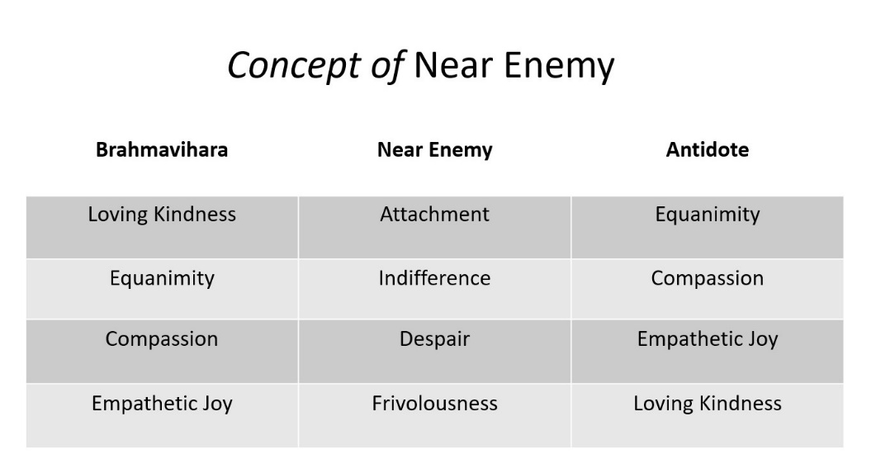
Figure 2: Understanding Near Enemies
A Change Process:
An individual’s patterns of thoughts and behaviours are driven by desires (raga) and aversions or dislikes (dvesha). There is a movement towards desires and a movement away from aversions. These are based on an individual’s actions and reactions, and are generated from habitual patterns (samskaras) arising from our proclivities (vasanas).
These habitual patterns continue until a need arises to change. This is either due to external sources or internal reasons. Change happens when there is a ‘big’ why for the need to change. There is dissatisfaction or insufficient satisfaction in one's present state, and a need to move away to another desirable state. This change model aligns to Kurt Lewin’s simple yet extremely powerful change model (Burnes 2011) shown in figure 3. Both the externally rising need to change and the internally arising reasons to change instigate each other to complete and sustain the motivation to change.
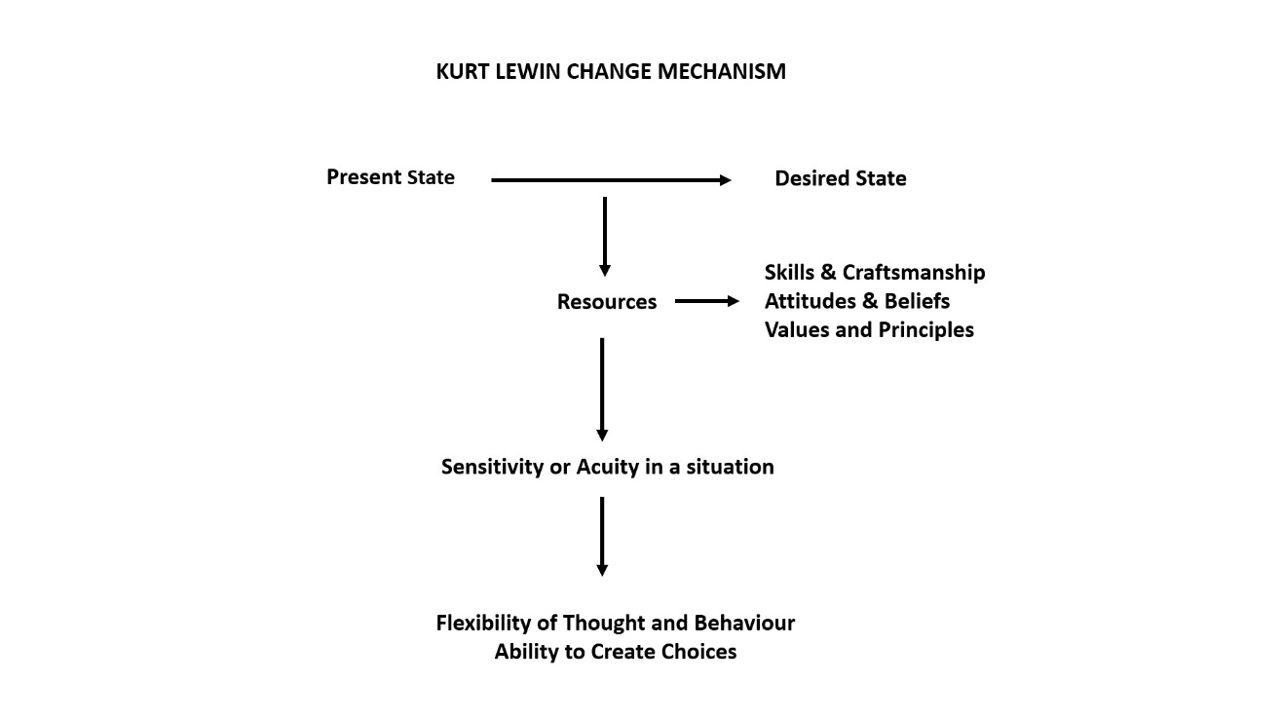
Figure 3: The Kurt Levin Change Model – Adapted
The process of interventions in this research began with the process of residual cleansing as shown in figure 4 below.
Figure 4: The Process of Residual Cleansing
Why is residual cleansing important or necessary? We usually walk into different situations from some carry-over emotional state arising from a previous engagement. It is not a clean-slated mind that grapples with new circumstances or situations, since we are always ‘coming from somewhere else’. For example, these states could be positive or negative and often colour the activity that is to follow, with the contamination of an earlier emotional energy. Specially, when we are coming from an over excited state or a negative state, the work that needs to be carried out at hand is often affected negatively. This process of residual cleansing is similar to ensuring that your plate is clean before you eat food, or a blunt from use pencil is sharpened before you begin to use it.
There are habitual patterns of aggression or not being able to tell the truth. If there is a desire to change or stop negative patterns of behaviour, then taking the help of generating positive or resourceful states like calm abiding or a state of relaxed concentration of focus helps. Residual cleansing is an excellent tool to help manage one’s course of action proactively which is based on principles and values and on emotions and desires. These altered states as resources can bring about thought and behaviour process to practice restraints or yama, and to observe positive states of thought feeling and behaviours such as the niyama cluster. The practice of restraints yama and observance of niyama creates proactive opportunities and spaces and facilitates in the practice of creative-kindness through the practice of the four immeasurables or the brahmaviharas.
A structure to Morals and Ethics
The idea we carry of ourselves arises from and determines our likes and dislikes. Indian yogic and Buddhist philosophies terms them as raga (desires) and dvesha (aversion or dislikes). Our fundamental motivations as shown in figure # below are therefore determined by striving to get what makes us happy (sukha) and push away or discard what makes us sad (dukha). In pursuit of happiness too there is cautionary note that the philosophies advocate – the choice between temporal or temporary happiness and genuine or authentic happiness.
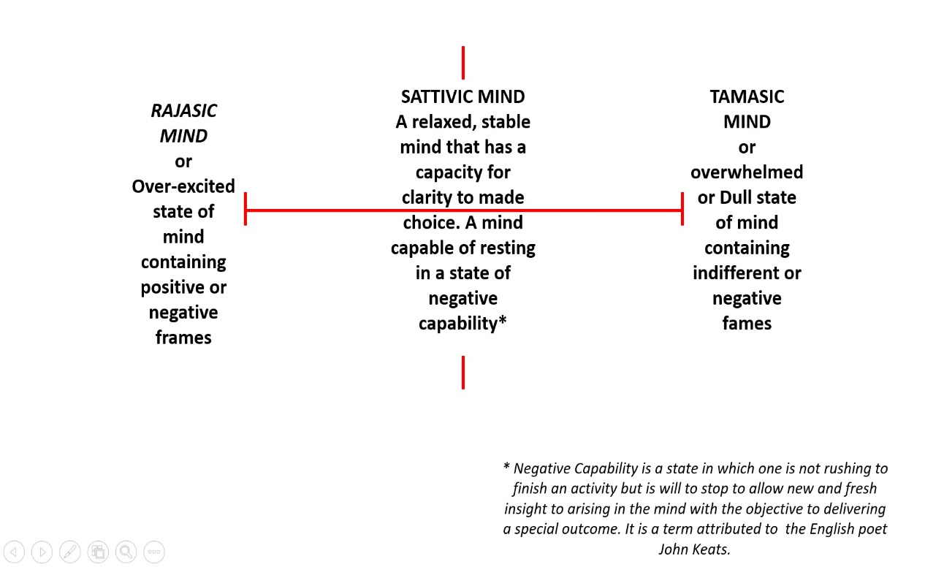
Figure 5: Guna or Qualities of the Mind
In figure 5 above when there are strong desires or agitation in one’s mind either to achieve happiness or to avoid pain the mind is in a rajasic or energy-charged state. This state can arise from an imbalance between one’s needs and wants. This in turn arises from emotional unrest and causes discontentment. This discontentment usually emerges from mental defilements and act as obstacles to adhering to moral and ethical restraints and leads to a tamasic or dull, depressed or tired mind from becoming overwhelmed. When change is sought with a sattvic mind it becomes a relaxed, stable and clear mind, This kind of mind arises from being established in values and principles and invokes persistent effort (tapa), reflective learning (svadhaya) and engaging proactively with grace and faith (ishwarapranidhana).
Then one is also not rushing through with outcomes at a frenzied pace but allows oneself empty spaces for iterative alternatives to emerge by invoking one’s negative capabilities or reflective inaction (Simpson, French, Harvey, 2002). This is also an aspect of a larger emergent harmony and authentic happiness that emerges as one practices restraints (yama) and observances (niyama). Therefore, the earlier children are familiarized and conditioned with ethics and morals it will help them in making the right ethical and moral choices.
What if – Morals and Ethics Leads Towards an Ethos of Cosmic Harmony?
More fundamental questions that arise from this are: Why is there a need for morals and ethics ? What do the practice of morals and ethics do for us? Where can it lead us?
Interestingly the etymology for the expressions of morals, ethics and character are fundamentally connected. Morals are considered as virtuous principles of right and wrong and often conveyed through stories as moral lessons.
Though morals are part of our cognitive conditioning they are established in life through one’s behaviours, and it follows that a person of virtue exhibits high moral standards in thought, feelings and beliefs. Similarly, ethics is also associated with qualities that are morally upright and necessary. The word character stems from its Greek ethos or the fundamental essence of who one is or the features that one possesses. While ethics is a division of philosophy that deals with notions of right and wrong behaviour stems from particular individual actions. Ethos is a term that is used to describe primary beliefs or standards and forms the cultural basis of a social group or an ideology or tenet.
Morals, ethics, character and pro-social skills development promote a larger ethos for model behaviours representing good conduct that act as harbingers of harmony and synergy within and between various segments that constitute our daily lives.
Confucius in his commentary on the I-Ching or the book of changes uses the term ‘superior man’ for someone who has both the acuity and the flexibility to adaptability to the changing forces of life while staying in harmony with this. This principle of harmony is initiated at an individual thought-behaviour level of ‘superior man’ and has the potential to encompass the universe in cosmic harmony (Wilhelm 1990).
Harmony between one child and another child; harmony between children and their families; harmony between families and the larger society and harmony between society and other sentient beings and life forms is what constitutes cosmic-harmony. Verily the purpose is to inculcate a repository of thought and behaviour through which they align moral and ethical behaviours by becoming important cogs in establishing harmony in the world that we exist in.
In this sense cosmic-harmony is not merely a philosophical thought or idea envisaged in an ivory tower but real-time experiencing or darsana through individual behaviours that help in connecting or building synergy with all that surrounds us.
A Look at Human Consciouness and its Impact on Nature in the Anthropocene Epoch
The consciousness of beings, wrapped in ignorance, and scaffolded with desires and aversions has fundamentally remained the same. Over the vast millennium of historical era we have been motivated more by our need to dominate, control and hold power, even using religion and clever philosophies to subdue, govern and rule over others. While our humanism or the new humanism that wishes to espouse points towards qualities of love, affection, care and concern for others these are merely couched as a manipulative jargon lacking in integrity and honesty.
So how does this current era get differentiated by the eras of the past? In no other era is the past since the 1800’s has the influence of human beings grown to such sinister proportions. Human have critically altered biogeochemical elements (Li 2020) such as the protective ozone layer, oxygen, phosphorus and sulphur, that are fundamental to life on the Earth. By intercepting, altering and polluting the flow of water from the catchment source to the sea we have adversely affected both the quantity and quality of water available to sustain a healthy life for the flora and fauna on our planet.
Indiscriminate extraction of fossil fuels and minerals, dumping of hazardous and toxic waste in landfills and on our ocean floors are all ticking time bombs. While we express love, care and concern we have for our children with our words, and in our speeches, we are woefully short with regard to protecting vital aspects of nature that promote sustainable well-being for future generations to come. Short term profits seem to be the motivational force driving human endeavour irrespective of the negative consequences that would be faced by our children.
Collective greed of humans has given rise to a menacing meaning to the Anthropocene epoch. Humans with special abilities of intellect and skills who could have taken on the mantle of responsible care-takers of the Gaia have instead emerged as the predominantly destructive species. Having got to such a state the meta-capacity of humans places a greater responsibility rather than entitlement.
This paper is being written from the perspective of human-beings and their practice of humanism via moral and ethical behaviour and a direction that we can point our children towards.
The point of departure being that humans are placed as a dominant species at the centre of our planet with unprecedented power to influence the fate of other species, the environment and the future of the quality of bio-diversity of life on earth. There is a refrain from some quarters that this call to align with moral and ethical values in the lives we live and the occupations we follow is too little and too late – like shutting the stable door after the horses have bolted.
As Nobel Laureates Paul J. Crutzen and C. Schwägerl, put it, “It’s no longer us against ‘Nature.’ Instead, it’s we who decide what nature is and what it will be.” In Analects 15.29, Confucius famously said, “it is the capacity of humans to promote nature (Tao), it is not for the nature (Tao) to promote humans”.
The Anthropocene reflects a fundamental fact of our time. Rather than knowing their place in the order of things it is as though humans decide on the basis of their self-interests what nature should be like or how it should exist. Scholars like Dallmayr’s through their scholarly inquiry are calling for a mega-humanism to halt the degeneration of the Gaia caused by human intellect and technological advancements by seeking succour is a far cry from the triadic cosmic harmony advocated by Confucius and the cosmic-moral order of the Vedic Ṛta (Londhe 2018, Das 2018).
Philosopher and formulator of Integral Psychology Kenneth Wilber has a different prognosis with his meta theory that suggests a holonic structure to consciousness. Wilber posits an evolutionary automacity in human consciousness that will right the wrongs of the Anthropocene epoch. According to him when a critical mass of human beings evolve from the orange meme of the strategic achiever in the current corporate flatland that we are living in, to a more ecologically responsible and benevolent expressions of care and concern, they move to the communitarian and egalitarian green meme in which one will move away from greed, dogma, and divisiveness. In Wilber’s green meme feelings, sensitivity, and caring supplant cold rationality of the political-economists.

Towards Behavioural Changes
A philosophy to be pragmatic and useful should have doable components in it else it a just armchair theorizing. This paper promotes the Yogic and Buddhist philosophical principles as means to invoke triadic harmony through the practice of yama and niyamas, the brahmaviharas and their alignment with the Mahayana and the structure of the paramitayana (Govinda 1960, Gyatso, Rigzin, Russell, 1985, Trungpa 2014).
In figure 6 illustrated below when we investigate the Paramitayana of Mahayana Buddhism each of the paramitas or perfections that lead to ‘cosmic-harmony’ on the Bodhisattva pathway has specific action points as a doable.
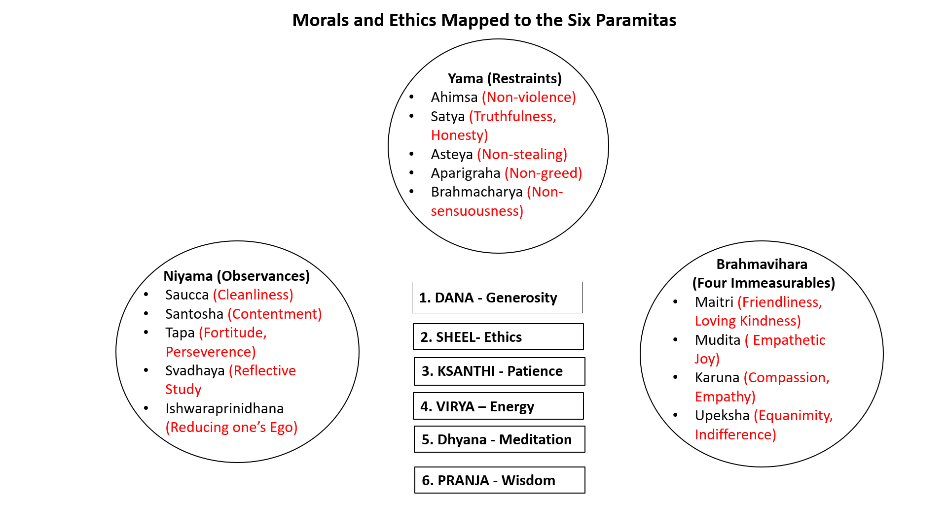
Figure 6: Morals & Ethics Mapped to Six Perfections

The aspiring Bodhisattva on his journey has to perform certain patterns of behaviours to achieve competency on the path. On unravelling the paramitas on the path we see the following behavioural structures emerge that need to be followed or adhered to:
To accomplish the first perfection of giving or dana-paramita one requires a clean and contented mind. The act of giving is in real life experiences is in the practice of giving material things, doing things for you, spending time with them, positively motivating and encouraging, and in loving and caring. This arise of the equanimous practice of loving kindness, empathetic joy, compassion and empathy or the practice of the brahmaviharas.
To accomplish the second perfection of ethics or sheel-paramita the restraints should be adhered to. These are the ten restraints of body, speech and mind from Buddhaghosa’s Visuddhimaga, and the five restraints prescribed by Patanjali in the Yoga Sutras are enumerated above in this paper.
The third perfection is ksanthi-paramita of practice of patience. This requires that one observes all the restraints. The essence of the practice of restraints is not harming others or the practice of non-violence (ahimsa). We hurt and harm others based on our likes and dislikes. Patience allows us to act out of values and morals that we subscribe to and not out of our likes and likes.
Similarly, the fourth perfection which is virya-paramita or application of enthusiastic energy requires one to be being diligent and persevering in one’s effort (tapa). Also, the applied energy needs arise from a clean (saucca) and contented (santosha) mind and lead us towards reflective learning (svadhaya), humility (ishwarapranidhana), and the practice of the four immeasurables (brahmaviharas) (Aranya 1977, Taimni 2010).
The practice of the fifth perfection or meditation or dhayana-paramita is in practice of choosing an object for meditation and placing one’s mind on it. Meditation is practiced through watching one’s breath (anapanasati samadhi) (Bkra-śis-rnam-rgyal, Lhalungpa, 2001), awareness of sensations (vedana) arising in the body, choosing and watching objects, and smells, and through the practice of prescribed techniques of clam-abiding (samatha), special insight (vipassana) (Bkra-śis-rnam-rgyal, Lhalungpa), 2001and the esoteric observance of thoughts, images, and feelings as they arise and dissolve in the mind, in the practice of Mahamudra meditation (Bkra-śis-rnam-rgyal, Lhalungpa, 2001).
In order to practice meditation proficiently one will need to clear the space in the mind from agitation and defilements. This entails being mindful and aware of practicing of restraints (yama) which results in keeping the mind clean (saucca) and contented (santosha) and a fit instrument for practicing meditative. Other practices that form part of the skilful-means (upaya) in the practice of mediative awareness and mindfulness are tapa and perseverance (fortitude), humility from realizing there is a greater reality to the self (isharapranidhana) and un-flailing or steady practice of the four-immeasurables (Thurman 1989, Hopkins 2014, Wayman 1978, Schroeder 2004). This reinforces the capacity for formal meditative practices mentioned above.
If all the practices or paramitas listed above are the roots, trunk branches, foliage and flowers of a tree, the manifestation of the sixth perfection or awakening of wisdom or prajna-paramita grows which is like is like the fruits ripening on a tree.
From the perspective of Patanjali’s Yoga Sutra flow chart of the cognition and behaviour relating to the outcomes that can lead to authentic happiness and creativity from the perspective of the Yoga Sutras of Patanjali is presented in figure 7. The book chapters and the sutra numbers associated with these cognitive behavioural results are succinctly elaborated.
In Yoga Philosophy the starting point is asmita (I-sense) that gives rise to ego with the ensuing of attachment rāga (desires) and dveṣa (aversion) which becomes the basis of interacting with the world and its objects through our senses. This in turn gives rise to our thoughts, feelings, beliefs which are our cognitive functions. Our cognitive functions in turn affect our states of body and mind. These could be sattva (calm relaxed), rajas (energized) or tamas (tired) states of mind, body and emotions. When the mind is filled with strong attachments and aversions it can become distracted and agitated and oscillates between rajas (frenzy) and tamas (weariness). Then there is a need to make choices that will pull oneself towards sukha or becoming calm and relaxed. Patanjali prescribes the use of pratipakshabhāvana or applying opposing thoughts (reframing) as an antidote to calm and relax an agitated mind from distraction and wandering that it is able to make ecological and holistic choices. These are choices that are anchored in values and principles rather than personal likes (attachments) and dislikes (aversions). Strong personal likes and dislikes mirror a strong egoistic hold. They come in the way of expressing care and concern for others. When one becomes adept at application of pratipakshabhāvana or able to substitute negative thoughts and feelings with positive thoughts and feelings one can practice the yamas or restraints of not harming others and the niyamas or observances that facilitate self-management. This include the all-important practice of kriya-yoga that include tapa (perseverance), svādhyāya (reflective-learning) and īśvarapraṇidhāna (realizing there are higher realities that ourselves).
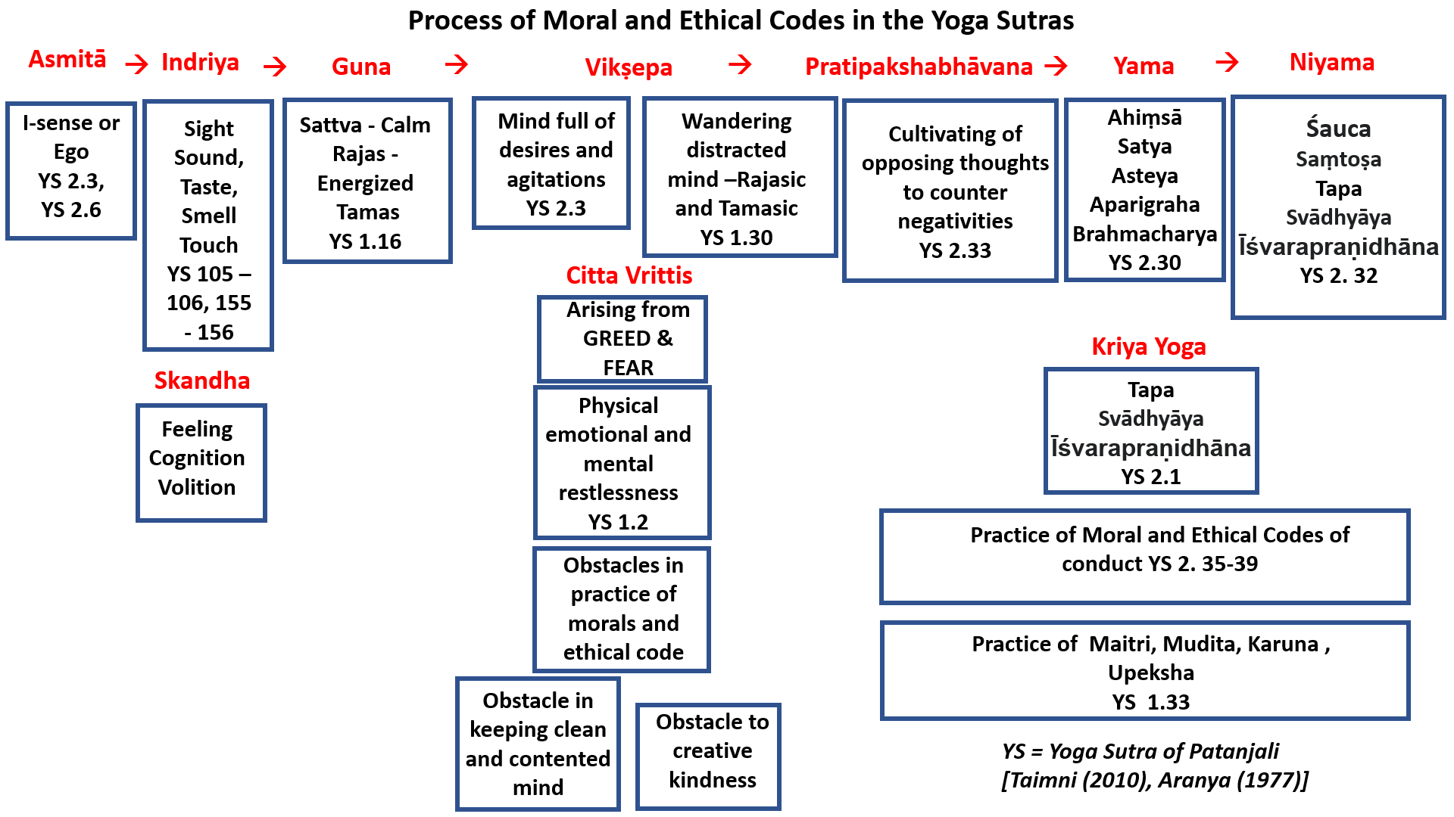
Figure 7: Process of Moral and Ethical Codes in the Yoga Sutras
Conclusion:
The direction in which our world seems to be heading indicates increased burden on the natural resources and imbalances in vital biogeochemical elements. The Anthropocene epoch suggests there is negligence on the part of humans due to lack of ethical values and concern for care and concern of future generations. Values and ethics prescribed in Indian philosophies from the Yogic and Buddhist schools can provide frameworks for robust pedagogies to children. These ministrations can be tailored to provide moral and ethical direction and scaffolding to children in a manner that they are conditioned to make value-based choices out of care and concern for others rather than their personal likes and dislikes in terms of what would individually profit them.
Essentially the goal would be to inculcate value-based decisions in choice of behaviour rather than reactive selfish choice of behaviours in children. These would align with growth in character, enhancement with pro-social skills that would lead to cognitive and behavioural skills that would enable them to protect their relationship with one another, maintaining the optimum balance of biogeochemical elements, and protect the flora and the fauna to co-exist in harmony with them to not just survive but to thrive collectively.

References:
- “This Column Will Change Your Life: Near Enemies.” The Guardian. Guardian News and Media, June 7, 2014. https://www.theguardian.com/lifeandstyle/2014/jun/07/change-your-life-near-enemies-buddhism.
- Bkra-śis-rnam-rgyal, and Lobsang Phuntshok Lhalungpa. Mahamudra: The Quintessence of Mind and Meditation. Delhi: Motilal Banarsidass, 2001.
- Blo-bzang-grags-pa, Tsong-kha-pa, and Alex Wayman. Calming the Mind and Discerning the Real: From the Lam Rim Chen Mo. New York: Columbia University Press, 1978.
- Blo-bzang-grags-pa, Tsong-kha-pa, and Thurman Robert A F. The Speech of Gold: Reason and Enlightenment in the Tibetan Buddhism. Delhi: Motilal Banarsidass, 1989.
- Bstan-ʼdzin-rgya-mtsho, Tsepak Rigzin, Jeremy Russell, and Bstan-ʼdzin-rgya-mtsho. Opening the Mind and Generating a Good Heart. Dharamsala, H.P, India : Library of Tibetan Works and Archives, 1985.
- Buddhaghosa, and Ñānamoli Bhikkhu. The Path of Purification: (Visuddhimagga). Kandy: Buddhist Publication Society, 2010.
- Burnes, Bernard. (2011), “Kurt Lewin and the Origins of Od.” The Routledge Companion to Organizational Change, n.d. https://doi.org/10.4324/9780203810279.ch1.
- Das, B.C, (2018), Vedic Concept of Ṛta, The Journal of East West Thought Vol. 8 No. 1: Spring 2018
- Gampopa, Guenther Herbert V. (1986). Jewel Ornament of Liberation: The Wish-fulfilling Gem of the Noble Teachings, Shambala Publications, Boston
- Govinda, Anagarika. Foundations of Tibetan Mysticism: According to the Esoteric Teachings of the Great Mantra oṁ maṇi Padme hūm. Bombay: B.I. Publications PVT, 1993.
- Gyatso, Kelsang. (2016), Meaningful to Behold: Becoming a Friend of the World. Ulverston, Cumbria: Tharpa Publications.
- Hopkins, Jeffrey. Meditation on Emptiness. Somerville: Wisdom Publications, 2014.
- Lekden, Kensur, and Jeffrey Hopkins. Meditations of a Tibetan Tantric Abbot: The Main Practices of the Mahayana Buddhist Path. Ithaca, NY: Snow Lion Publications, 2001.
- Li, Chenyang. “New Humanism with Cultural Roots for the Anthropocene — a Confucian Perspective.” New Humanism and Global Governance, 2018, 19–32. https://doi.org/10.1142/9789813236189_0002.
- Londhe, Manali. Vedic Concept of Ṛta. Proceedings of the XXIII World Congress of Philosophy, 2018, 143–48. https://doi.org/10.5840/wcp23201816629.
- Marco. “The near Enemies of Awakening.” Jack Kornfield, March 9, 2016. https://jackkornfield.com/near-enemies-awakening/.
- Mitsuhashi, Y. (2018). Ikigai: Giving every day meaning and joy. Kyle Books, Hachette, UK
- Schroeder, John W., and T. P. Kasulis. Skillful Means: The Heart of Buddhist Compassion. Delhi: Motilal Banarsidass, 2004.
- Shantideva, Batchelor S., (1978), Guide to a Bodhisattva’s way of Life, Library of Tibetan works and Archives, Dharamsala.
- Simpson, P. F., French, R., & Harvey, C. E. (2002). Leadership and negative capability. Human Relations, 55(10), 1209–1226. https://doi.org/10.1177/0018726702055010081
- Slatcher RB, Trentacosta CJ. Influences of parent and child negative emotionality on young children's everyday behaviors. Emotion. 2012 Oct;12(5):932-42. doi: 10.1037/a0027148. Epub 2012 Mar 5. PMID: 22390707; PMCID: PMC338752.
- Terzi, Alex & Matos, Diogo & Rodrigues, Martha & Demarzo, Marcelo. (2020). Mindfulness in Education and Paulo Freire: a reflective approach. Interface - Comunicação Saúde Educação. 24. 1-14. 10.1590/Interface.200015.
- Trungpa, Ch. Bodhisattva Path of Wisdom and Compassion: The Profound Treasury of the Ocean of Dharma, Volume Two. Shambhala Publications, Incorporated, 2014.
- Wallace, B. Alan. The Attention Revolution: Unlocking the Power of the Focused Mind. Australia: Accessible Publishing Systems PTY, Ltd., 2010.
- Wilhelm, R., Baynes, C. F., Jung, C. G., & Wilhelm, H. (1990). The I ching or book of changes. Princeton University Press.

